CASE WESTERN RESERVE UNIVERSITY
Case School of Engineering
Department of Electrical Engineering and Computer Science

ENGR 210. Introduction to Circuits and Instruments (4)
Quiz No. 7 10/17/03

Name (Section): _________________________

Put answers in the space provided and show your work
Problem 1 (10 points)
In part (a) of the Figure shown below, fill in the values of the Proportionality factors provided by the circuit in part (b), and show the signal range (min and max) at each node in the circuit.
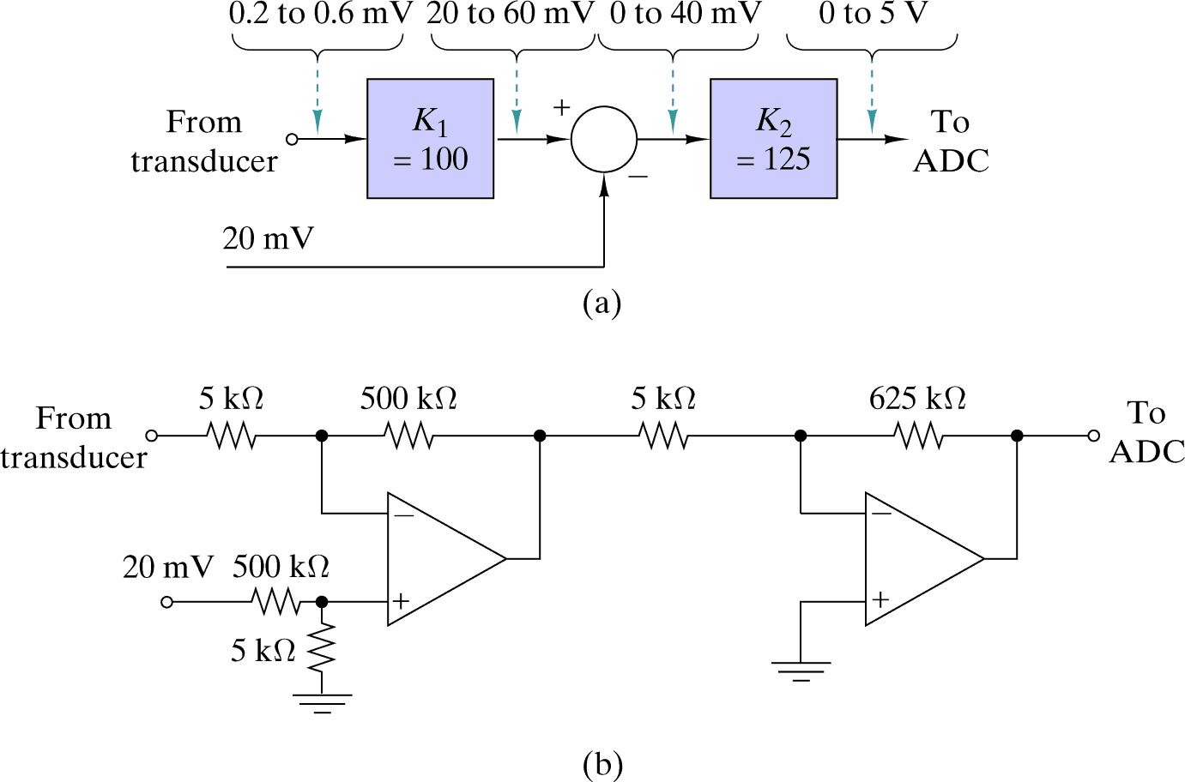
to
to
to
Problem 2 (10 points)
In the circuit shown below, an OP AMP is used as a comparator with its power supply terminals connected to +15 V and ground. A lamp is lit when its voltage is greater than 5 V. Determine the range of input voltages for which one, none, or both of the lamps is lit and complete the table. If there is no input voltage that produces a particular lighting combination, write “N.A.” (not applicable).
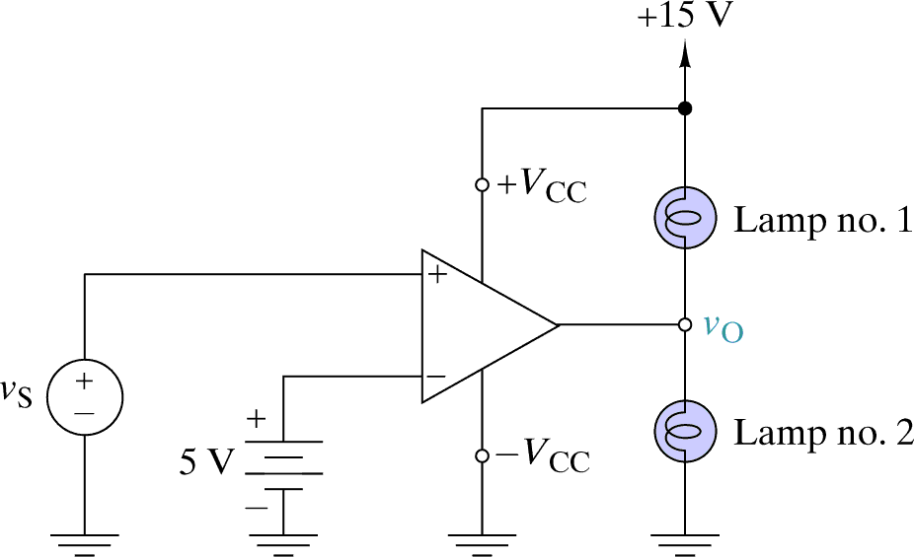

Lamp Condition | vS Range
No lamp lit | to
Lamp no. 1 lit | to
Lamp no. 2 lit | to
Both lamps lit | to

