CASE WESTERN RESERVE UNIVERSITY
Case School of Engineering
Department of Electrical Engineering and Computer Science

ENGR 210. Introduction to Circuits and Instruments (4)
Quiz No. 6 10/10/03

Name (Section): _________________________

Put answers in the space provided and show your work
Problem 1 (10 points)
A particular operational amplifier is operated using supply voltages of ±15 V, and has a voltage gain in the linear region of 10⁶. Calculate the minimum and maximum, input and output, voltages that bound the linear operating region of this operational amplifier. Complete the table.
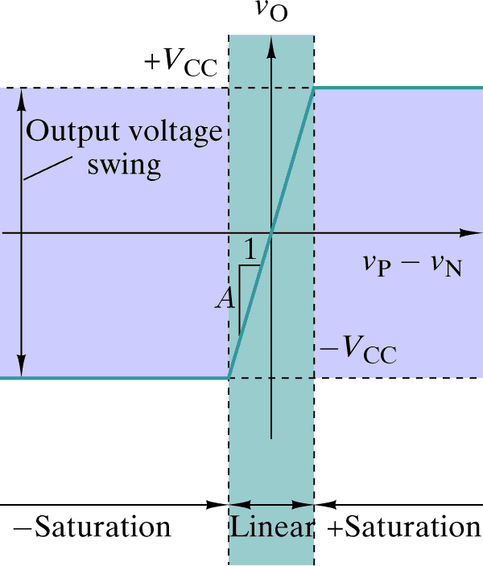

Variable | Value
(v_{P}-v_{N})_{min}
(v_{P}-v_{N})_{max}
v_{O,min}
v_{O,max}
Problem 2 (10 points)
Draw the schematic diagram of the OP AMP circuit that implements each of the functions shown in the table below. Each circuit should use exactly one OP AMP and one or more resistors. Be sure to label resistor names.
