CASE WESTERN RESERVE UNIVERSITY
Case School of Engineering
Department of Electrical Engineering and Computer Science

ENGR 210. Introduction to Circuits and Instruments (4)
Quiz No. 5 10/03/03

Name (Section): _________________________

Put answers in the space provided and show your work
Problem 1 (10 points)
Calculate i_{X}, v_{O}, and p_{O} (the power dissipated by R_{L}) given
v_{S} = 4 V, r = 40 kΩ, and R_{L} = 70 kΩ. Complete the table.
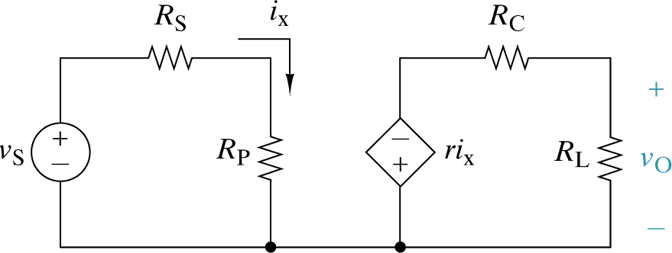
5 kΩ
10 kΩ
15 kΩ

Variable | Value for  v_{S} = 4 V, r = 40 kΩ, and R_{L} = 70 kΩ
i_{X}
v_{O}
p_{O}

Given v_{S} and r as above, choose the value of R_{L} that give maximum p_{O}, and calculate this value of p_{O}. Complete the table.

variable | Value for maximum power
R_{L}
p_{O}
Problem 2 (10 points)
Find the Thevenin and Norton equivalent circuit parameters for interface v_{O} in this circuit. Complete the table.
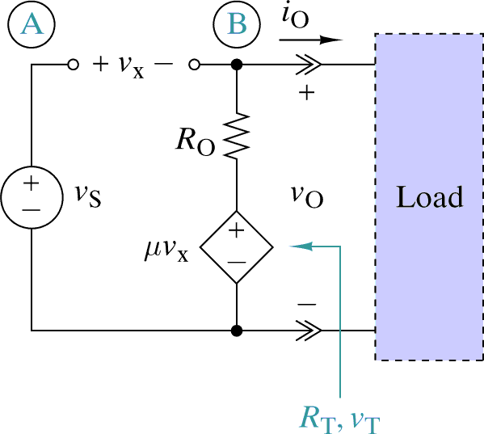
μv_{S}

Element | Value
v_{T}
R_{T}
i_{N}
R_{N}

