CASE WESTERN RESERVE UNIVERSITY
Case School of Engineering
Department of Electrical Engineering and Computer Science

ENGR 210. Introduction to Circuits and Instruments (4)
Quiz No. 3 9/19/03

Name (Section): _________________________

Put answers in the space provided and show your work
Problem 1 (10 points)
Each of the following two-element circuits can be replaced by an equivalent circuit using just one element. Complete the table, being sure to indicate the value of the element in the equivalent circuit.
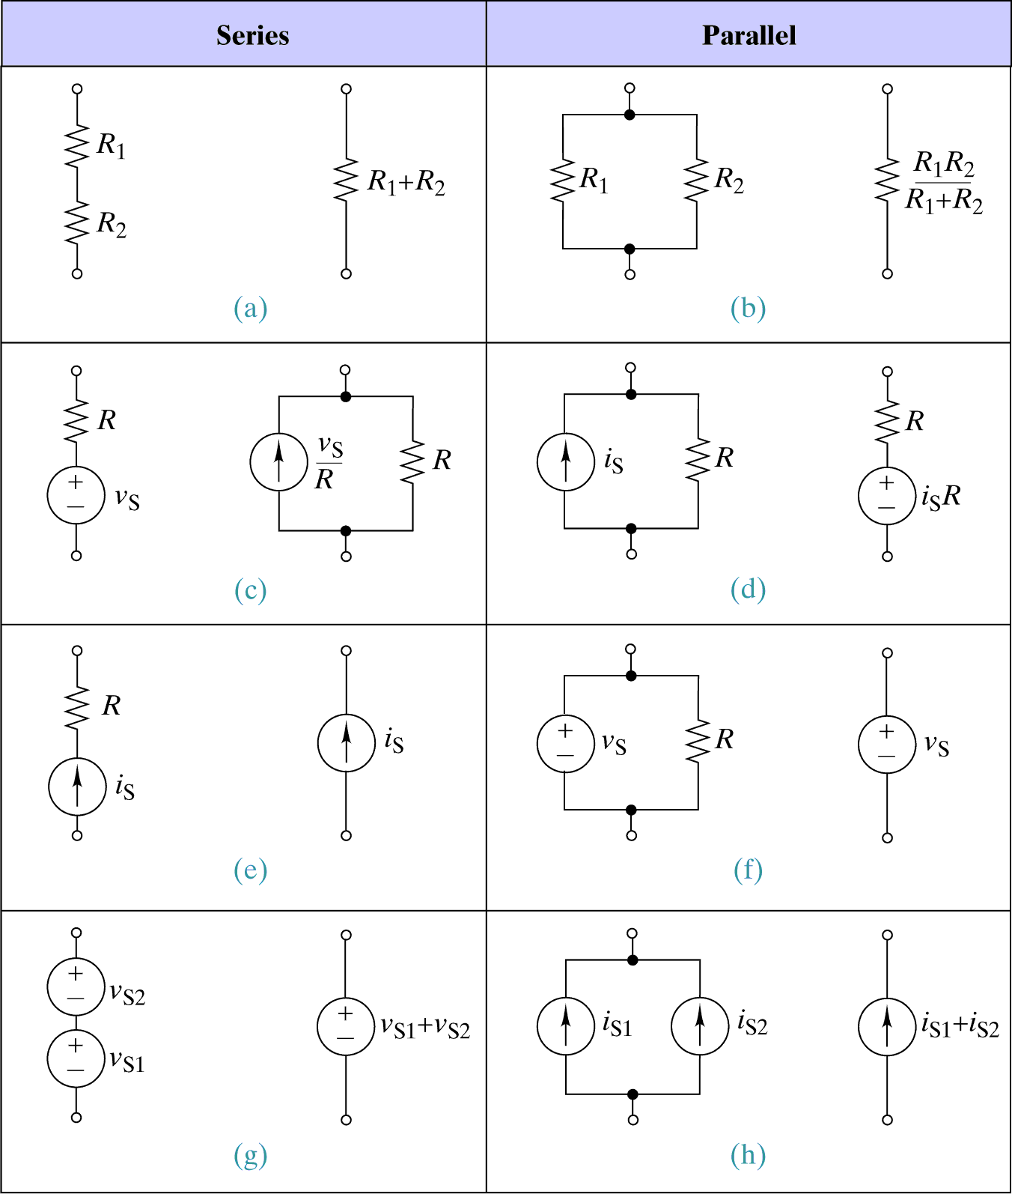

Problem 2 (10 points)
Find the node-voltage equations for this circuit. Complete the table.
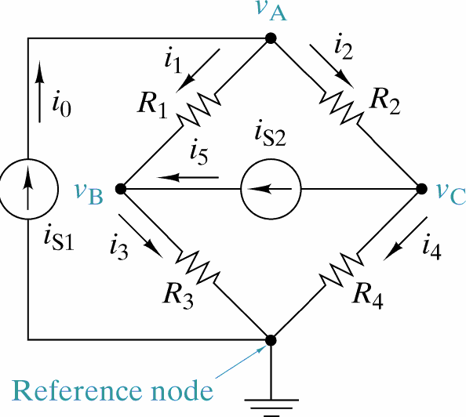

KCL  NODE | Node-Voltage Equation
A | ________ v_{A} + ________ v_{B} + ________ v_{C} + = ________
B | ________ v_{A} + ________ v_{B} + ________ v_{C} + = ________
C | ________ v_{A} + ________ v_{B} + ________ v_{C} + = ________

