CASE WESTERN RESERVE UNIVERSITY
Case School of Engineering
Department of Electrical Engineering and Computer Science

ENGR 210. Introduction to Circuits and Instruments (4)
Quiz No. 2 9/12/03

Name (Section): _________________________

Put answers in the space provided and show your work
Problem 1 (10 points)
Use KVL, KCL, and element constraints to find the current that flows through each element in this circuit. Use polarities defined by the arrows. Complete the table.
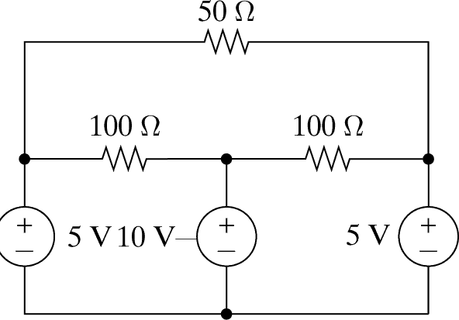
R₁
R₂
R₃
V₄
V₅
V₆

Element | Current
R₁ | I₁ =
R₂ | I₂ =
R₃ | I₃ =
V₄ | I₄ =
V₅ | I₅ =
V₆ | I₆ =

Problem 2 (10 points)
Find the equivalent resistance between each pair of terminals (with the other two terminals left disconnected). Complete the table.
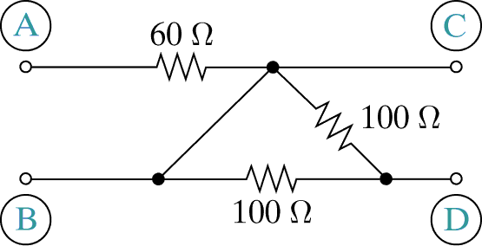

Terminals | Resistance
A-B | R =
A-C | R =
A-D | R =
B-C | R =
B-D | R =
C-D | R =

