CASE WESTERN RESERVE UNIVERSITY
Case School of Engineering
Department of Electrical Engineering and Computer Science

ENGR 210. Introduction to Circuits and Instruments (4)
Quiz No. 1 9/5/03

Name (Section): _________________________

Put answers in the space provided and show your work
Problem 1 (10 points)
Complete this table.
Quantity | Symbol | Unit
Power
Charge
Current
Voltage
Resistance

Problem 2 (10 points)
Write the KCL equations for this circuit, then solve for the unknown currents. Complete the tables.
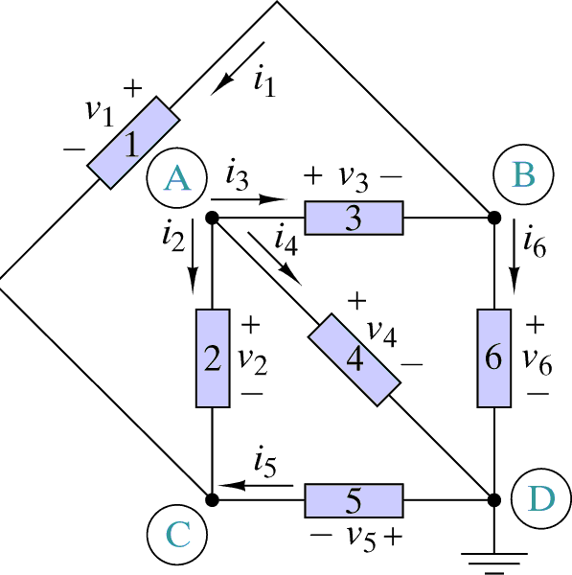
Node | KCL Equation
A | = 0
B | = 0
C | = 0

Element | Current
1 | I₁ = 1 A
2 | I₂ = 2 A
3 | I₃ = 3 A
4 | I₄ =
5 | I₅ =
6 | I₆ =

