ENGR 210 Lab 3
The Single Channel VI and Physical DC Measurements

Background
This week, you will make DC measurements using LabVIEW 6.1 and the Keithley Digital Multimeter (DMM). In the first part of the lab, you will modify your VI from Lab 2 to measure voltage using a data acquisition board. In the second part of the lab, you will use a DC power supply and a DMM to make voltage, current, and resistance measurements.

Computer Measurement of Voltage
In Lab 2, you constructed a VI that continuously displayed random numbers on a chart indicator through the action of a while loop. The diagram window shown in Figure 1 displays a VI with similar structure. This VI continuously reads voltages from the data acquisition board, displaying them on a chart. The random number generator and accompanying arithmetic have been replaced by the Keithley analog input (Ai) sample channel sub-vi.
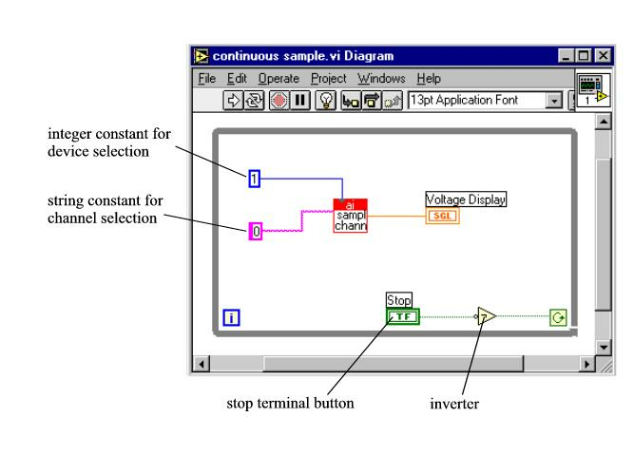
Figure 1. LabVIEW Program to Read a Voltage from a Single Channel and Display that Voltage Value on a Waveform Chart.

As described in Lab 2, the Ai sample channel block (Figure 1) performs the data acquisition (DAQ) procedure that reads voltage levels. Keithley Instruments has performed all of the programming that drives the DAQ system and has wrapped all of the code into the Ai sample channel sub-vi.

Figure 2 shows the front panel for the continuous DC sampling VI. When the run button is pressed, the VI will begin plotting voltages from channel 0 of the DAQ board. The voltages will be sampled as quickly as the while loop can cycle, and acquisition will stop when the stop button is pressed.
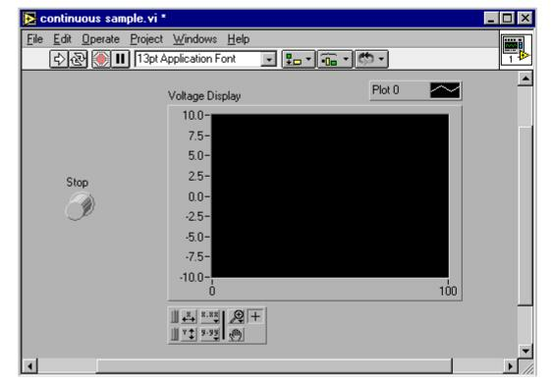
Figure 2. Front Panel of a Program that Reads and Displays a Voltage Input

The voltage that is being measured by the DAQ board is ideally represented by a real number with arbitrarily large upper and lower bounds. However, when the DAQ board digitizes the input voltage levels, the resulting digital representation has a limited number of bits (16 bits for the KPCI-3108). This limits the resolution of each measurement. The Keithley KPCI-3108 DAQ boards in the Glennan 308 Lab read and digitize voltages in the range of -5 to +5 volts by default. The input range is software configurable via additional parameters to the sub-vi. The maximum input range is –10V to +10V, but better voltage resolution is achieved by using smaller measurement ranges. More will be said about this in Lab 5. If the input voltage is not within the configured range, the card will return the appropriate high or low limit. You should always be aware of the range of voltages entering the DAQ board so that your measurements are accurate.

Building Circuits Using a Solderless Breadboard (Prototyping Board)
You have already seen one protoboard configuration in the Lab 1 simulation. The solderless breadboard, or prototyping board, is a white plastic device with holes that are connected together in a specific pattern. These connections function as wires by providing continuity between components in the circuit as follows. Circuit components are placed in the breadboard by inserting their wires or “leads” into the holes on the breadboard. Since the holes are connected together in a specific pattern, many components can be connected together without any additional wiring. The typical hole-to-hole connection patterns for most of the solderless breadboards used in the Glennan Laboratory are shown in Figure 3. Note that some breadboards may differ slightly, if you have any questions ask a TA or use your DMM to determine the continuity pattern of your protoboard.
Figure 3. Solderless breadboard

The heavy lines in (Figure 3) indicate electrical connections or continuity. In rows 2 and 3, the heavy lines run from top to bottom; this indicates vertical continuity. In rows 1 and 4, the heavy lines that are connected by the light and dark horizontal lines indicate horizontal continuity. Please note that for rows 1 and 4, the lines on the left half of center are not connected to the lines on the right half of center. The horizontally connected holes are generally used for power and for ground connections while the vertically connected holes are usually used for general-purpose circuit connections. The spacing between the holes is standardized so integrated circuit (IC) components will fit nicely into the breadboard. Resistors and other components with flexible wire leads also fit nicely into the breadboard.

LABORATORY PREPARATIONS
To prepare for this Lab you should complete the following calculations before you come to the laboratory.

1. Voltage Divider Circuit
25 V
+
-
1.2kΩ
8.2kΩ
13kΩ
+
-
V
1
+
-
V
2
+
-
V
3
I
Figure 4. Voltage divider circuit.

The circuit shown above (Figure 4) is a voltage divider. Calculate the total current, I, in the circuit and the voltage across each resistor using the voltage divider relationships that were discussed in class. Record your results in Data Table 2 of the Data Sheets.

2. Current Divider Circuit
25 V
+
-
2kΩ
+
-
V
1
1.2kΩ
+
-
I
2
13kΩ
V
2
I
3
I
1
Figure 5. Current divider circuit.

The circuit shown in Figure 5 includes a current divider. Using the current divider relationship, calculate the current that you would expect to measure through each resistor. Use the results from the current divider relationship to calculate voltages V₁ and V_{2.} Record your results in Data Table 3 of the Data Sheets. Hint: Combine the parallel resistors (13K and 1.2K) then add this result to the series (2K resistor) to find the total resistance in the circuit. Next use Ohm’s Law to find the total current (I1) in the circuit. Finally calculate the currents I2 and I3 using the current divider rule. Another approach requires a source transformation and then the use of the current divider rule, however, please remember that the current value of the transformed current source is NOT the same as the total current in the circuit!

Part 1: LabVIEW Measurements
In part 1, we will write a LabVIEW virtual instrument (VI) that can read and display voltages. The idea is to build an instrument that works like a graphing digital voltmeter. This requires a PC with LabVIEW software and a Keithley data acquisition (DAQ) board. The computers in the Glennan 308 circuits lab have the necessary data acquisition cards installed in them.

PLEASE MODIFY YOUR VI FROM LAB 2. Your file from lab 2 should be located on the network drive (I:). Please remember that the file will be on the network (I:) drive in the location that corresponds to the person in your group who logged in the last time you were in the Lab! Other group members may also want to put copies of the work that was done during Labs 2 and 3 on their own partition of the network (I:) drive using their own account. It is probably best to transfer the files to your group members over the network or by placing them in the C:\temp directory when in Glennan 308. If you decide to transfer files in the lab, please remove your files from the temp directory before leaving the lab.

Since you will be doing LabVIEW programming, a short summary of some LabVIEW commands is given in Table 1.

Command/Tool | Purpose | Used When | Picture
Delete key | Deletes selected objects | There are unwanted objects in the program | <Delete>
Ctrl-S | Saves files | You want to save your Changes | <Ctrl-S>
Positioning tool | Moves and selects objects | You need to move or delete program elements or insert new ones
Wiring tool | Connects objects together | Program elements must be connected to allow data to flow between them
Ctrl-B | Removes all broken wires | There are several unwanted wires in the program; use with caution | <Ctrl-B>
Operating tool | Changes values | You need to change a value in a front panel object
Text tool | Edits text | You need to change a label or a comment
Table 1. Some Useful Commands and Tools

A. Building a DC Voltmeter with LabVIEW
- The easiest way to create this VI is to modify your program from Lab 2. Save the program from Lab 3 under a different name, for example Lab3meter.vi. Please remember to use the extension *.vi for all of virtual instrument files that you will create this semester.
- The following instructions assume that you are modifying your VI from Lab 2. Remove the random number generator, the (addition, subtraction, and multiplication blocks), as well as all of the wires that were connected to the removed components. We will not remove the output terminal, it will be renamed by first selecting the "operate tool" (looks like a pointing finger) from the tools pallet and then typing in a new name. The upper and lower limits for the input will also be removed by clicking on the upper and lower limit boxes from the panel window and selecting clear from Edit menu.
- In general, a sub-VI is LabVIEW's version of a C function. Next, we will insert the Ai sample channel sub-VI needed for data acquisition into the while loop. The Ai sample channel sub-VI is located in the Functions Palette in User Libraries » Keithley DAQ VIs » KI Easy VIs » ai sample channel.vi. Remember that you can find this menu by pointing the cursor to where you want the icon to appear on the diagram window and clicking the right mouse button.
- Open the Help window by typing <Ctrl-H> and positioning the cursor on the ai sample channel Sub-VI.

(a) Diagram View | (b) Front Panel View

Figure 6. Sample VI that Reads Channel 0 from Device 1

- Selecting from the Functions palette again, insert a digital constant to set the device number for Ai sample channel. This digital constant should be set to 1 for the PC's in the Glennan 308 Laboratory. The digital constant can be located by following the path Function palette>>Numeric (the blue box that contains the numbers 123)>>Numeric Constant (another blue box that contains the numbers 123). Use the wiring tool to connect to the numeric constant to the appropriate input of the Ai sample channel (Figure 6a). Hint: The wire should be blue.
- From the Functions palette, insert a string constant to set the channel number for Ai sample channel. String constants work the same as digital controls, except they use a different data type. Set this string constant to 0 [Not 6 as shown in Figure 6a] for the PC's in the Glennan 308 Laboratory. The clip leads on the input board are connected to the appropriate screw terminals for the channel 0 and 1 inputs. The string constant symbol is located by following the path Function palette>>String>>String Constant (i.e. the pink box that contains the letters abc). Please remember to save your VI after every few changes, this way you can return to a known state if an error occurs.
- Use the wiring tool to connect the output of the KI AI Sanple Channel.vi to the Waveform Chart terminal.
- Save your file.

Part 2: DMM Measurements
A. Instrument Familiarization
In this part of the laboratory, you will use both a power supply and a digital multimeter (DMM). Both instruments are rather sophisticated so we will test some of the instrument capabilities before actually using them for circuit measurements. Since we will be using these instruments for the rest of the semester, it is very important that you learn to use them correctly.

1. Triple Output DC Power Supply (HP E3631A)

The front panel of the Triple Output DC Power Supply is shown in Figure 7. This power supply can produce output voltages in the range 0V to +6V, 0V to +25V, and 0V to -25V. The +25V and -25V supplies have a common terminal and all three supplies are isolated from earth (power line) ground, although any terminal can be grounded.
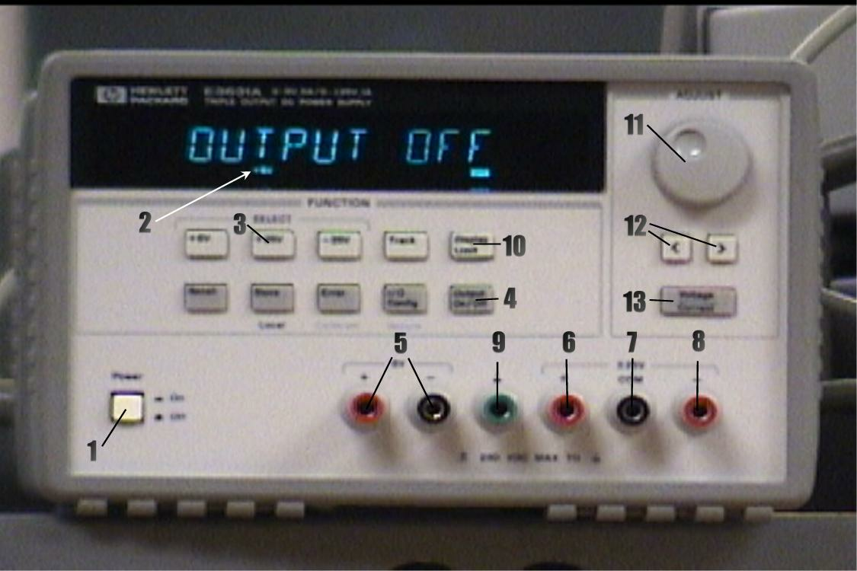
Figure 7. HP Triple Output DC Power Supply
1) With no connection to the outputs, turn on the power supply by pressing the Power switch (1). After a self-check, the display will indicate OUTPUT OFF and show that the +6V supply is connected for metering (2). Select the +25V supply for metering by pressing the +25V button (3). The LED display will indicate that the +25V supply has been selected.
2) Turn the output on by pressing the Output On/Off switch (4). This connects the output of each of the three supplies to the appropriate output terminals, with the value of the selected supply displayed. The +6V output is available between + and - terminals (5) under the 6V label, the +25V output is available between the + terminal (6) and COM (7) terminal, and the -25V between the - terminal (8) and COM (7) terminal. YOU SHOULD ALWAYS USE THE COM (7) TERMINAL TO GET +25 or -25 OUTPUTS. Do NOT use the - terminal (5) of the 6V output or the ground terminal (9) to complete a + 25 or - 25 V output connection.
All three supplies are isolated from power supply ground. The +25V and -25V supplies can be referenced to ground by connecting the COM (7) to ground (9). Either side of the +6V supply can be referenced to ground by connecting the + or - terminal to ground.

At power on, the power supplies are set to the following maximum current outputs:

Supply | Max V_{out} | Max I_{out}
6V | 6V | 5.0 A
+25V | 25V | 1.0 A
-25V | -25V | 1.0 A
To view the limits, press the Display Limit switch (10). On doing this, the term “Lmt” appears just below the output numbers on the display and the second digit of the voltage display is blinking. When “Lmt” is illuminated, the display shows the limiting (maximum) current available from the selected supply. After 6 seconds of inactivity an internal timer automatically switches the “Lmt” display back to the meter mode.
3) Use the display Limit function and the Select switches to check the above default settings. If the “Lmt” illumination turns off, press the Display Limit switch again.
4) Select the +25V output for display. Turn the Adjust knob (11) and observe that the output voltage changes. The digit that is being adjusted is selected by using the Left/Right arrow keys (12). Experiment with the adjustment and digit selection until you understand how the system operates, then set the output voltage back to 0V and switch off the output using the Output On/Off switch.

Although we have not used them, the +6 V and -25 V supplies are controlled in the same manner as the +25 V supply. The remaining switches are for functions that we will not use, so do not press them.

B. Testing your LabVIEW DC voltmeter
- Use the alligator clips to connect the +6V output of the power supply to input 33 (channel 0) and the -6V output of the power supply to input 18 (analog ground) on the green terminal strip of the Keithley STP-36 analog connection module. This is the green printed circuit board that contains 36 mechanical compression terminals and is connected by a cable to the Keithley DAQ card inside the computer. You should have already specified channel 0 and device number 1 in steps 4 and 5 above. See Figure 8 for additional help.
- Select the +6V output of the power supply and turn the output on. Start your VI and measure the voltages of the five different voltage levels of the power supply. DO NOT apply more than +5 V to the Keithley STP-36 analog connection module. It is not rated to handle more voltage than this, and using more could destroy it. Record the voltage displayed on the power supply and the corresponding measured voltages from your LabView VI, and these same outputs measured by the digital multimeter (see below), in Data Table 1.
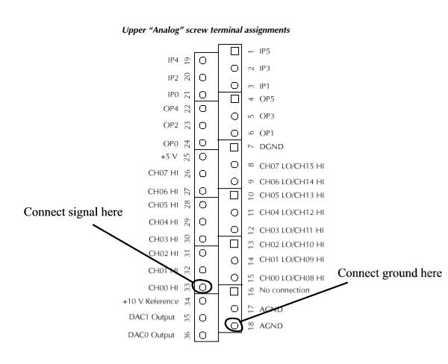
Figure 8. Analog screw terminal assignments

2. Digital Multimeter (Keithley Model 2000)
The front panel of the Keithley Model 2000 Multimeter (DMM) is shown in Figure 9. This is a very sophisticated instrument that can measure resistance by two methods, as well as DC and AC voltage and current, power level, frequency, continuity, and temperature. For each of these functions, the DMM automatically selects the most appropriate range for the specific measurement being performed. We will use only a few of its capabilities in this lab.
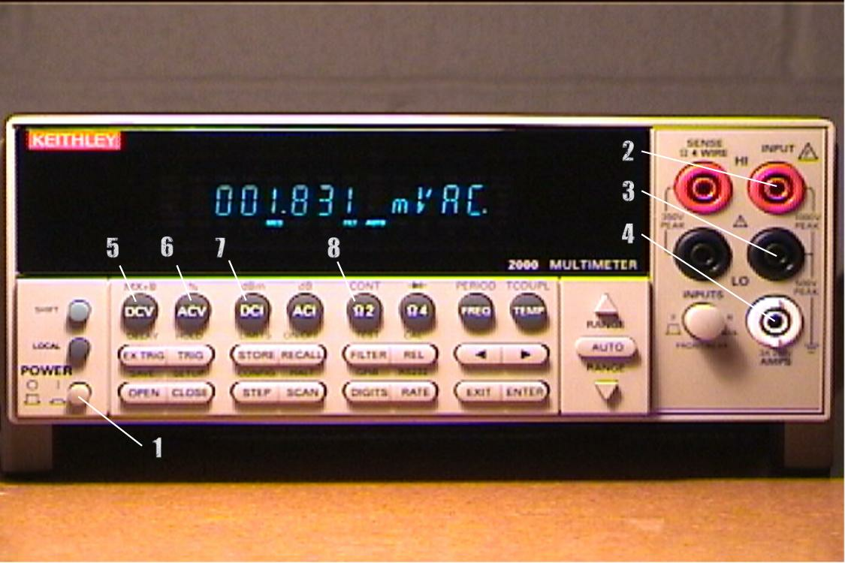
Figure 9. Keithley Model 2000 Multimeter

Although the DMM has a large array of functions, we will only work through some of the functions that are needed for DC voltage measurements. Start by pressing the Power switch (1). The display will indicate the ROM revision number, after which it will show a measurement in V DC and some of the least significant numbers will be changing continuously. The DMM automatically adjusts or “autoscales” its range based upon its voltage level at its input. In this case, there is no voltage source connected to the DMM input so the voltmeter defaults to DC volts.
- Before proceeding with measurements, let’s try out some of the controls while nothing is connected to the input of the DMM. Since the meter is currently in the DCV mode, press the ACV switch (6) and observe that the display now indicates mVAC. Press the Ω2 switch (8) and the display reads MOHM; OVRFLW (overflow) indicates that an open circuit is present at the input terminals of the DMM. OVRFLW means that the resistance of the open circuit input is much larger than the meter can read. Return to the DC voltage measurement mode by pressing the DCV switch (6).
- Make sure that the output of the power supply is turned off using the Output On/Off switch. You will measure the output at the +25V terminal of the Power Supply by connecting “banana” test leads from the +25V output to the DMM. In general, voltage measurements are made by connecting the voltage source to the “Input HI” input (2) and the “LO” input (3). Connect the +25V output of the power supply to the HI input of the DMM. Next, connect the COM output of the power supply to the LO input of the DMM. After you have done this, turn on the power supply using the Output On/Off switch and adjust the output to +25V, using the display on the HP E3631A Power Supply. The DMM should read approximately +25V. Record both the voltage that is displayed by the DMM and the voltage that is displayed on the Power Supply in Data Table 2, then switch off the power supply output using “Output On/Off.
3) Reverse the connections at the DMM (connect the + output to the LO input and the COM output to the HI input). Again, turn on the power supply output and record the DMM and Power Supply display voltages in Data Table 2. Turn off the power supply output and return the leads to the configuration that you used in Step 2 above.

We will learn about other functions of the DMM as we proceed with the following experiments.

Notes on instrument accuracy
When using the DMM to measure output voltage of the power supply, you may observe that the readings obtained from the DMM do not exactly agree with those indicated by the Power Supply display. This does not mean that the power supply is malfunctioning or that the DMM is making erroneous measurements. The discrepancy results because the accuracy specifications of the two instruments are different.

The accuracy specifications for the Power Supply readout are given in Table 2 and those for the DMM are given in Table 3.

 | +6V Output | +25V Output | -25V Output
Voltage | ±(0.1% + 5 mV) | ±(0.05% + 10 mV) | ±(0.05% + 10 mV)
Current | ±(0.2% + 10 mA) | ±(0.15% + 4 mA) | ±(0.15% + 4 mA)
Table 2. Power Supply Readout Specifications [±(% of output + offset)]

Function | Range | Accuracy
DC Voltage | 100.0000 mV  10.00000 V  1000.000 V | 0.0030 + 0.0030 mV  0.0015 + 0.0004 V  0.0020 + 0.0006 V
Resistance | 100.0000 Ω  10.00000 kΩ  1.000000 MΩ | 0.0030 + 0.0030 Ω  0.0020 + 0.0006 kΩ  0.002 + 0.0006 MΩ
DC Current | 10.00000 mA  100.0000 mA  1.000000 A | 0.006 + 0.0015 mA  0.01 + 0.015 mA  0.02 + 0.0015 mA
Table 3. Selected Multimeter Accuracy Specifications (6 1/2 digit resolution)
[±(% of reading + % of range)]

B. VOLTAGE and CURRENT MEASUREMENT
- Voltage divider circuit
25 V
+
-
1.2kΩ
8.2kΩ
13kΩ
A
+
-
V
1
+
-
V
2
+
-
V
3
V
V
V
Figure 10. Voltage divider circuit.

1) Obtain 1.2kΩ, 2.0kΩ, 8.2kΩ and 13kΩ resistors from the resistor drawers in the Glennan 308 Lab. Connect the alligator connectors to the banana plug leads at one end of each test wire and plug the other end of each test wire into the input (2) of the DMM. Put the DMM into resistance measurement mode by pressing the Ω2 button (8) on the DMM front panel. Measure each of the resistors that were obtained from the instrument room and record these measured values in Data Table 3.
2) Build the circuit shown in Figure 10. Start by inserting the three resistors into the breadboard so that they are connected in series as shown. Before connecting the power supply to your circuit, connect the DMM directly to the +25V output and, use the DMM to test the output voltage of 25V. A good practice is to always turn the power supply off using the Output on/off switch (4) [in Figure 7] before connecting the power supply to your circuit. Do so now.
3) In order to measure the total current of the voltage divider (Figure 10), it is necessary to connect the DMM as a current meter. To do this, connect the + output of the power supply to the AMPS input (4) of the DMM as shown in Figure 9. Connect the LO input (3) (this is immediately above the AMPS input (4)) to the positive power supply end of the 1.2kΩ resistor as shown in Figure 10. Connect the negative power supply end of your 13kΩ resistor to the COM terminal of the power supply. To select the DC current mode of the DMM, press the DCI button (7). The DMM display should indicate mADC.
4) Switch the power supply output on and record the current measured by the DMM in Data Table 2. Do NOT adjust the power supply output voltage or current. Turn off the output of the power supply using “output on/off” and return the DMM to the DC voltage measurement mode.
5) Remove the current meter from the circuit and connect the +25V side of the power supply directly to the input of the 1.2kΩ resistor in the circuit.
6) Turn on the power supply output and measure the voltage drop across each resistor and the output voltage of the power supply with the DMM. Do NOT adjust the power supply output voltage or current. Record your data in Data Table 2. Turn off the power supply output.
2. Current divider circuit
1) Build the circuit shown in Figure 11. Start by inserting the resistors into the breadboard so that they are connected in the series/parallel combination shown. Before connecting the power supply, make sure that the output is 25V using the DMM. Turn the output off and connect the DMM in series with the resistor circuit (Figure 11) to measure the total current, I₁.
25 V
+
-
2kΩ
+
-
V
1
1.2kΩ
+
-
I
2
13kΩ
I
3
I
1
V
A
A
A
V
V
2
Figure 11. Current divider circuit.

2) Switch the power supply output on and record the current, I₁, measured by the DMM in Data Table 3. Do NOT adjust the power supply output voltage or current. Turn off the power supply output when you are done.
3) In sequence, connect the DMM in series with each of the two resistors that are in parallel and measure the currents I₂ and I₃. Note that you have to pull one end of resistor that you are measuring out of the breadboard and connect the DMM current meter in series with the resistor that you are measuring— this is just like the current divider simulation in Lab 1. Record your measurements in Data Table 3. Turn off the power supply output while you are modifying the circuit. Make certain that the entire circuit is correctly connected before each measurement! Turn off the power supply output when you are done.
4) Connect the resistor circuit directly to the power supply. Use the DMM to measure the input voltage to the circuit. Then use the DMM to measure the two voltages V1 and V2 shown in Figure 11, i.e., across the 2kΩ resistor and across the parallel combination of the 13kΩ and 1.2kΩ. Record your results in Data Table 3, then turn off the power supply output when you are done.
DATA AND REPORT SHEET FOR LAB 3

Student Name (Print): Student ID:
Student Signature: Date:
Student Name (Print): Student ID:
Student Signature: Date:
Student Name (Print): Student ID:
Student Signature: Date:
Laboratory Section Day and Time: ____________________________________

Voltage Source | LabView Voltage (V) | Digital Multimeter Voltage (V)
Data Table 1: LabVIEW Voltage Measurements

 | Power Supply Meter Voltage | DMM Voltage | % Difference
2.A.2, Step 2
2.A.2, Step 3
Data Table 2: Multimeter Measurements

Nominal Value | Measured Value | % Difference
1.2kΩ resistor
2.0kΩ resistor
8.2kΩ resistor
13kΩ resistor
Data Table 3: Resistor Measurements

Parameter | Calculated Value | Measured Value | % Difference
Supply voltage | 25 V
I
V₁
V₂
V₃
Data Table 2: Voltage Divider Circuit

Parameter | Calculated Value | Measured Value | % Difference
Supply voltage | 25 V
I₁
I₂
I₃
V₁
V₂
Data Table 3: Current Divider Circuit

Questions

- Were the measured voltages using your VI and the measured voltages using the DMM in Data Table 1 in agreement? Did you record any voltages greater than +5 V when using your LabView VI? If not why not?

- In Data Tables 2 to 5 complete the % error calculations (%Error=100*{[measured value-calculated]/calculated value}). SHOW ALL WORK! What is the most likely source of % error in the above calculations?

- In the voltage divider circuit, did you notice a relationship between the amount of resistance and the amount of voltage drop across each resistor? If so what did you notice?

- In the current divider circuit, did you notice a relationship between the amount of resistance and the amount of current that flowed through the two resistors in parallel? What did you notice?

