CASE WESTERN RESERVE UNIVERSITY
Case School of Engineering
Department of Electrical Engineering and Computer Science

ENGR 210. Introduction to Circuits and Instruments (4)
Final Exam 12/15/03

Name: _________________________

Instructions
1. Please write your name on the above line.
2. You may use the front or back of any of the pages in the exam for intermediate work.
3. Please be sure your final answers to each problem are written in the space provided.
4. Notes and books are not permitted; any required formula sheets have been attached.
5. Calculators are permitted.
6. There are six problems, weighted as shown in the following table.
7. You have 180 minutes to complete the exam. If you finish early, you may quietly leave. Have a nice holiday !

Score Points
Problem 1 15
Problem 2 15
Problem 3 20
Problem 4 15
Problem 5 20
Problem 6 ___ 15
Total 100

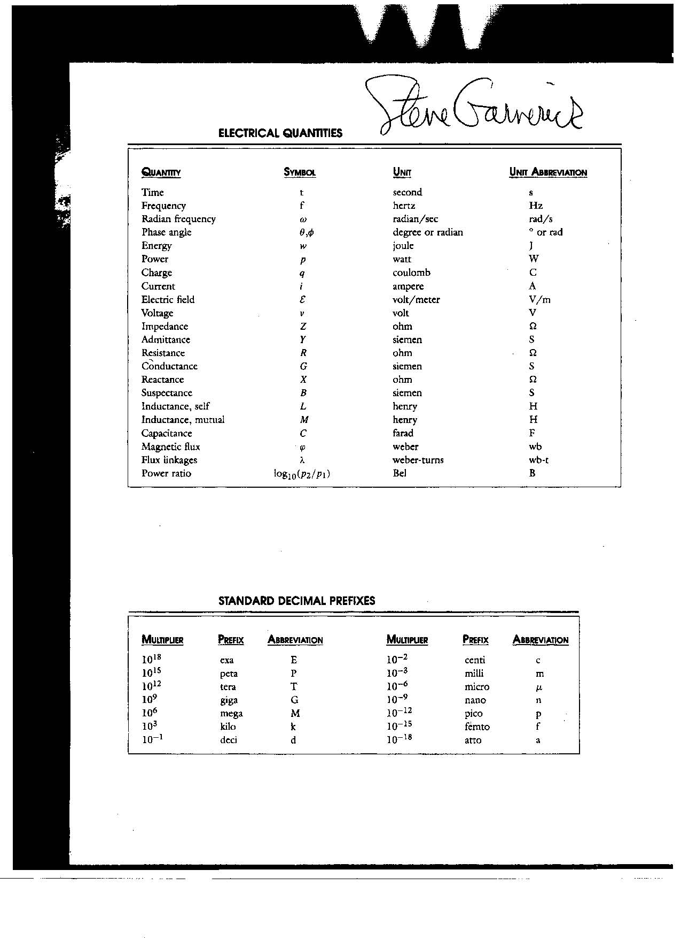

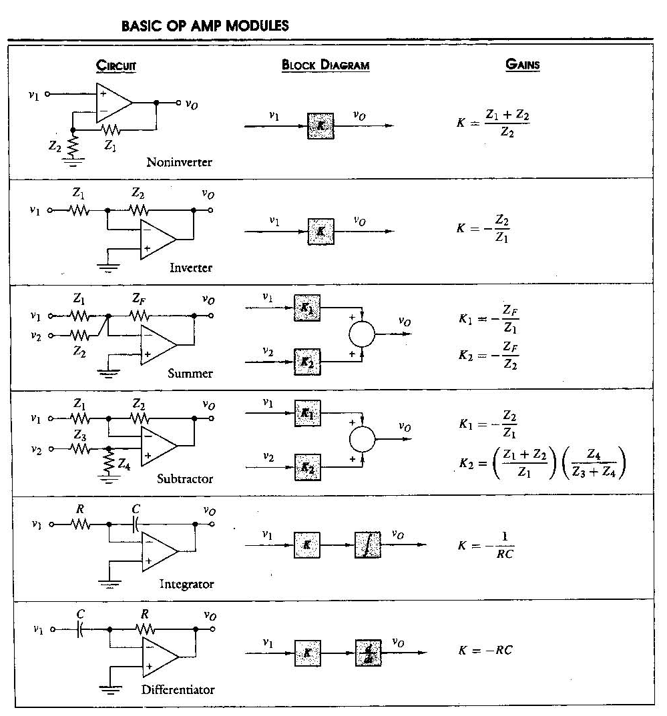
Problem 1 (15 points)
- Write the node voltage equations for this circuit.
Hint: convert resistor values to conductance values, before proceeding.
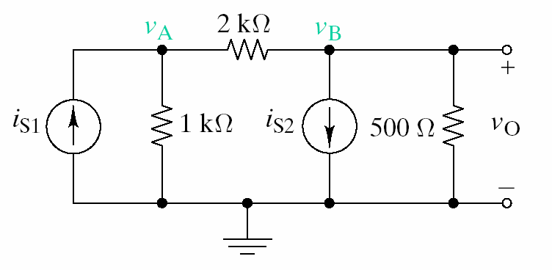
Node | Node-Voltage Equation
A | ____________ v_{A} + ____________ v_{B} = ____________
B | ____________ v_{A} + ____________ v_{B} = ____________
- Use any method to find the proportionality factors for this circuit, and complete the following table.
Hint: the above matrix equation could be solved, but superposition, equivalent resistors, and current dividers is probably easier.

Node | Node-Voltage Equation
A | v_{A} = ____________ i_{S1} + ____________ i_{S2}
B | v_{B} = ____________ i_{S1} + ____________ i_{S2}

Problem 2 (15 points)
Sketch the following time-dependent waveforms. Be sure to label the horizontal and vertical axes and/or points on the waveform to clearly indicate time and amplitude scales.
- $v(t)=5−\text{10}e^{−\text{100}t} V$. Note: e⁻¹ ≅ 0.368, e^{-2.3} ≅ 0.1, e^{-4.6} ≅ 0.01.
- $$i(t)=4+2\text{cos}(\text{200}π⋅t+\frac{π}{2}) \text{mA}$$
- $$v(t)=3⋅\left[u(t)−2u(t−1)+u(t−2)\right] V$$
Problem 3 (20 points)
Consider this time-dependent circuit in which the switch is initially open and no current is flowing. The switch closes at time t = 0.
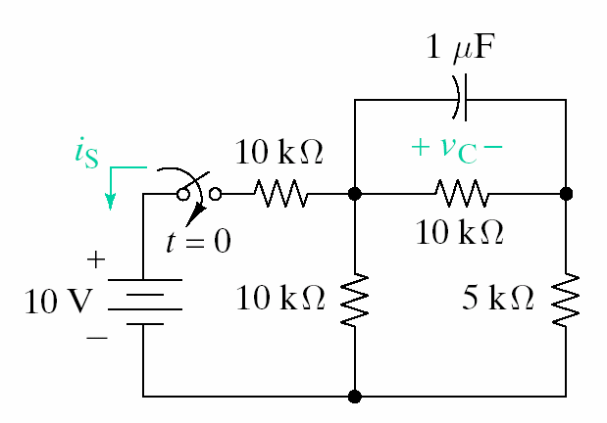
10

- Define and label the state variable in this circuit: ______________
- Find the Thevenin equivalent of the circuit seen by the capacitor for t > 0.
V_{T} = ______________
R_{T} = ______________
- Write the initial value, final value, and time constant of the state variable.
initial value = ______________
final value = ______________
T_{C} = ______________
- Write the expression for the state variable for t > 0.
state variable = ____________________________
- Write the expression for i_{S}(t) for t > 0.
i_{S}(t) = ____________________________
Problem 4 (15 points)
- Consider a series RL circuit which has i(t) = 2 r(t) mA, where r(t) is the unit ramp function. The inductor has value 4 mH and the resistor has value 10 kΩ. Calculate the following for time t = 3 sec. Numerical answers are required.
resistor power = ______________
resistor voltage = ______________
inductor energy = ______________
inductor voltage = ______________
total charge flowed = ______________
- Consider a parallel RC circuit which has $v(t)=5e^{{−t}/{T_{C}}} V$. The capacitor has value 2 μF and the resistor has value 5 kΩ. Calculate the following for time t = 4.6 T_{C}. Numerical answers are required. Note: e⁻¹ ≅ 0.368, e^{-2.3} ≅ 0.1, e^{-4.6} ≅ 0.01.
time constant = ______________
capacitor charge = ______________
capacitor current = ______________
resistor power = ______________
capacitor energy = ______________
Problem 5 (20 points)
This circuit is operating in the sinusoidal steady state. The OPAMP is ideal. Element values are
R₁ = 4 kΩ, C₁ = 2.5 μF, R₂ = 5 kΩ, C₂ = 20 nF.
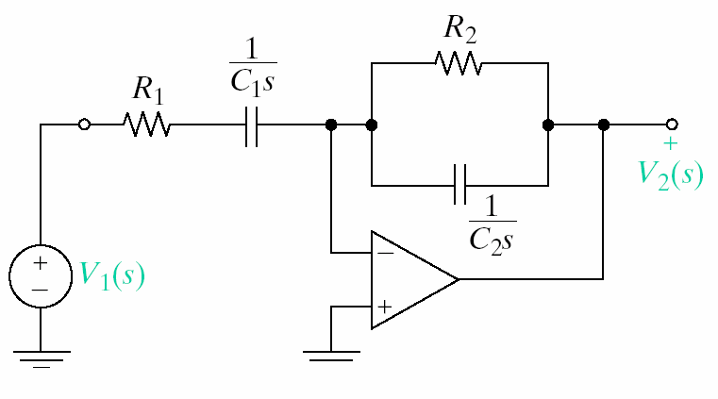
- Find the transfer function $T(jω)≡\frac{V_{2}(jω)}{V_{1}(jω)}$ using symbolic element values, i.e. Z_{R1}, Z_{C1}, Z_{R2}, Z_{C2}.
T(jω) = ______________________
- Find the impedance of each element, evaluated at the angular frequency ω = 1000 rad/sec.
Z_{R1} = ___________ Z_{C1} = ___________ Z_{R2} = ___________ Z_{C2} = ___________
- Evaluate the transfer function obtained in part a) the impedances at ω = 1000 rad/sec that were determined in part b). Your final answer should be computed using magnitude/phase notation.
|T(ω=1000)| = ___________
∠T(ω=1000) = ___________
- Compute the phasors that represent the input voltage v₁(t) and the output voltage v₂(t) when v₁(t) = 10 cos 1000t V, and write the result using magnitude/phase notation.
|V₁| = ___________
∠V₁ = ___________
|V₂| = ___________
∠V₂ = ___________
Problem 6 (15 points)
- Find the specified voltage and currents given i_{S} = 30 mA.
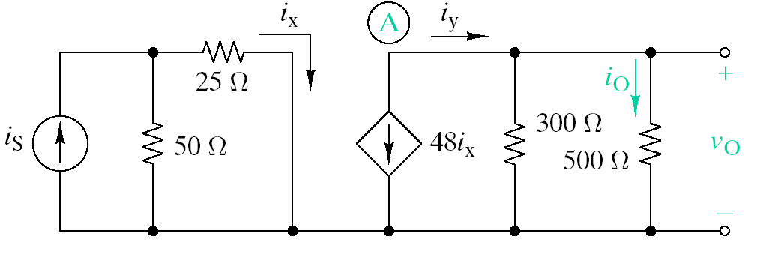
i_{x} = ___________ i_{y} = ___________ i_{o} = ___________ v₀ = ___________
- Draw a block diagram that represents the function of this OPAMP circuit. Your diagram should use two types of symbols: proportionality (a square) and summation (a circle).
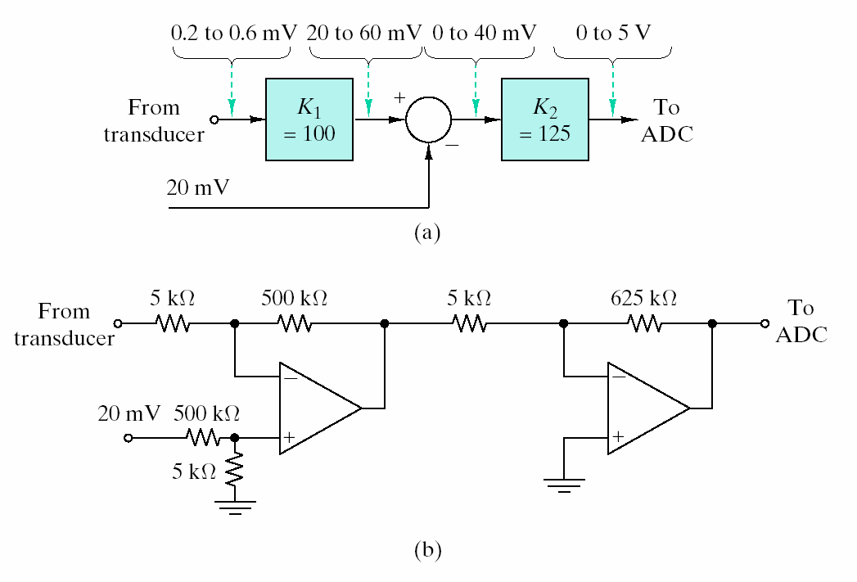
v_{O}
v₁
v₂

- Based on the block diagram draw in part b), write the value of v_{O} in terms of v₁ and v₂.
v_{O} = _______________________________

