Project #3 Edge Processing
Due Tuesday October 9th (October 12th for ITN students)

As mentioned in class our projects (as appropriate) will be directed towards mobile robot vision as might be applicable to the DARPA Urban Grand Challenge.

Background:
As part of the DARPA Urban Grand Challenge robotic vehicles must navigate ordinary roads and streets. DARPA will provide a GPS based road map before the competition, but the GPS locations may be spaced far apart and other methods such as vision will be necessary to navigate the robot vehicle.

In addition to simply traveling roads and streets, the DARPA Urban Grand Challenge requires that vehicles obey relevant traffic laws such as speed limits, are able to pass stopped or slow moving vehicles, and can navigate traffic at intersections or traffic circles. One of the major challenges is to simply detect the road and stay on it.

In this project we will investigate several different image processing techniques and their potential application to determining the edge of the road. There is no specific right way to do this assignment but suggestions will be made.

Supplied image data:

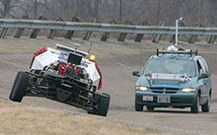
Figure 1. Dexter (TeamCase’s entry) followed by DIDI, TeamCase’s data acquisition vehicle.

Figure 2. DIDI acquired road image with a vehicle mounted camera which acquired color images (320x240 pixels) at 8 frames/minute. This image is from Cedar Road. Wide roads pose unique challenges: it may be difficult to find the extreme edges, but the lane markers may be easier to find.

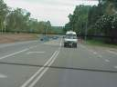
Figure 3. This image shows one of the common problems with locating the road — a shadow across the road and a car in your lane. This image came from Google Images.

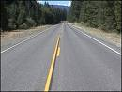
Figure 4. This should be a very easy image to identify the road edges and might be the first one you want to try processing. This image also came from Google Images.

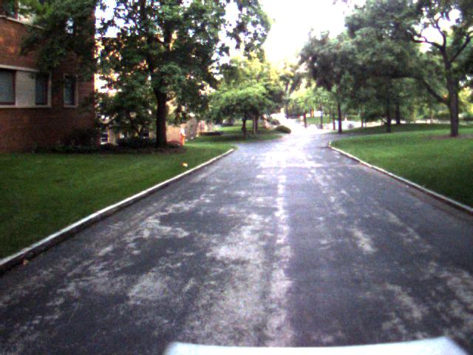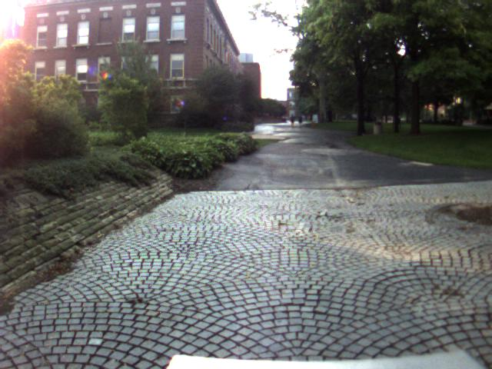

Figure 5. Some exceptionally difficult images came from the Case Quad. These were acquired using Dexter’s vision system.

Figure 6. An earlier version of Dexter’s vision capabilities. The sensors include multiple RGB cameras, an IR camera, multiple LIDAR sensors, a stereo camera, radar, and (just recently) UWB radar.

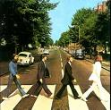
Figure 7. The ultimate challenge. Some roads edges are very difficult to identify due to parked cars, crosswalks and pedestrians.

Although these images are color you will probably want to work with gray scale images for this assignment. This can be done by simply converting the three color bands to an intensity such as . Alternatively you can compute the edges using just one of the Red, Blue or Green band images. There are many images on the Web and you are free to choose your road images.

NOTE: We did a related project in EECS 490 last fall where students were required to locate lane markers on Euclid Avenue — this was using color segmentation. I will separately make a student movie and several student papers available to you as additional references.

Part 1. Edge Detection
Using the edge detector of your choice find the lane markers or edges of the road.

COMMENTS
It is not expected that the results from Part 1 will be immediately useful for driving a robotic vehicle as your edge operators will typically find many edges in the image. You typically want to average the image prior to using an edge operator to minimize the detection of unwanted objects. Later assignments will examine how to actually identify objects of interest using such techniques as image segmentation and color image processing.

You may use any technique (or multiple techniques) to determine edges. However, you should critically evaluate each technique with regard to computational speed, ability to find the same edges in multiple images, and ability to simply locate the road.

Part 2. Developing a simple model of the road edges
Edges are useless unless you can use them for something. The second part of the assignment is (for a few simple roads) to develop a road model.

A simple road edge model is to fit either a straight line or a quadratic equation to your edges. This is very difficult since you need to (a) curve fit and (b) know something about where the road edge should be. You might want to consider sticking to simple straight roads and define a ROI (region of interest) where you think the edges for a typical road might be. However, your report should show where you can locate a road edge and where you can’t.

A pair of students at Utah documented the issue of fitting hyperbola to edge data for road localization. This was for a computer vision class. You might want to look at how they documented their work.
https://tactile.mech.utah.edu/~virost/Week_12-14.htm

INSTRUCTIONS FOR WRITE-UP:
This will be a longer write-up than the previous assignments. Identify Part 1 and Part 2 and include images of typical results. Your grade will be based on the quality of your reasoning. Include any thoughts on what extensions may be necessary to make these techniques actually work in a variety of situations. Don’t be too disappointed if your techniques only work in very simple situations.

Feel free to use suitable images of your own. Also, I have many images which I can share with you. Ask if you need any.

Some related but not directly applicable references. The most useful thing is to learn how to evaluate algorithms.
ZuWhan Kim, “Real-time Road Detection by Learning from One Example,” Seventh IEEE Workshops on Application of Computer Vision, 2005. WACV/MOTIONS '05 Volume 1. Volume 1, Jan. 2005 Page(s):455 - 460
Qing Li, Nanning Zheng, and Hong Cheng, “Springrobot: a prototype autonomous vehicle and its algorithms for lane detection,” IEEE Transactions on Intelligent Transportation Systems, Volume 5, Issue 4, Dec. 2004 Page(s):300 – 308
Hong Wang and Qiang Chen, “Real-time lane detection in various conditions and night cases,” Proceedings Intelligent Transportation Systems, 2006, Page(s):1226 – 1231

Edge operators which may be useful include the gradient, the Laplacian, and X and Y directed Sobel operators. An advanced edge operator is the Canny operator which has been briefly discussed in class and will be discussed later in this class. A fast way to compute a rotationally insensitive gradient is to simply sum the absolute values of the x- and y-directed gradients, i.e.,

