Project #2 Affine transformations
Due Thursday September 25th.

A. Geometric Transforms

Background:
Many images are related to each other by simple geometric transformations of the form where
(1)
Equation (1) describes scaling by s, rotation by , and translation by (t_{x},t_{y}). Consider re-writing X as
(2)
If the re-written X contains all the image points we can warp the entire image in one operation. This describes a forward mapping of the entire image. Since you usually want to do a backwards mapping, invert the transform to get which is now a backwards transformation of the entire image. I leave it as an exercise for you to determine T⁻¹ and complete the implementation of this equation.

HINT: Suppose we have a corresponding point pair [x’,y’] and [x,y] and the transformation described by s, , t_{x},t_{y} is unknown. We can re-arrange the transformation just as for the polynomial warp to give
(3)
which can be easily solved for the transformation parameters.

Find the geometric transformation parameters which relate image (b) to image (a) and construct a larger image which displays the complete street scene. This is an example of constructing a photomosaic.

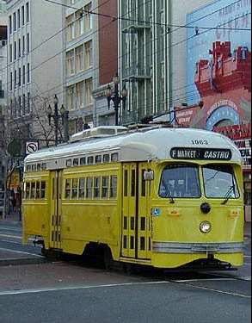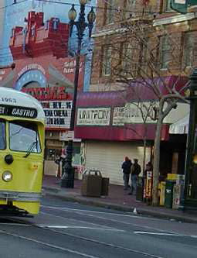
(a) (b)

B. Polynomial warping
Construct a polynomial warp to photomerge image (b) with image (a). Compare the results of this polynomial warp with the Euclidian transform of part A. Which is better and why?

Check out
http://graphics.cs.cmu.edu/courses/15-463/2004_fall/www/hw/as2/as2.html
for an example of a similar project at CMU.

Feel free to substitute suitable images of your own.

