________________________________________________________________________

Programmable Message Board
(PMB)
Final Project Report
04/23/2003
________________________________________________________________________

Team Members | Signature
Ferreri, Gregory (Team Leader)
Bacon, Lucas
Miller, Matt
Lin, Chen
Lingaraju, Navin

PROJECT ADVISOR

Dr. Francis L Merat: ___________________________________

TABLE OF CONTENTS

I. EXECUTIVE SUMMARY …………………………………………………… 03

II ABSTRACT ………………………………………………………………… 04

III INTRODUCTION ………………………………………………………… 06
- Problem Description …………………………………………………… 06
- Prior Work ……………………………………………………………… 06
- Specifications …………………………………………………………… 06
- Group Structure ………………………………………………………… 08

IV METHODOLOGY ………………………………………………………….. 09
- Hardware Component Selection and Design ……………………………... 11
- Firmware Development ………………………………………………….. 15
- PDA Software Development …………………………………………….. 16

V RESULTS……………………………………………………………………… 19

VI REVIEW OF OTHER IMPLICATIONS……………………………………. 24

VII CONCLUSIONS …………………………………………………………… 25

VII RECOMMENDATIONS…………………………………………………… 26

APPENDICES…………………………………………………………………… 27

I. EXECUTIVE SUMMARY

The goal of the programmable message board (PMB) is to eliminate the use of Post-it® notes or a dry-erase board as a means of informing colleagues of one’s whereabouts. The PMB establishes a wireless connection with a PDA (personal digital assistant) and downloads the daily schedule of the user. Based on the information in the schedule, the PMB displays an appropriate message at a given time. In addition, a custom away message can be sent from the PDA to the display unit overriding the current message. The PMB has been designed for the specific needs of Professor Francis Merat in the department of EECS. Hence, the PMB display size has been limited to five inches in width and is intended for being mounted on a wall or behind a window.

The design and implementation of the PMB has been divided into three tracks: PDA/Palm® software, LCD/microcontroller firmware, and circuit design. The PDA software has been developed such that it is capable of transmitting a daily schedule from the date-book of a Palm® PDA and displaying a custom away message sent from the PDA to override the current one. However, to-date successful operation of the Palm® software with the PMB has yet to be demonstrated. The microcontroller firmware manages the communication between the IR transceiver, the LCD controller and the system microcontroller. The microcontroller successfully transfers incoming information from the IR transceiver and sends the appropriate commands to the LCD display. The circuit designs focused on developing a printed circuit board to house and power the embedded system to which the LCD module is connected. A working prototype has been built and successfully demonstrates many of the functions of the PMB.

II. ABSTRACT

Project Title:
Programmable Message Board

Team Leader:
Ferreri, Gregory (gsf@po.cwru.edu)

Team Members:
Bacon, Lucas (leb6@po.cwru.edu)
Miller, Matt (mem30@po.cwru.edu)
Lin, Chen (cxl70@po.cwru.edu)
Lingaraju, Navin (nbl@po.cwru.edu)

Project Sponsor:
Dr. Francis L Merat (flm@po.cwru.edu)

Project Advisor:
Dr. Francis L Merat (flm@po.cwru.edu)

Project Description:
The goal of the Programmable Message Board (PMB) is to eliminate the use of Post-it® notes or dry-erase boards in allowing a person to keep co-workers informed of one’s whereabouts. In doing so, the PMB allows people make better use of each others’ time without having to use more intrusive means of communication such as email or the telephone. The PMB was designed for the specific needs of Dr. Francis L Meart, Department of EECS at CWRU.

Specifications and Operation:
The PMB consists of an LCD module w\controller, a microcontroller, IR transceiver unit and a power supply unit for the system logic and LCD display. The LCD module displays a message concerning the whereabouts and\or return time of its owners based the contents of a stored daily schedule or displays a custom away message in its place. In addition, the LCD module displays the current time and the duration of the posted activity.

The schedule is downloaded from a standard PDA with an IR communications port. This information is stored in the microcontroller memory and is used as the basis of the away message. The PDA software also provides the option of displaying a custom away message in the event that one’s schedule changes on the spur of the moment. This custom away message overrides any current information displayed. An additional feature built into the PMB is the use of a quick message button. This may be used in instances where the user may need to leave his office for a short duration due to any pressing matters (pick up mail, visit research lab, use restroom, etc…). This is a push button located on the side of the PMB unit. The PMB has been designed to operate using a 9V DC source. The LCD display is the primary source of power drain in the PMB. A motion sensor was integrated into the power supply to turn on the LCD module only when a passerby seeks to trigger the PMB. While developing a battery powered product was a tentative goal, this was not realizable at the completion of the project period.

Results and Validation:
The PDA software was designed for all the functionality mentioned above. However, its successful operation has not been verified. The firmware for the microcontroller transfers information from the IR transceiver unit to the microcontroller and sends appropriate commands to control the LCD module. This has been verified by the use of an HP logic analyzer, test firmware and visual confirmation on LCD screen. The power supply for the PMB consists of three modules – a 9V to 5V,3.3V DC step down, a 9V to -12V DC inverter and a motion sensor. All three modules have been implemented independently and integrated into the PMB prototype. Successful operation was verified using an HP34401 digital multimeter and by successful operation of the prototype. The power drawn by the circuit when the LCD unit is turned off is around 0.045W. Based on this power consumption, a 9V battery will only last 120 hours.

Future Work:
As of 4/21/03, the group has made plans to continue work on the project with the intention of developing a marketable product. The focus of this work is to demonstrate communication with PDA through an IR link and investigate procedures for limiting the power drawn by the circuit to extend the battery life to a few months. For more information contact Greg Ferreri (gsf@po.cwru.edu).

III. INTRODUCTION

Problem Description:
In the current work environment, people are always on the move – meeting with customers or co-workers, out in the field or working at a different location. With the structure that exists in most workplaces, each and every person is intimately involved with the work of his/her employees, co-workers or superiors. During the course of the day it becomes necessary for these people to get in touch with one another for things like getting approval on an order or just stopping by to give a quick update on a project. Even though we are in the midst of an amazing information/technology revolution, we still use Post-it® notes or a dry-erase board to let people know of our whereabouts. While email and the cell-phone are pervasive means of communication, they are too intrusive. It is unnecessary to flood these lines of communication every time someone seeks an audience. We have developed the programmable message board as a solution to this problem.

Our sponsor for this project is Dr. Francis Merat in the Department of Electrical Engineering and Computer Science at CWRU. Dr. Merat has also served as our project advisor. While the PMB has been developed for the specific needs of Dr. Merat, this product can be easily adapted to most office environments.

Prior Work:
Stock tickers and other similar displays are seen in widespread use in the office environment, yet no one has adapted this concept to suit the needs of individuals at the workplace. Since PDAs are playing a greater role the in daily lives of many people, we have chosen this as the technology to interface with the display unit. In keeping with current trends, the communication between the PDA and the PMB will be established through a wireless IR link. To our knowledge, the application for which the PMB is being developed is a novel one.

Specifications:
The LCD module will display the current activity of its user and the duration for which it will be in effect. The time the user is expected to return to his/her office will be displayed. In addition, the current time will be displayed on the screen. The daily information of the user is downloaded from a PDA with an IR port enabled for wireless communication. This information is stored in the PMB and used as the basis for the message displayed. Should the user experience any sudden change to his/her daily schedule, a custom away message (such as ‘at research lab’, ‘in faculty lounge’, etc…) can be sent to PMB through the PDA as the user leaves the office, and this away message will override any current information displayed. Upon his/her return, the user can restore the PMB status to display information from the daily schedule. Another feature that the PMB has been equipped with is the quick message button. This is an external push button one can use in the event of any pressing matters such as leaving to check one’s mail, picking up a package or using the restroom. A courtesy message such as ‘Back in 5 min’ will be displayed for a duration determined by the user.

The physical dimensions of the PMB have been determined based on the requirements set forth to us by Dr. Merat. The display unit is does not exceed five inches in width (such that it can be mounted behind the window in his office door) and is light weight, such that it is wall-mountable.

One of the primary goals in designing the PMB was to make a low-power device. The display of the LCD module is far and away the most power hungry component of the PMB. This device can be made very power friendly by turning the display on only at times of use. This has been achieved by the use of a motion sensor to trigger the LCD module only when a passer by seeks to read information off of it.

Group Structure:
The design of the PMB proceeded along three tracks – PDA software development, firmware development and circuit design. The implementation of this project was delegated to individual members of the group based on these tracks:

PDA Software | Lucas Bacon
Firmware Development | Greg Ferreri
Circuit Design | Matt Miller  Chen Lin  Navin Lingaraju  Greg Ferreri

IV. METHODOLOGY

The design of the Programmable Message board was accomplished in a series of distinct steps, modeling a true product design phase lifecycle. Once the problem was firmly understood, the following functional specifications and constraints were devised to govern the design of the project:

- Interface standard Palm date book application with PMB
The device will interface with a PDA running Palm OS. A custom application will be written that extracts data from the built-in date book and transmits it to the PMB via the Palm IR port.

- Allow selection of default or custom away messages
The PMB will have the ability to allow the user to select from a list of standard “away messages” which will supercede any date book scheduling information. This is desirable in the event that a non-scheduled activity arises. This message will include a time of return.

- Provide a Quick Message Button
The Quick Message Button, when pressed, will instantaneously display a courtesy message such as “Will return momentarily.” This message will supercede all other display information. A second press will return the PMB to its original display.

- Display current time.
The current time will always be displayed for reference purposes.

- Display current activity on the LCD screen
The PMB will retain the current day’s schedule information in its memory. At a given time during the day, the information displayed will include a description and time duration of that activity. In addition, the time of next availability will be shown.

- Display text readable from a sufficient distance
The LCD will display static text messages of sufficient size to be read by a person standing up to 1m away

- The display unit must run on a battery
In order for the device to be portable it will need to run off a battery. Once we all the components are selected a detailed idea of the power requirements will be known. We expect that the LCD component drawing most of the power, and we will investigate the use of 9V, AA, AAA and the button batteries.

- The display unit must be compact and lightweight
The embedded system and the LCD must be light enough to mount on an office door or cubicle wall. The embedded circuitry and will be laid out on a PCB and other space saving techniques will be employed.

In addition to these general functional requirements, and primarily based thereof, a detailed functional specification was written for the embedded microcontroller firmware, which can be found in the appendices. Furthermore, a general block diagram was devised which shows the logical functional areas of the PMB board layout (figure 1). The Palm OS software was also designed according to a functional specification, included in the appendices.

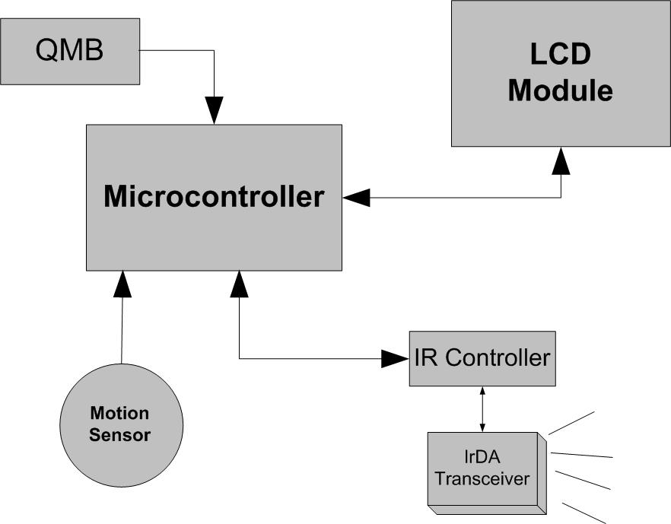
Figure 1 – System Block Diagram

Following a complete definition of product requirements and specifications, work commenced on the design process. This design process was split between hardware and software into three major sections: Hardware design, firmware design, and Palm OS Software design. The design process of these subsections is detailed below.

1. Hardware component selection and design
A great deal of consideration and effort went into selecting the major hardware components for the Programmable Message Board. These components include the liquid crystal display unit (LCD), the microcontroller unit (MCU), the Infrared (IrDA) controller and transceiver, and several integrated circuits to supply the proper voltage to the various other hardware components. Following is a list of these components, organized by functional unit.

Infrared Communications (Matt Miller)

Upon much internet research, we determined that the Microchip MCP2150 was the ideal solution for our IrDA needs. The MCP2150 provides support for the IrDA standard protocol “stack” plus bit encoding/decoding. The device has a serial interface to the UART with user specifiable baud rates. Likewise, the IR baud rates are user selectable to one of five IrDA standards. The primary device specifies the IR baud rate. While the default rate is 9600 baud, the other four options include 19200, 37400, 57600, and 115200. Figure 2 shows the basic connection between the microcontroller, the MCP2150, and the IrDA transceiver.

The MCP2150 operates in Data Terminal Equipment (DTE) applications and fits between an infrared transceiver and a UART. The operation of the device includes the encoding of asynchronous serial data streams into corresponding IR formatted pulses. In addition, the MCP2150 decodes the IR pulses received and converts them into UART formatted serial data.

The IR connection is “point-to-point” only, meaning one Primary device and one Secondary device. The connection is established and data is communicated using hardware handshaking. The connection sequence is displayed in Figure 3 on the next page. The MCP2150 can be placed in shutdown mode when it is not being used. This is an attractive feature for our design because we want to extend battery-life as long as possible.

The MCP2150 requires several external hardware components. These include:
- One parallel cut 11.0592MHz crystal oscillator
- Two 20pF capacitors
- One 43 ohm resistor

The MCP2150 was paired with the Vishay TFDU4205 IrDA Transceiver to complete the IrDA communications hardware design. A complete schematic of this design can be found in the Appendices.
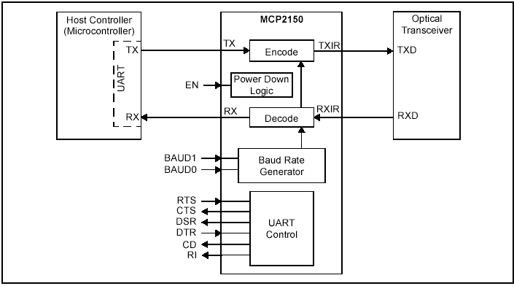
Figure 2 – IrDA System Block Diagram
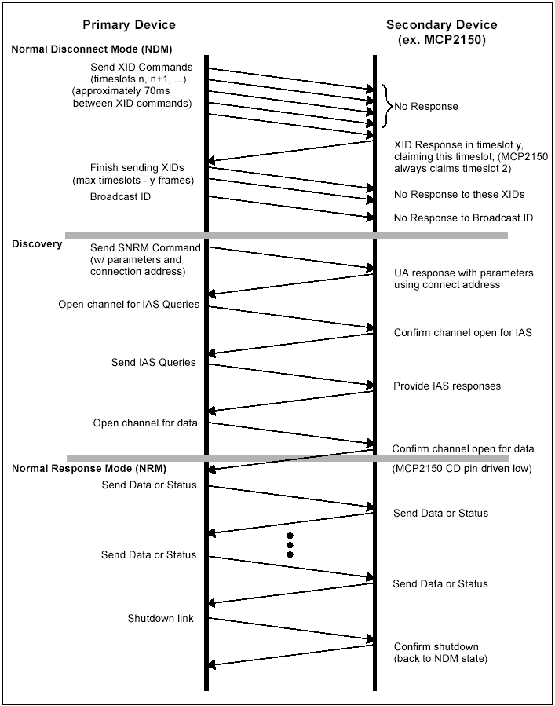
Figure 3 – Connection Sequence
Power Supply Circuitry (Chen Lin/Navin Lingaraju)

For our entire project, we had several components that required many different voltages. We needed +5V for the LCD and the microprocessor. The IrDA transceiver required a +3.3V. For the contrast adjustment, we needed 0V to -12V for the LCD bias voltage.
We plan to run all these power supplies off one 9V battery. Maxim has provided many datasheets on their website that are designed to aid engineers with their products. For this reason we used the MAX639, MAX640, and MAX759 for our circuits. We needed to build one circuit for each desired voltage. The +5V and +3.3V was essentially the same circuit that only differed in the MAX639 and MAX640 chips, respectively. Both of these circuits will have a 9V input. The 0V to -12V circuit utilizes the MAX759. It will require a +5V input. We have used the schematic diagrams provided for us by Maxim in their datasheets, seen in figure 4 and 5 below.

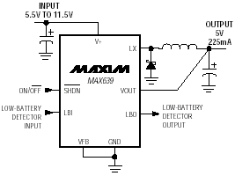
Figure 4 – 5V and 3.3V Power Supply Circuit
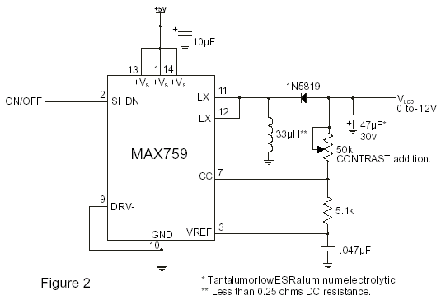
Figure 5 – LCD Bias Voltage Circuit

Motion Sensor Circuit (Navin Lingaraju)

The LCD display is far and away the most power-hungry component of the PMB. In order the limit the duration for which the LCD display is turned on, we decided to integrate a motion sensor into the PMB. The goal was to have a motion sensor that would:
- Trigger an interrupt on the microcontroller which would then shutdown the LCD power supply.
- Be insensitive to the background level of illumination, i.e. be equally sensitive during the evenings (indoor lighting) and daytimes (sunlight).
- Have an adjustable sensitivity.

The motion sensor was implemented using a phototransistor to serve as an illumination dependent voltage source, a op-amp differentiator and an op-amp comparator. The following parts were used in the construction of the motion sensor were a phototransistor and dual package single supply op-amp. The op-amp differentiator magnified any sudden change to the phototransistor voltage and this signal was passed on to the op-amp comparator. The detector sensitivity can be adjusted by varying the voltage level against which the differentiator signal is compared with.

Microcontroller and PCB Layout (Greg Ferreri/Navin Lingaraju)

The most critical component of the design of the Programmable Message board was the selection of a capable microcontroller unit. Several criteria were used in selecting the proper MCU for the project. The ideal solution would provide sufficient memory, program space, I/O lines, external interrupts, timers, and provide real-time clock capabilities. on-chip. Also, hardware and software development tools for the MCU must be inexpensive. For these reasons, the Atmel ATMega16L microcontroller was selected. An inexpensive development board, the STK500, is available for chip programming and prototyping. Furthermore, a GNU C compiler is available for this processor. The following table summarizes the important physical criteria provided by this chip:

Feature | Needed | Provided
I/O Control Lines | 23 | 32
External Interrupts | 2 | 3
SRAM | ~1KB | 1KB
Low power consumption | As low as possible | 3.8 mA typical @ Vcc = 3V
Flashable (rewriteable) Program Memory | Currently 8.52KB | 16KB

The number of extra components necessary for the ATMega16L to function is minimal. A clock selectable from 1MHz to 4MHz is included internally. To achieve a real-time clock, one 32.768kHz crystal oscillator is required as an input to the asynchronous timer.

A complete circuit schematic was developed with the ATMega16L as the centerpiece, showing all connections necessary for operation. This schematic is included in the Appendices. From this schematic, a Printed Circuit Board (PCB) was designed and manufactured as a prototype for testing and proof of concept.

2. Firmware Development (Greg Ferreri)
The microcontroller firmware is essentially the brains of the Programmable Message Board. Sound engineering design principles were applied to the specification and design of the software to ensure proper functionality, maintainability, and efficiency. Initially, the problem was understood and defined succinctly, which has been previously described. Then, based on these problems, a functional specification was devised to address each of these problems and propose a solution. Following the functional specification, parts were researched and selected that will allow for this functionality; these parts include the Atmel ATMega16L microcontroller, the Hantronix 128x128 pixel graphical LCD unit, the Vishay TFDU4201 Infrared transceiver, and the Microchip MCP2150 IrDA controller. Once these parts were known, a technical specification could be devised describing the operation of the firmware.

Thanks to the Atmel STK500 development board, the firmware implementation could begin without a hardware prototype on which to test. By use of the LEDs, switches, and UART/RS-232 interface provided by the development board, individual units of the code were developed and unit tested. Following is a list of program functional units developed and unit tested using the STK500:

- IrDA communication: IrDA communication was simulated by use of the UART/RS-232 interface and a terminal application running on a PC.
- “Quick Message Button”: This button was simulated using the built-in switches of the STK500. Later, an independent switch was built on a breadboard and connected tot eh development board via an expansion port.
- Motion Sensor: This functionality was also simulated using the built-in switches. The motion sensors behavior is to pull a control line low when motion is sensed, which is the same as pressing a switch.
- Real-time clock: The watch crystal oscillator was attached to the ATMega16L while on the development board, and its behavior was verified by observing the LED’s counting each second from 0-59 and cycling back to 0.

Algorithms for communicating with the LCD module were implemented and checked for correctness using a logic analyzer until a working LCD unit was available.

Once a working hardware prototype was available, the ATMega16L was moved to this environment and each functional component was tested once more for correctness. Furthermore, the LCD function library was verified using the actual Hantronix LCD module instead of logic analyzer waveform analysis.

The STK500 development board, while not a part of the finished product, was absolutely critical for the development of the software while the hardware was not ready. Without this board, the firmware could not have been completed successfully. All design documents, as well as the complete source code for the PMB firmware, can be found in the Appendices.

3. Palm OS Software Development (Lucas Bacon)
Functionality requests for the Palm Software were designed around a user-friendly application that would make updating of information on the display quick and easy. The main functionality of the application is as follows:

- Ability for the user to synchronize their Date Book information for the current day on the PMB.

- Setting of the PMB system time directly from the Palm.

- An “Away Message” function which allows the user to choose from a list of five away messages to send to the PMB to display briefly until they return.

- Editing of those five “Away Messages” by the user so they may customize the text displayed.

The main programming development tool used was Code Warrior for the Palm OS, which has a Palm specific compiler with the SDK’s built in. The other option which was available was the use of the PRC tools which is a free development package provided by Palm Source for application development. Although the Code Warrior software tool was a trial version, it was invaluable to the development of the PMB Sync application. Also built into the Code Warrior tool was a Constructor, which allowed for visual development of the forms and how they were to be displayed on the Palm screen.

While the PMB Sync application was being written, tests were made on the fly as to whether the application was working properly. The tests were done on the freeware Palm Emulator which was downloaded directly from the Palm Source website. This emulator was another important tool even though there were some areas in which the emulator was lacking in functionality. The most important of these was when trying to test the infrared communication. Since the emulator was being run on a windows machine, there was no way of testing the infrared since the emulator simply simulates what would happen and because there are no devices to respond to the emulator, nothing happens when trying to connect to an external device. This posed to be a major problem in the development process.

The following is a brief overview of the design of each function of the Palm Sync software:

PMB synchronization with the Palm Date Book
The information needed to be sent to the PMB is parsed out of the Date Book database and placed in variables according to which field they represent. This is then sent to a function, which prepares the string to be sent one appointment at a time to the PMB with an initial byte appended to the beginning to determine that it is a Date Book synchronization and another byte is appended to the end of each message to signal the end of the transmission. This is then sent to the IrConnectReq function to be sent over the IR port to the PMB. Some formatting may need to be done to match that which will be used in the receiving end of the PMB for parsing into the memory. There are alerts within this functionality, which alert the user if the database cannot be opened, if there is a problem with the sending of the information or if the data is sent successfully.

Setting the PMB System Time
The time is retrieved through built in date formatting within the Palm OS. This date is then divided into the individual sections and then reparsed back into a variable in the format with which to be sent to the PMB. There is an alert for the user when the PMB time has been successfully set.

Choosing to Send or Editing of One of Five Away Message
This functionality was a little more in-depth and was one of the most time consuming areas of the application. The function requires that a database be created with values already in it, then display those options to the user. Who will choose which one they would like to either send or edit by clicking the checkbox next to the text. By choosing to send the message, the message that is indexed at that position in the database is placed in a variable and sent to another function that sets up the IR sending utility for the away message which appends an Id byte and a length byte to the message when sending to allow for easier receiving by the PMB.

If the user chooses to edit the checked message, another form launches which contains an editable text field in which the user can edit the message accordingly. When finished, the user saves the message and is redirected back to the main away message screen where they can choose to send a message or edit another message.

Alerts for the away message area are whether the database was created and able to be opened. Whether the sending of the away message was successful or failed the user is alerted accordingly.

Menu Functionality
An addition to the specifications was the incorporation of a basic menu for the application. There are two choices in the menu, which are “PMB Sync Home” which returns the user back to the Main PMB Sync screen where the application starts at launch. The second choice is “About PMB Sync” and brings up an alert message telling the user basic information about the PMB Sync program.

V. RESULTS

The Programmable Message Board hardware was correctly and fully implemented first on breadboards, then on a combination of a printed circuit board and soldered protoboards. The following summarizes the results of the three major sections of the PMB development process.

1. Hardware design

Power Supply Circuits (Chen Lin)

We constructed all three circuits on the breadboards. They produced +5V, +3.3V, and 0 to -14V. We did not send the circuits to the PCB manufacturer to have them made; instead we built them on proto-boards. The power supply requirements were essential to our entire project. As can be seen in the oscilloscope captures in figures 6-8, we have successfully fulfilled the requirements of supplying adequate voltage to the various components of the PMB.

Figure 6- +5V circuit
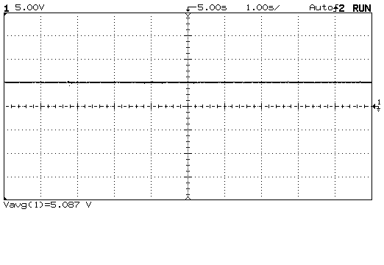

Figure 7: +3V Circuit
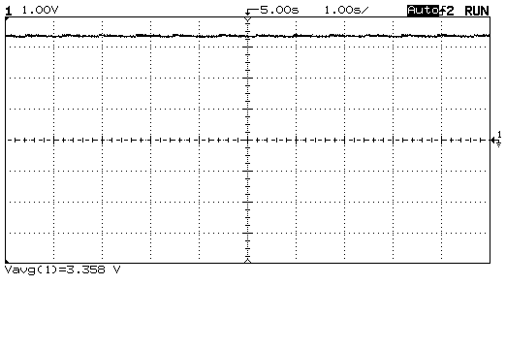

Figure 8 – 0 to -12V LCD Bias Circuit
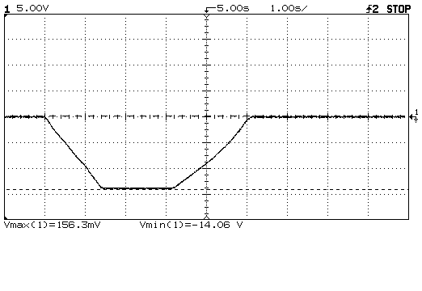

IrDA Controller (Matt Miller)

A prototype has been successfully built. Using a terminal program loaded onto a Palm, we successfully established a connection. However, since working Palm software has not been completed we have no way of testing the full capabilities of the IrDA system.

Initially, we had some problems establishing a connection with the IrDA system. This problem occurred because we initially built the circuit with the wrong capacitors as well as a series cut crystal. Once we swapped those components with the correct ones, we were able to establish a connection.

Motion Sensor (Navin Lingaraju)

The motion sensor circuit was successfully designed and implemented as indicated in the functional specification. When a change in light is detected, the control line connected to the MCU is sent to ground, triggering the interrupt routine of the firmware. This behavior has been verified using a voltmeter as well as observing the reaction of the firmware to the interrupt.

2. Firmware Design (Greg Ferreri)

The PMB firmware has performed exceptionally well with respect to the functional and technical specifications written for it, considering the lack of a functional hardware prototype on which to test for most of the duration of the project. Development was further hindered by the lack of a Palm software prototype with which to interface. Every functional module of the code has been individually tested for correctness. Many of these functions were tested with the actual PMB prototype circuitry. However, due to a lack of Palm OS software, the only verification of IR communications was performed using the STK500 development board, as explained in the methodology section.

Liquid Crystal Display

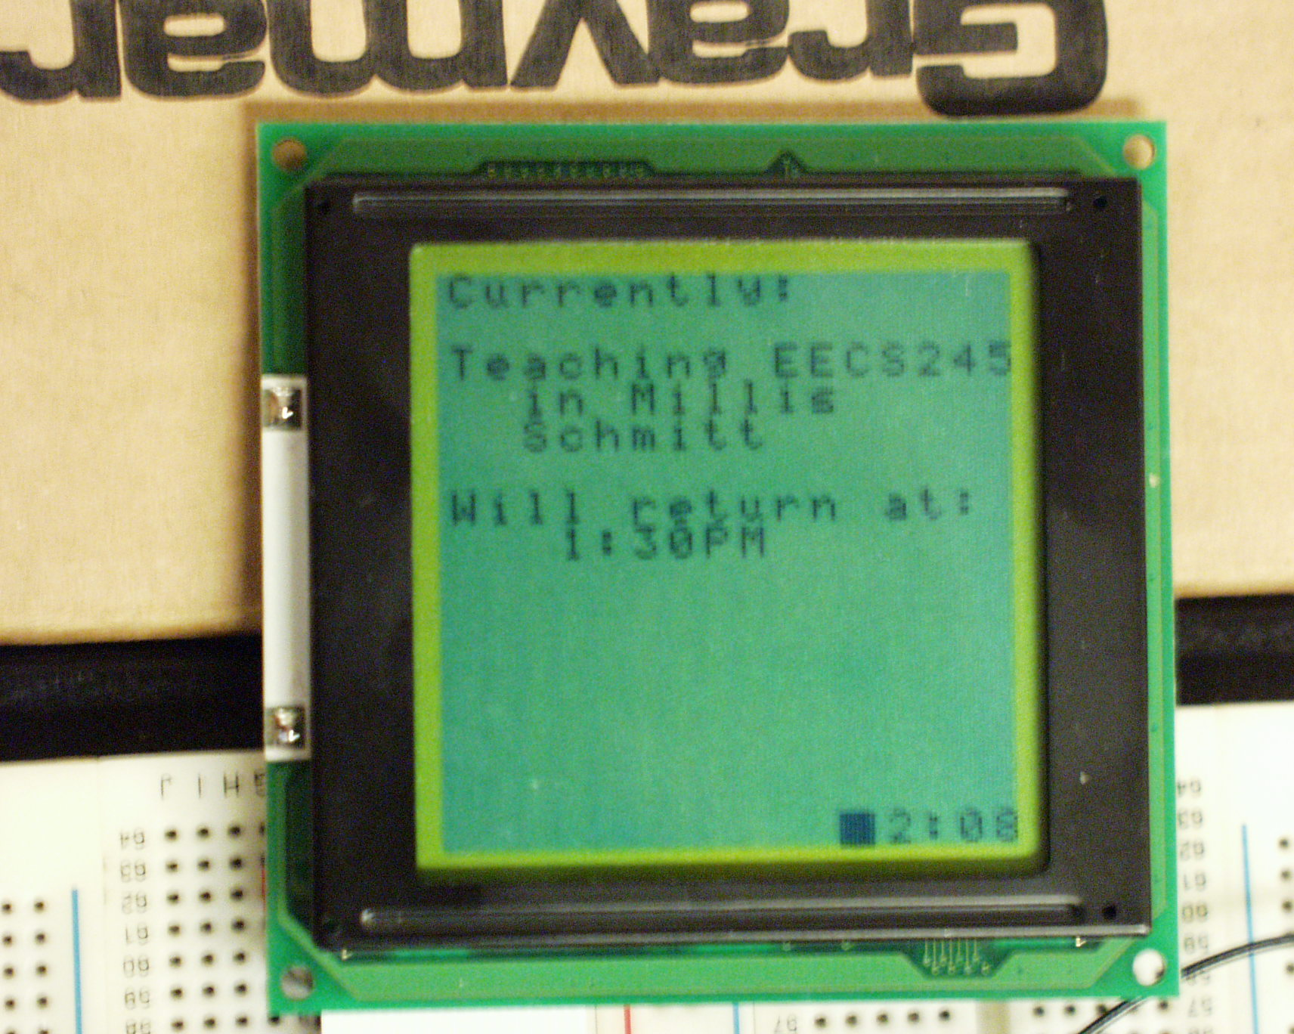
Several problems were experienced in attempting to interface with the real Hantronix LCD module. The first module we received showed uncharacteristic behavior with respect to contrast adjustment and response to commands sent to it. A second Hantronix display was acquired; this too was inoperable, as the +5V and GND lines were shorted. Finally, a third LCD module was acquired and interfaced successfully. The firmware function library provides the ability to clear the screen, and write strings of text to the screen at any position desired using a “cursor” which is settable to any x,y coordinate within the 16x16 matrix.

Clock

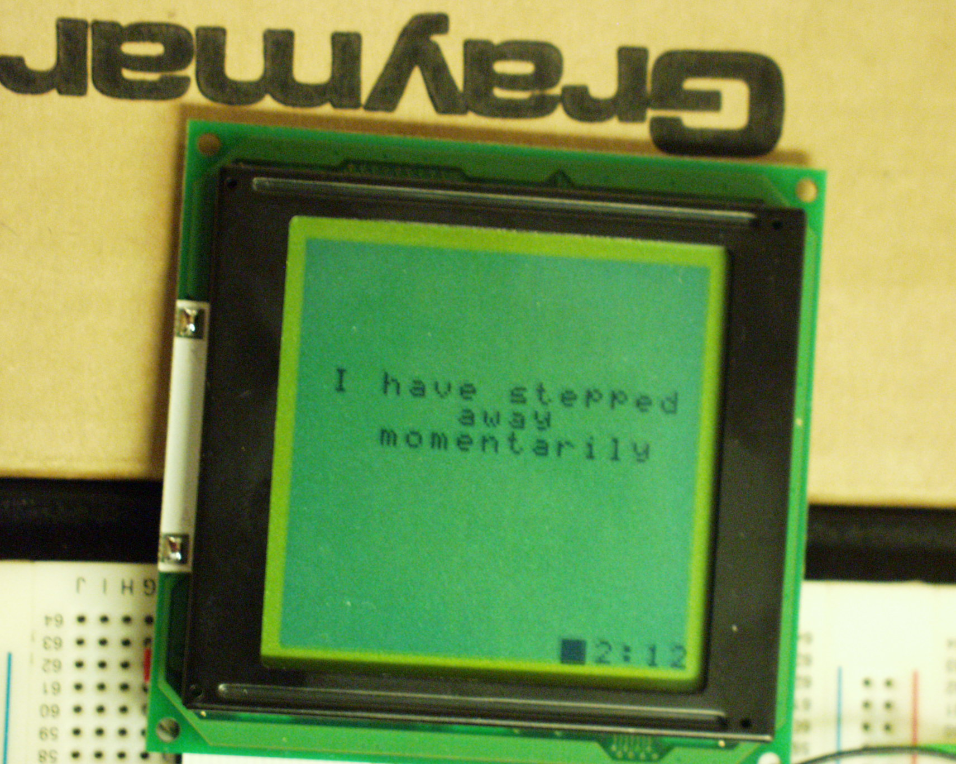
The real-time clock module works exceptionally well, and the time is constantly displayed on the bottom row of the LCD. This can be seen in the pictures of the LCD display. Once per second, the firmware will update the time displayed on the screen.

Quick Message Button

The Quick Message button provided on the PCB prototype board functions as an interrupt generator. When the button is pressed, the LCD screen of the PMB will display the message “I have stepped away momentarily.” When the button is pressed again, this message will disappear. A minor problem has been discovered that the button occasionally triggers several interrupts with each press. A future implementation of the PCB will include de-bounce circuitry to prevent this problem. From a software standpoint, there are no problems with the code.

IrDA Communication

While the Palm Sync software was not available for testing, the IrDA communication capability of the PMB firmware was tested and verified using the STK500 development board. By use of the UART – to – RS-232 converter chip on the development board, data was transmitted between the MCU and a PC running a terminal emulation program. In this fashion, commands to set the time and away messages were verified.

Motion Sensor

The motion detection routine concept has been proven. When motion is sensed, an interrupt routine is called which displays the message “Motion sensed!” on the display.

3. Palm OS Software (Lucas Bacon)

The user interface component of the Palm Sync software has been implemented and tested for correctness. A hierarchy of user menus has been developed. The main menu allows for the selection of the following three choices: “Sync with Date Book”, “Set Away Message”, and “Set PMB System Time.” When the “Set Away Message” option is selected, the user is presented with 5 choices of predefined away messages. In addition, there is an “Edit” button which allows each of the away messages to be customized by the user. It is clear that the user interface meets the requirements set forth for the Palm Sync software.

Project Timeline:
Task | Due date | Completion
1. Component Research  2. Circuit Design  3. Printed Circuit Board Layout  4. Functional Protoype  5. Software Design  6. Firmware Design  7. Software Implementation  8. Firmware Implementation  9. Software Testing  10. Firmware Testing  11. Packaging/Field Testing | Feb 23  Mar 23  Apr 6  Apr 20  Mar 16  Mar 16  Apr 6  Apr 6  Apr 20  Apr 20  Apr 25 | Mar 9  Apr 6  Apr 13  Apr 24  Mar 16  Mar 16  ??  Apr 23  ??  In progress  n/a

Schedule Modifications:

Component Research – Our group committed to this project on February 5th because of we had learned that our initial choice of project would be unfeasible. As a result, our proposal was prepared without a full knowledge of the requirements of the final product. After an initial survey of parts we found that we had chosen a microcontroller with insufficient control lines.

Circuit Design – Circuit design was delayed by two weeks due to the delay in selecting parts.

Printed Circuit Board Layout – (see Circuit Design)

Functional Prototype – This was an area we had deemed that sufficient leeway was given for making up time that was lost earlier in the project. Unfortunately, the display unit provided by Hantronix Inc. provided us with some problems. Our first display unit was failed to function properly. We believe this was because we did not follow the timing sequence when powering on the display. However, this has not been conclusively determined. We proceeded to order a second display unit and which also found to defective. This time all safeguards we followed, but the display failed to work. Our numerous requests for technical support from Hantronix Inc. were answered via email only. We made the decision to purchase a third unit at our own cost (cost borne by members of the group) which did function properly and is currently being used in our prototype.

Firmware Testing – (see Functional Prototype)

Packaging/Field Testing – (see Functional Prototype)

VI. REVIEW OF OTHER IMPLICATIONS

While we originally estimated the budget of our project to be around $70, our actual development costs were significantly higher. The approximate cost of building only one PMB has been determined to be around $180, not including shipping expenses. An item such as the $80 AVR development board added to the initial cost of the project. An itemized list of project costs is included in the Appendices.

Once a working design has been prototyped, the necessary components can then be verified. This verification gives the builder an exact price for each part, and thus a total project cost. There should not be any additional unanticipated costs at this point. The price per each component will vary depending on the quantity ordered. Therefore, we estimate the actual cost of a PMB in the production stage will be around $45 in the development stage. This estimate is attained by taking 1/4th of the original costs, which is reasonable considering the degree of volume discounts offered by large vendors such as Digikey Corporation.

Our underestimation of the costs is a result of inexperience and the unanticipated costs that were incurred. This shows how difficult it is to predict the total cost of a project during the development stage. Our unanticipated costs included the PCB manufacturing, a second and third LCD module, and excessive shipping costs.

With the completion of a working prototype, we believe that our device has a possibility of being marketed. While we are currently unaware of anything similar on the market, the value of such a device might become apparent to consumers as they learn of its availability.

While we designed the PMB specifically to hang on Dr. Merat’s office door, this device would fit nicely into any office setting. The possibilities are almost endless. Hypothetically, the usage of a PMB could greatly reduce the amount of paper-waste in the form of Post-it® notes.

VII. CONCLUSIONS

The PMB prototype demonstrates all display functionality that was originally outlined. It displays the current whereabouts based a stored daily schedule and also displays the time that the user is expected to return to his/her office. The current time is displayed in the lower right corner of the screen.

The actual IR communication between the PMB and the PDA was not successfully demonstrated due to the lack of a successful Palm application prototype.

The PMB was designed with the goal of making it energy efficient. The display of the LCD module was the primary source of power drain. A motion sensor was integrated into the PMB to trigger the PMB only when a passerby seeks to view information off of it. The motion sensor is triggered only by sudden changes in light intensity and is therefore insensitive to the level of background radiation. Also, the sensitivity of the motion sensor can be adjusted by turning the screw on the potentiometer.

The project did not meet all the requirements outlined in the proposal. Development of a fully functional prototype was not made possible until April 23. The primary reason for this delay was trouble encountered in obtaining a fully functioning display unit. As mentioned earlier in the report a total of three displays were ordered, of which only the final one worked. Assistance was sought from the LCD module manufacturer, but to our dismay our only means of communicating with the manufacturer was through email. Our questions, while highly specific were only answered by being provided with application notes that were already in our possession. We also sought help from Dr. Merat with this regard, but were unable to diagnose the problems with the first two displays ordered. We are able to adequately compensate for any lost time from deadlines missed earlier on in the semester. However, the development of a fully functioning prototype was a task set for the end of the project period. As a result we were unable to meet some of the milestones set towards the end of the project. The tasks not completed are as follows: Palm software testing, PMB packaging and field testing. All other milestones were achieved in a timely manner and a prototype capable of all functions outside these tasks has been assembled.

VIII. RECOMMENDATIONS

A prototype circuit has been developed and demonstrated. However, several improvements must be made before the PMB is ready for customer delivery. First and foremost, the Palm OS application must be further developed and tested to ensure proper communication and date book synchronization. Second, a new printed circuit board must be laid out and manufactured that incorporates all of the power supply circuitry needed for the device. Third, a neat and attractive housing for the device must be engineered and manufactured. Lastly, the firmware must be embellished to dynamically handle date book information. Currently, a proof of concept has been shown; however, little firmware implementation was done in terms of the actual storage and retrieval of date book information.

We truly believe in the marketability of the Programmable Message Board. Based on our cost estimates for a finished product, the price range would be such that it could be a viable retail product. A complete marketing study should be undertaken, including surveys, interviews, and prototype feedback as methods of gauging public interest in the product. With this task accomplished, along with sound financial backing, the Programmable Message Board can be successfully launched into full-scale production and sale.

