Smart Traffic Signs

Final Project Report

By
Preston DeFrancis and Salil Gokhale

Submitted April 19, 2002

Signatures

Preston DeFrancis - ____________________________________

Salil Gokhale - ________________________________________

Dr. Frank Merat - ______________________________________

Executive Summary
The goal of the Smart Traffic Sign project is to replace a traditional road sign with a wireless communications link. The information on the sign is transmitted directly inside a motor vehicle over this link. The road sign information is then displayed to the driver on an illuminated liquid crystal display. Expensive “bridge structure” interstate signs, common to United States interstates, are specifically targeted for replacement.
In the original project plan, work was divided into two major areas: hardware and software. The hardware component of the project called first for the design of power supplies for each of the Smart Traffic Sign units; later, packaging for the units was also designed. The project required software to be written that controlled the units and their output. Finally, the software and hardware components of the project were integrated to complete testing and to provide a prototype to demonstrate the Smart Traffic Sign concept. With a few minor exceptions, the project plan was executed unaltered from its original form, and the performance of the Smart Traffic Sign prototypes was verified.

Introduction
Imagine driving on Interstate 495, headed towards Washington, D.C. It is the 4th of July, so traffic is heavy. All morning, dark clouds have been looming overhead. When the rain finally hits, visibility becomes poor and traffic slows to a crawl. Your navigator reluctantly informs you that you missed the exit to take you to Georgetown. You will have to retrace your steps; in these conditions, it could be hours before you get to your annual family reunion.
Anyone who drives on unfamiliar roadways is used to problems similar to these. Such circumstances can cause frustration and anxiety, states that often lead to reckless driving. Unfortunately, these situations have become common to motorists everyone in America. This is because interstate traffic signs do not always convey the information contained on them effectively to motorists. Poor weather conditions, ineffective sign placement, and unclear information all can contribute to a driver’s confusion. And perhaps most frustrating of all is that road signs are popular items with youthful thieves.
If traffic signs were inexpensive, perhaps their inefficiency would be tolerable. However, according to Dr. R.L. Mullen, chair of Civil Engineering at Case Western Reserve University, “bridge structure” signs (Figure 1) have an initial cost of $300,000. These signs are commonly found on United States interstates and therefore are an enormous expense.
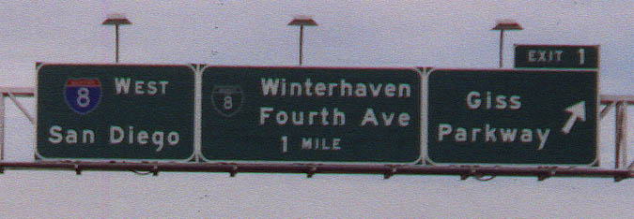
Figure 1: Bridge Structure Interstate Sign

Clearly, interstate traffic signs are due for an upgrade. The goal of the Smart Traffic Sign project is to address the numerous problems with traditional road signs by designing and demonstrating a more efficient solution.
The Smart Traffic Sign project followed a two-semester design schedule. A major component of last semester’s work was research. Several different modes of wireless communication were considered, including infrared and laser. However, radio frequency (RF) communication was found to be the best choice. RF signals are valid even in heavy rain and snow, conditions in which Smart Traffic Sign messages could be particularly helpful to motorists. Another advantage of radio frequency is that commercially available RF modules are relatively inexpensive. A receiver and transmitter pair was obtained from Parallax, Inc., and a simple feasibility test was done to prove that the modules could effectively transmit the information contained on a traditional road sign.
The goal of this semester’s work was to deliver a demonstration prototype of a Smart Traffic Sign transmitter and receiver module. The Parallax RF modules purchased last semester were integrated with BASIC Stamp microprocessors so that interstate sign messages could be sent via the wireless link. The transmitter unit encodes a packet of data and sends it serially to a receiver that decodes the information. This decoded data is then displayed on a liquid crystal display (LCD), also purchased from Parallax, Inc.
The prototype has specifications nearly identical to a Smart Traffic Sign that could actually be implemented. First, the signal is sent out by the transmitter at a rate of 9600 baud and was found to be valid for approximately 300 feet. Within that range, the receiver display outputs only a perfectly received message because of error checking that the receiver module does. This range allows a meaningful message to be transmitted to a car traveling at speeds of up to 80 miles per hour. The transmitter and receiver will operate on a frequency of 433.92 MHz and use simple loop antennas.
The receiver unit will plug directly into the 12 V DC supply available from a car’s cigarette lighter. It was assumed that 120 V AC would be available for the transmitter unit, since most interstate signs in urban areas are already illuminated with halogen lamps. A power supply was designed to convert this 120 V AC into the 12 V DC for the transmitter unit. Finally, packaging was developed to house these modules. The receiver unit was housed in a small, user-friendly package that can attach with Velcro to a car’s dashboard. The transmitter unit was built into a larger, weatherproof package.
The prototype modules developed this semester show that the Smart Traffic Sign concept is viable. The results of tests with the Parallax modules prove that RF technology could become a less expensive alternative to bridge structure interstate signs. Traffic sign information can be delivered directly to motorists, no matter what the weather or time of day. Confusion caused by poorly placed or missing signs will be gone. Drivers will feel safer and more confident.
The design team working on the Smart Traffic Sign project is composed of Preston DeFrancis and Salil Gokhale. Mr. Gokhale is in charge of writing the software that controls the transmitter and receiver units and the drivers for the LCD screen. Mr. DeFrancis is in charge of designing and constructing the voltage regulation hardware, as well building the packaging for both of the units. Mr. DeFrancis is also in charge of documenting the project’s progress. Both team members will assist with the integration of the software and hardware components as well as troubleshooting any difficulties.

Methodology
The Smart Traffic Sign project can be divided into two major areas of work: software and hardware. In the discussion of each area that follows, reference is made to the project plan, found in Appendix A.
Work on the software portion of the project progressed in three major stages. First, it was necessary to program the transmitter microprocessor with the information needed to encode information and send it serially. To minimize the amount of data to be sent out, a protocol was used. This protocol allowed a meaningful message to be communicated to the driver when, in fact, only a few characters were transmitted. According to the protocol, the transmitted characters stood for whole words. For example, a transmitted “I” stood for “Interstate” and a transmitted “E” stood for “East.” The full code for the transmitter microprocessor can be found in Appendix C. This work (Task 7) was completed as scheduled.
Next, it was necessary to write the code for the receiver. This code contained the instructions necessary to decode the serial data as well as the protocol conversation instructions. These protocol conversation instructions contained the information about which received characters actually stood for whole words. At first, the modules were tested using a computer screen to display output. Eventually, LCD driver code was written into the code loaded to the receiver microprocessor, and data could be displayed on the LCD screen. The complete receiver microprocessor code can be found in Appendix D. These tasks (Tasks 13 and 18) were both completed on time.
The architecture of the receiver and transmitter systems appear below (Figure 2).
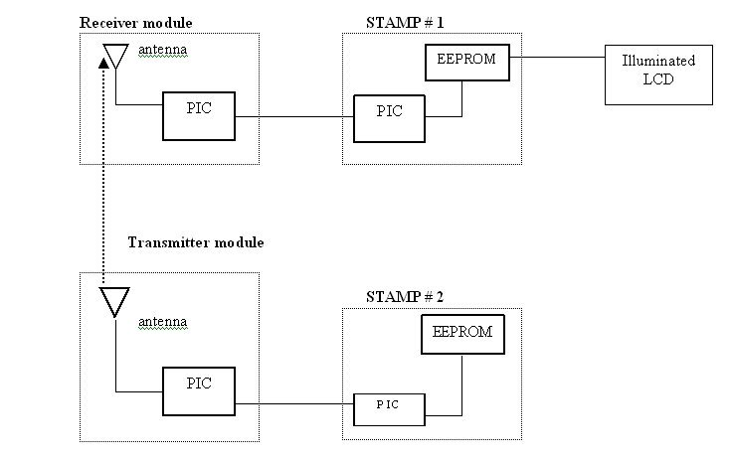
Figure 2: Transmitter and receiver system architecture

The hardware portion of the project had two distinct areas of work: building power supplies for the transmitter and receiver modules, and constructing packaging to house these modules.
First, research started on the voltage regulator hardware needed to power the receiver unit. This task turned out to be much easier than originally expected. The Stamp microprocessors are built onto evaluation boards. These evaluation boards contain built-in voltage regulation hardware. So a cord that plugs into a car’s cigarette lighter was purchased from Radio Shack, and this was used to power the receiver module. Since no actual design was needed, less time was spent on this (Task 6) than anticipated.
Building the power supply for the transmitter unit was more challenging, however. For the transmitter, it was assumed that 120 V AC would be available. This assumption was valid because most bridge structure interstate signs in urban areas are illuminated by halogen lamps that use 120 V AC. To convert the 120 V AC to 12 V DC, it was first necessary to use a 12.6 V, 1.2 amp transformer to step down the voltage. Next, a diode bridge rectified the alternating current into direct current. A 220 uF capacitor was used to smooth voltage across the diode bridge. Finally, this voltage was the input to a 7812 voltage regulator chip to ensure a very constant 12 V DC output. A circuit diagram for this design appears below (Figure 3).

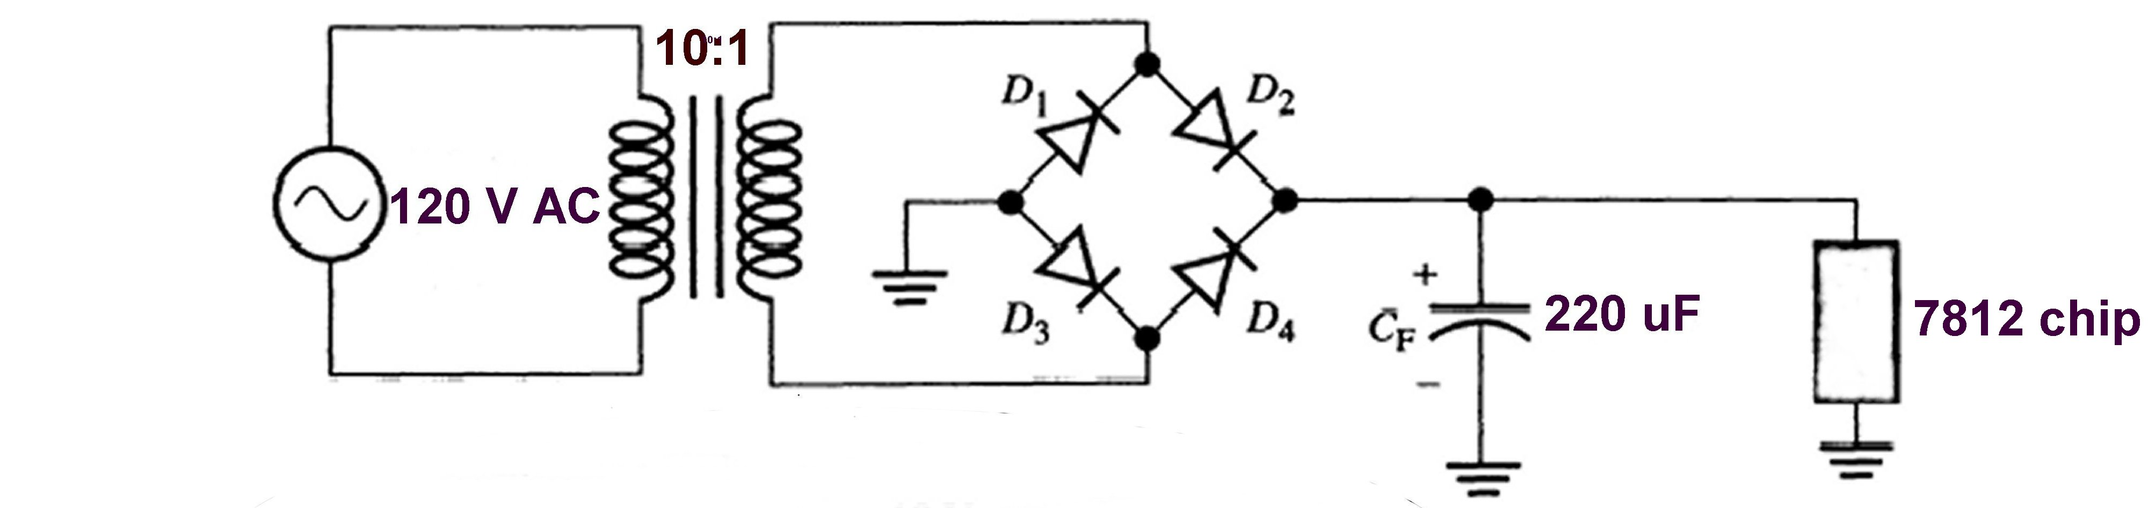
Figure 3: Schematic drawing of transmitter power supply

The components were installed on a standard prepunched perfboard and soldered together. Work on this power supply (Task 14) was completed a scheduled. Below is a picture of the finished power supply (Figure 4).
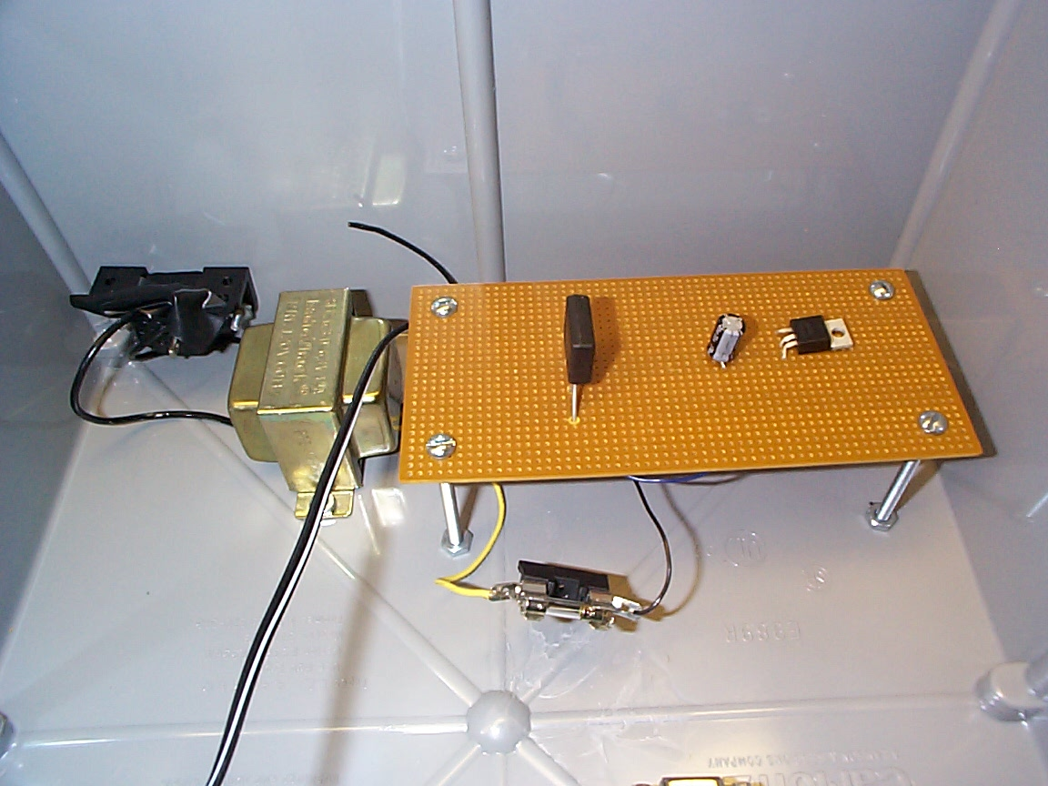
Figure 4: Constructed transmitter power supply
Next, the modules and power supplies had to be integrated into packaging. The goal of the packaging was to house the units in boxes that could actually be used in a real-world scenario. Thus the receiver package was designed to be small and easy to use, and the transmitter package was designed to be weatherproof. Both purchased boxes were plastic, ensuring that no signal attenuation would take place. Next, the boxes had to be significantly modified to house the units. It was necessary to use a jigsaw to make a hole in the thick plastic of the transmitter box for the power cord receptacle. Holes were drilled in the base of the packaging, and the transmitter and microprocessor modules were screwed into place. Similar modifications were made to the receiver box.
Tests of the units were conducted at several stages of the design process. The first significant test occurred when the software and power supplies were completed, but packaging had not yet been started. This field test (Task 23) was especially noteworthy because it took place during a heavy snowfall. The final test of the prototype units (Task 28) occurred after the modules had been fully integrated into packaging. This test occurred on a warm, sunny day, providing an excellent comparison of measured range performance to the earlier test. A full discussion of the results of these tests appears below. Both tests were completed as expected in the project plan.
Because all work was done on time or earlier than expected, there was some extra time in the schedule. At mid-semester, it was decided that this extra time could be used to possibly improve on the design originally discussed in the project specifications. Essentially, an added goal of the project became to create a second generation Smart Traffic Sign. To implement this improved design, new RF modules were purchased from Linx Technologies. These modules were smaller than the original Parallax modules. Also, instead of a built-in loop antenna, these modules had an “antenna output” pin, allowing for the use of any type of antenna. These modules transmitted at 915 MHz and used frequency modulation (FM).
These new modules could have nearly tripled the performance of the first generation Parallax modules. Unfortunately, there was not enough time in the schedule to deal with all the issues related to implementing these new modules. A full discussion of the problems with and potential of these modules follows in the Recommendations section.

Results
The Smart Traffic Sign demonstration prototype was completed as expected. Field tests confirmed that the modules performed nearly as well as expected. An outline of the original requirements of the modules appears below.
 | Requirements
Frequency of Operation | 433.92 MHz
Receiver Power Supply | 12 V DV
Transmitter Power Supply | 120 V AC
Display | Backlit LCD
Antenna Type | Loop
Maximum Range | 400 feet

The original project plan can be found in Appendix A. All expected tasks were completed; the list of the major completed tasks can be found in Appendix B.
First, the receiver unit was required to be small, user-friendly, and plug into a car’s cigarette lighter. This unit is pictured below (Figure 5).
. 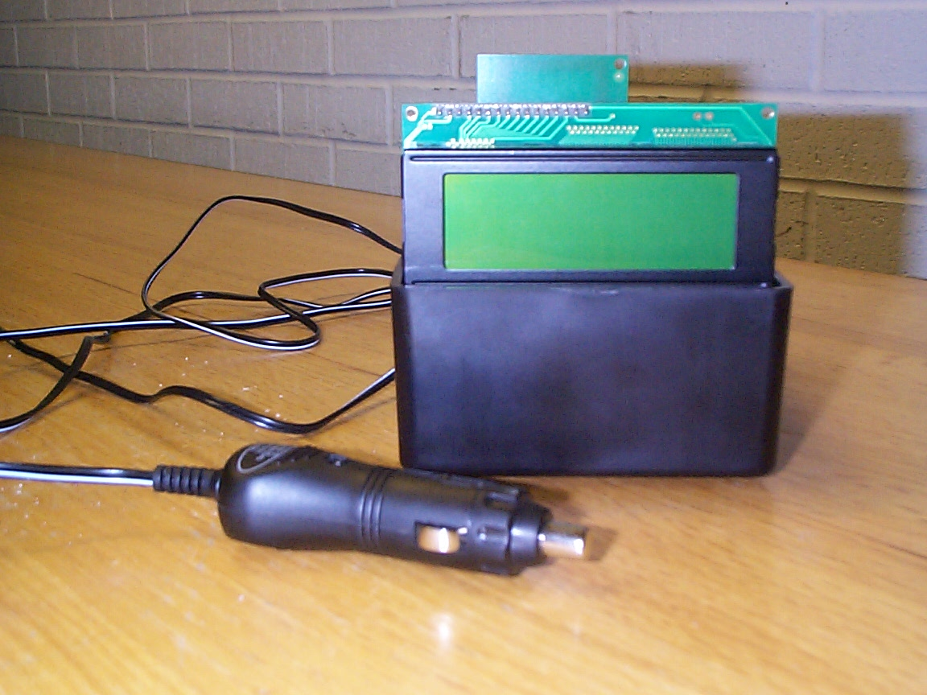

Figure 5: The completed receiver unit

The receiver unit easily attaches with Velcro to the dashboard of any car. The unit is seen below from a driver’s viewpoint (Figure 6). Note that the display is backlit for readability even at night.
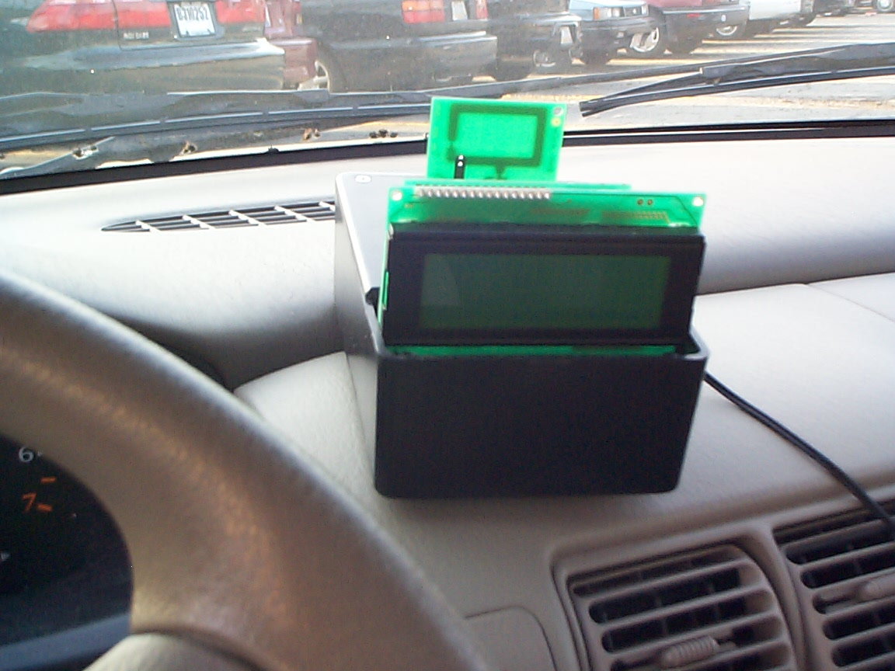
Figure 6: The installed receiver unit

The transmitter packaging was required to house the power supply, the microprocessor, and the transmitter itself in one weather-tight package. The transmitter package also has a power cord attached to it to plug into a wall outlet (Figure 7).
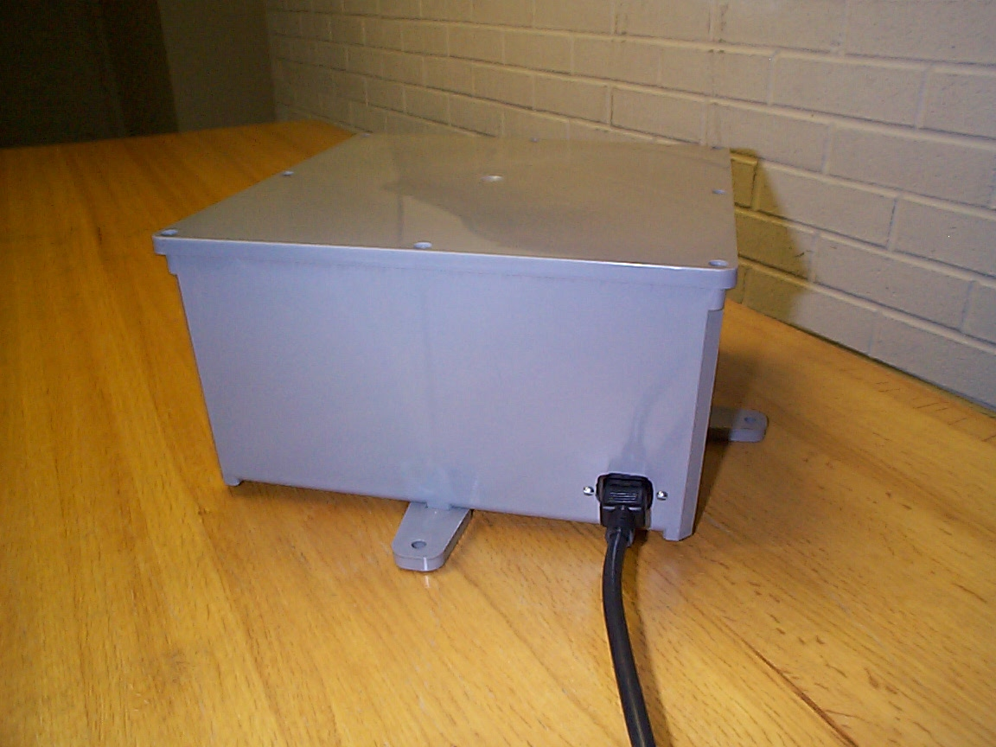
Figure 7: The completed transmitter unit

The contents of the transmitter package can be seen most easily from a bird’s-eye-view when the lid is removed from the package, as seen below (Figure 8).
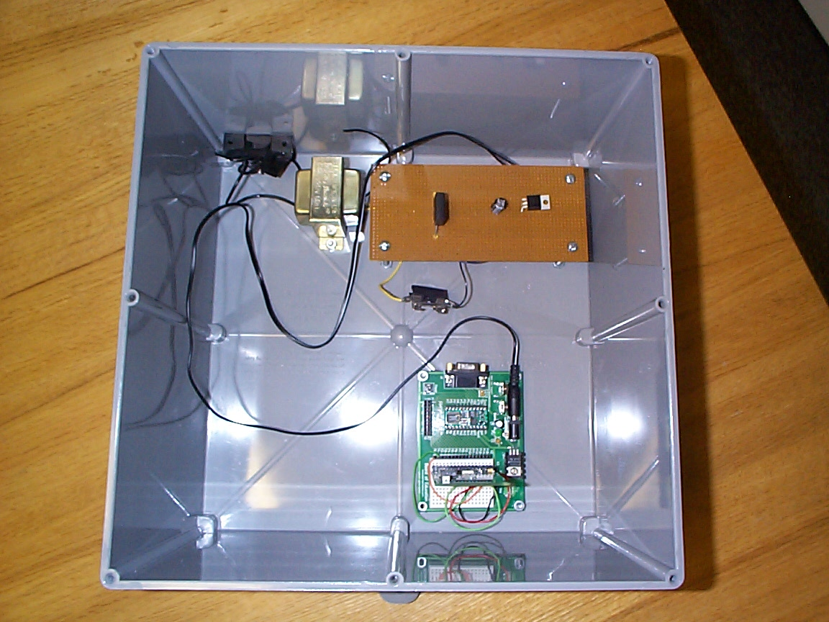
Figure 8: Contents of the transmitter package

To verify the performance of the modules at the original specifications, two tests were conducted. The goal of these tests was to determine the maximum distance between the receiver and transmitter over which a valid signal was still received. A valid signal was considered to occur if the receiver was continuously flashing the message on the LCD screen. The message was programmed to refresh every two seconds while the units were in range of one another, so it was easy to know if a valid signal was no longer being received. Note that the receiver will output only a perfectly received message because of error checking that the receiver module does.
The first test was conducted before the modules were installed in their packaging. This test occurred during a heavy snowfall. Shown below (Figure 9) is a team-member holding the transmitter module, wrapped in a plastic bag to keep it safe from the weather.

Figure 9: Testing the modules in heavy snow

It was not possible to get an exact measurement of the range during this test because of the extremely heavy snowfall. However, pictures documented the approximate positions of the car with the receiver module and the team member holding the transmitter module. The picture below (Figure 10) shows the barely-visible car from the position of the transmitter at its peak distance of separation.
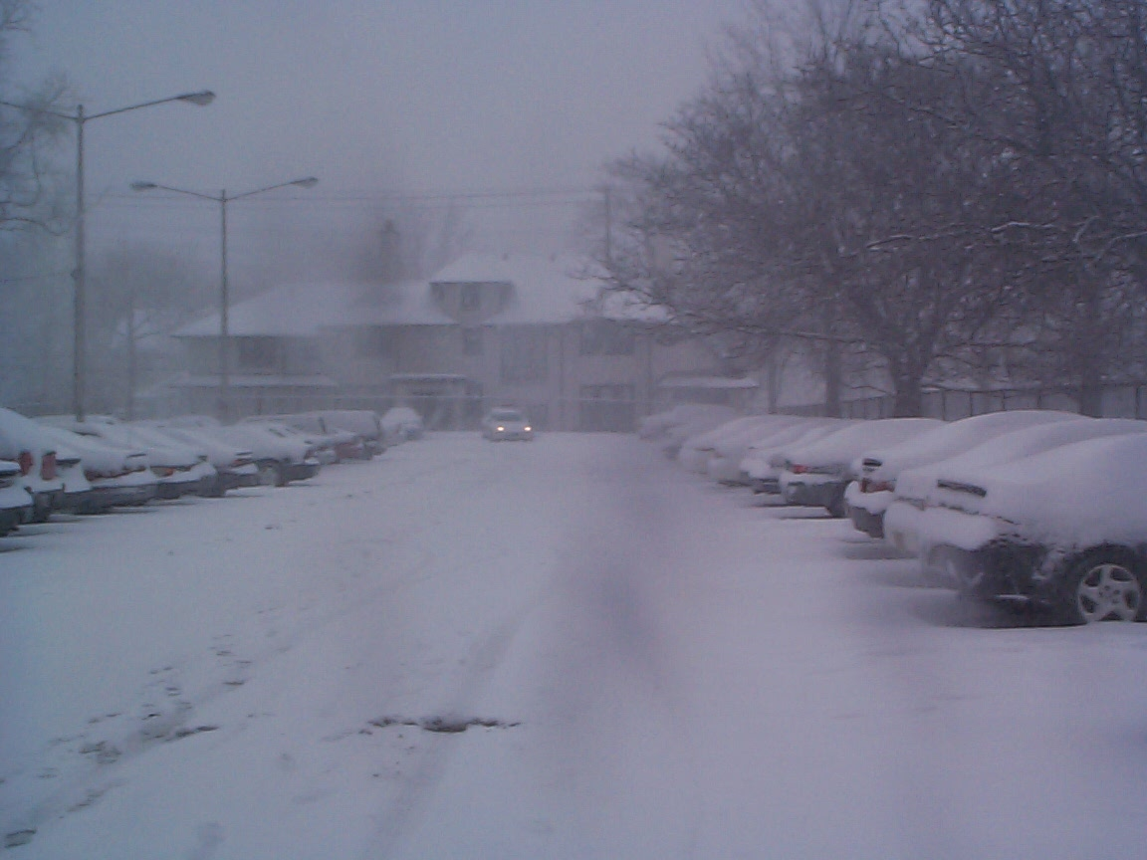
Figure 10: Distance of successful operation in heavy snow

Once the modules were in their packaging, a second test was completed at the same location. This test happened on a sunny, clear day. Below (Figure 11) is a picture showing the position of the team member holding the transmitter unit from the position of the receiver at its peak distance of separation.
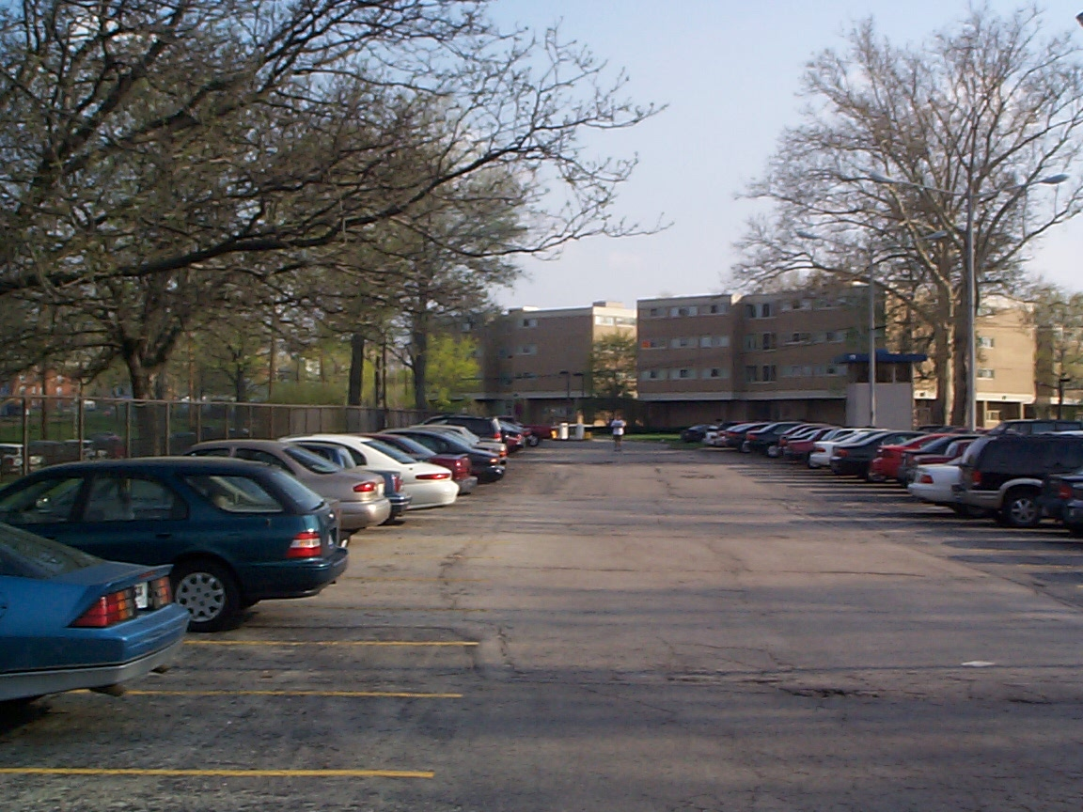

Figure 11: Distance of successful operation in clear weather

At this time, measurements were taken of the peak operating distances for both tests:

Range of modules in heavy snow: approximately 300 feet
Range of modules in clear weather: approximately 310 feet
As seen, the inclement weather does not significantly reduce the range of the modules. However, neither measurement quite reaches the original requirement of 400 feet. However, this requirement was based on tests performed last semester and is not necessary for the successful transmission of data to a moving vehicle.
It can be easily shown that a 300-foot range is sufficient for successful operation of the Smart Traffic Sign. First, assume that a car is traveling at a maximum speed of 80 miles per hour (117.33 feet per second). If this is true, the car will be in the range of the transmitter for:
Time = (Distance) / (Rate)
= (300 ft.) / (117.33 ft./sec)
= 2.56 sec
The modules transmit information at a rate of 9600 baud, or 9600 bits a second. For our modules, 8 bits are required to display a single character. So, the number of characters that can be transmitted each second is:
No. Characters per second = (Data Rate) / (Bits per Character)
= (9600 bits/sec) / (8 bits/character)
=1200 characters/sec
So, the total number of characters that can be transmitted is:
Total characters transmitted = (Time) * (No. Characters per sec)
= 2.56 sec. * 1200 characters / sec
= 3072 characters
Even with the overhead of processing required on the data, the number of characters that can be transmitted is more than adequate for the Smart Traffic Sign application.

Implications
One factor that may prohibit the success of the smart traffic signs is the cost to consumers. Unfortunately, drivers would have to purchase receiver modules and consumers may be hesitant to make an investment in such a youthful technology. Perhaps the best way to introduce the smart traffic sign is to focus on certain groups that could immediately reap benefits from it. Vision-impaired individuals may be able to easier receive licensing if they could use smart traffic sign technology to aid their sight. Installing the necessary hardware on commercial vehicles such as trucks or buses might also help improve public confidence in the new technology. In any case, care was taken to be sure that the receiver unit used only components that are relatively cheap and already commercially available.
Because Smart Traffic Signs use wireless technology, consideration must be given to the regulations set forth by the Federal Communications Commission (FCC). The FCC has very strict guidelines governing the use of frequencies and power levels. If the Smart Traffic Sign system is to be usable in a real-world scenario, the design must adhere to FCC regulations. Luckily, the Parallax RF modules are approved for low power applications such as the Smart Traffic Sign. Perhaps the FCC would allot a special frequency for the system because of its specialized transportation application.
Finally, one primary goal of the Smart Traffic Sign project is to improve the safety and confidence of motorists. Therefore, much thought was given to the in-car display. The LCD screen ultimately used is perhaps too small to be safely read by a driver faced with heavy traffic or bad weather. Possible, safer, solutions include a larger LCD or even the use of audio messages.

Conclusions
The prototype developed this semester does effectively demonstrate the Smart Traffic Sign concept. Stamp microprocessors were programmed to control the operation of the transmitter and receiver modules. Suitable power supplies were developed for each module, and appropriate packaging was constructed for each. The illuminated LCD gives drivers an alternate way of receiving information contained normally only on traffic signs. And, finally, the verification of the prototype’s operation was proven by field tests, both in clear and inclement weather. The only original requirement not fully met was the range of the modules. While 400 feet had been set as an original goal, this number was based on the performance of the modules as tested when parallel, single bit data was sent out. In this application, multiple bits of serial data are being sent out, and operation is successful only if every bit is received flawlessly. This accounts for the range reduction to 300 feet. This range is still long enough to allow for successful transmission and receipt of a message to a car traveling at speeds up to 80 miles per hour.

Recommendations
Work should continue on the Smart Traffic Sign project. Because this first generation demonstration prototype has been shown to be successful, it can pave the way for further testing and improvements.
There are many areas in which more work can be done. First, the second generation Linx modules that were purchased could be used to provide more range and antenna flexibility. Antenna flexibility is important because it can help boost range and achieve better directionality. The loop antennas used in the demonstration prototype provide omnidirectional signal propagation. An antenna with a different design, such as a Yagi antenna array, could focus all transmitter power on a single direction. Also, different receiver antennas could be smaller and less conspicuous than the rather gaudy loop antennas built into the current modules. If consumers are going to purchase the receiver units, they must be housed in small, attractive casings, so packaging could also be improved on future designs.
Some specific aspects the Linx modules that need extra work are RF board layout and cyclic redundancy checking (CRC) programming. Investigation into the problems with the modules found that one of the main reasons for their failure was that the board layout is very important for high frequency RF boards. This is because of the sensitivity of the receiver. The clock signal operating the Stamp microprocessor could have interfered with reception. A very specific board layout is recommended and its description is outlined in the handbook for the modules. Also, the Linx modules do not perform any error checking; therefore, error checking needs to be done in software. A complex CRC program would require more processing power than the current Stamp microprocessors would be able to handle. A more powerful processor would likely be required, but this could also allow other advanced features to be programmed into the Smart Traffic Sign.
Another great improvement to the Smart Traffic Sign system would be lane specificity. If lane specific information could be provided to motorists, they would be able to easily know if they are in the correct lane for exits, one of the primary causes of frustration when driving on unfamiliar roads. Perhaps this could be achieved by having one “master” transmitter unit send information for all lanes to all cars; but, a second, small transmitter embedded in the highway beneath each lane would select which lane-specific information to display to the driver.
Finally, further research needs to be done to determine what is the best mode to communicate to the driver the information transmitted to the Smart Traffic Sign receiver. Currently, the data is displayed on an LCD. But a safer option could be an audio-based system that “reads” the text of the sign to the driver.

Appendix B: Major Completed Tasks

- Develop power supply for receiver unit
- Develop power supply for transmitter unit
- Design code for receiver microprocessor
- Design code for transmitter microprocessor
- Write driver code for LCD screen
- Complete field tests of prototype modules without packaging
- Build packaging for the receiver unit
- Build packaging for the transmitter unit
- Complete field tests of prototype modules (VERIFICATION STEP)

Appendix C: Transmitter Unit Code

'{$STAMP BS2}

'---Set up Variables---
Value VAR BYTE 'Holds data value being transmitted

'---Set up Constants---
Tx CON 0 'Transmit I/O pin number
TxFlow CON 1 'Transmit flow control I/O pin number
N9600 CON $4054 'Baud mode value for 9600 baud

Initialize:
LOW Tx 'Initialize transmitter interface

'---------------------------------------- Main Routine -------------------------------------------

'Transmit data
SenderMain:

SEROUT Tx\TxFlow,N9600,["I"] 'send the first letter
PAUSE 100 'pause for 0.1s and then go to the next letter
SEROUT Tx\TxFlow,N9600,["2"]
PAUSE 100
SEROUT Tx\TxFlow,N9600,["7"]
PAUSE 100
SEROUT Tx\TxFlow,N9600,["1"]
PAUSE 100
SEROUT Tx\TxFlow,N9600,["E"]
PAUSE 100
SEROUT Tx\TxFlow,N9600,["3"]
PAUSE 100
SEROUT Tx\TxFlow,N9600,["5"]
PAUSE 100
SEROUT Tx\TxFlow,N9600,["4"]
PAUSE 1000 'Pause for 1 second

GOTO SenderMain 'Then start over again

Appendix D: Receiver Unit Code

'{$STAMP BS2}
' This is the program for the receiver
Rx CON 0 'Receive I/O pin number
N9600 CON $4054 'Set the 9600 baud mode
clrLCD CON 12 'Set the value to clear the screen
nocurs CON 4 'Set the value to clear the cursor
backon CON 14 'Set value to turn on the back light
backoff CON 15 'Set value to turn off the back light

'Define variables and print Interstate on the fly
Letter VAR BYTE
Name VAR BYTE
Counter VAR WORD

'This array is created so store the message received
Message VAR BYTE(7)

'Counter is setup so that the message is not received repeatedly
Counter = 0

'Check for I which is the beginnning of the stream
Again:
SERIN Rx,N9600, [Letter]
IF Letter="I" THEN Print
GOTO Again

'Store the incoming message in an array
Print:
SERIN Rx,N9600, [Name]
Message(Counter) = Name
Counter = Counter + 1
IF Counter<7 THEN Print

'Begin the output sequence
'This part is for the LCD display. Serout commands are used to send messages to the LCD display

serout 1,N9600,[backon]

serout 1,N9600,["Interstate "]

serout 1,N9600,[Message(0)]

serout 1,N9600,[Message(1)]

serout 1,N9600,[Message(2)]

'Check for the directions and output the appropriate words

IF Message(3) = "E" THEN East
IF Message(3) = "W" THEN West
IF Message(3) = "N" THEN North
IF Message(3) = "S" THEN South

'According to the direction output the
East:
serout 1,N9600,[" East,"]
GOTO E

West:
serout 1,N9600,[" West,"]
GOTO E

North:
serout 1,N9600,[" North,"]
GOTO E

South:
serout 1,N9600,[" South,"]

'Output the exit number for the interstate

E:
serout 1,N9600,[" Exit "]
serout 1,N9600,[Message(4)]
serout 1,N9600,[Message(5)]
serout 1,N9600,[Message(6)]

PAUSE 8000

'Turn the back light off
serout 1,N9600,[backoff]
serout 1,N9600,[clrLCD]

GOTO Again

END

Appendix E: Amplitude Modulation
The parallax RF modules work on standard amplitude modulation (AM). AM is mathematically defined as follows:
Let x_{s}(t) be the message signal
Let x_{c}(t) be the carrier wave
Let x_{m}(t) be the modulated wave
x_{c}(t) = cos(2πf_{c}t)
In our case the f_{c} will be 433 MHz for the parallax modules and 915Mhz for the HP-II Linx modules.
x_{m}(t) = (A_{c} + x_{s}(t)) * cos(2πf_{c}t)
Let A_{s} = |x_{s}(t)|_{max} and β = A_{s}/A_{c} (β is the modulation index)
The frequency spectrum of the modulated wave is shown below.
X_{m}(t) = $\frac{Ac}{2}[δ(f+fc)+δ(f−fc)]+\frac{βAc}{2As}[X(f+fc)+X(f−fc)]$
There are two delta functions at the center frequency of the carrier at 433MHz. The rest of the message is centered at that frequency on both ends of the spectrum (f_{c} , -f_{c}). This exact wave is radiated into the atmosphere by the transmitter antenna.
Assuming negligible noise in between the transmitted and the receiver, the received signal (x_{m}(t)) can be written as follows:
x_{m}(t) = (A_{c} + x_{s}(t)) * cos(2πf_{c}t)
To demodulate the signal we multiply it by the same carrier wave. The carrier wave is transmitted with the AM signal as seen in the frequency spectrum.
Let x_{D}(t) be the demodulated signal.
x_{D}(t) = x_{m}(t) * cos(2πf_{c}t)
x_{D}(t) = (A_{c} + x_{s}(t)) * cos(2πf_{c}t) * cos(2πf_{c}t)
cos(α)²= 0.5*(1 + cos(2*α))
x_{D}(t) = 0.5*x_{s}(t) + 0.5* x_{s}(t) * cos(4πf_{c}t)
After the first demodulation step you obtain a frequency component at 2f_{c} , -2f_{c} and at the central axis.
X_{D}(f) = 0.5*X_{s}(f) + 0.25* [X_{s}(f - 2f_{c}) + X_{s}(f + 2f_{c})]
If X_{d}(f) is passed through a low pass filter the high frequency components of the signal at 2f_{c} are filtered out.
X_{D}(f) = 0.5 X_{c}(f)
Now x_{D}(t) is the same as x_{c}(t) and the original message is recovered.

Appendix F: Antenna Strength and FCC regulations
Point I: While the prototype used a very simple antenna, modifications to this antenna could enhance transmission range.

In radio communications, power is generally calculated in decibels per milliwatt.
P_{dBm} = 10 × log₁₀(P_{watts})
The receiver that we used had the following power, exrpressed in decibels
P_{dBm} = 10 × log₁₀(1000)
P_{dBm} = 30 dBm
The following formula gives the relationship between power and distance:
$$\frac{\text{PG}}{4{πD}^{2}}=\frac{E^{2}}{\text{120}×π}$$
P = power transmitted in watts
G = numerical gain of the transmitting antenna
D = distance of this measuring point from the electrical center of the antenna
E = field strength in volts/meter

In our case, the power transmitted is 1 watt. The gain of the antenna is calculated as follows:
Length of a loop = $\text{1005}\begin{aligned}\frac{f\text{Mhz}}{}\end{aligned}$
Length of our loop = $\text{1005}\begin{aligned}\frac{\text{433}}{}\end{aligned}$
Length = 2.32 Feet = 0.707m.

G = η (4π/λ²) A
A = area of the loop
λ = wavelength
η = antenna efficiency (typically 0.55)

The loop antenna is square in shape; the circumference is 0.707m. The area is then 0.031m². The typical gain for such an antenna is about 26dBm and the attenuation is about –104dbm (4×10⁻¹³ without any units, obtained from the manual sheet). Antennas with larger gains are common in real-world applications.

Point II: The electric field strength of our prototype lies within FCC regulations.

The electric field is calculated using the gain as follows:

$$E=\sqrt{\frac{P×G×\text{120}×π}{4×π×D^{2}}}$$
$$E=\sqrt{\frac{1×4×{\text{10}}^{−\text{13}}×\text{120}×π}{4×π×9}}$$
E = 11.51 μV/m at 3m.
This is much less than 2833 μV/m, the FCC limit on for devices operating at 433.92 MHz.

