REPORT SHEET FOR LAB6 - PART A
Student Name (Print): Student ID:
Student Signature: Date:
Student Name (Print): Student ID:
Student Signature: Date:
Lab Group: __________________

ANSWER THE FOLLOWING QUESTIONS:

Function Generator
1. Describe how you set/adjust the output frequency of the function generator

2. Referring to in the lab: “If the maximum amplitude of the signal is 2.5 volts, and the minimum amplitude is -3 volts, what is the DC offset? Explain your answer.

3. Explain how to set the output impedance of the function generator to “high impedance”

4. Using , explain what setting the output impedance of the function generator to high impedance does.

5. Describe how you program the function generator to output a specified peak-peak voltage?

6. Describe how you program the Function Generator to output a sine waveform?

Oscilloscope
1. How do you adjust the oscilloscope for a 10:1 probe at its input?

2. Describe how to use the oscilloscope for a calibrated peak-peak voltage measurement?

3. Describe how to use the oscilloscope for a calibrated RMS voltage measurement?

4. Explain how to calculate the RMS voltage of a 5 volt peak-peak sine wave? (no theory, just the mechanics)

5. Describe how to use the oscilloscope for a calibrated time measurement?

6. What does the Delay knob on the oscilloscope do?

7. Explain how to use the Cursors button on the oscilloscope.

Exponential Waveforms:
1. Draw a schematic of the RC circuit you examined in this lab.

2. What frequency has a period of 10 milliseconds? (The frequency is the reciprocal of the period for any waveform.)

DATA SHEET FOR LAB6 - PART B

Student Name (Print): Student ID:
Student Signature: Date:
Student Name (Print): Student ID:
Student Signature: Date:
Lab Group: __________________

DATA:
1. f) fLO= _________ Hz; fHI=_________ kHz.
RECORD ONLY IF SPEAKERS WERE AVAILABLE IN LAB

3. b) What happened?

3. c) What happened?

4. b) VMAX = _________ Volts
VTOP = _________ Volts
VMIN = _________ Volts
VBOTTOM = _________ Volts

Overshoot:
tRISE = _________ Seconds
tFALL = _________ Seconds

4. c) frequency = _________ Hz
period = _________ seconds
duty cycle = _________ %

4. d) pulse width = _________ Hz
pulse period = _________ seconds

5. b) Sketch of square wave measurement w/o using scope probe.
Volts/div:

__________

Time/div

__________

Sketch of square wave measurement using scope probe.

Volts/div:

__________

Time/div

__________

5. c) Measurements with correctly adjusted scope probe.
VMAX = _________ Volts
VTOP = _________ Volts
VP-P = _________ Volts
Measurements with mis-adjusted scope probe.
VMAX = _________ Volts
VTOP = _________ Volts
VP-P = _________ Volts

6. a) Measured slew rate of 741 op-amp: ___________ V/µs

6. b) Frequency at which 741 output begins to drop: ______ Hz

REPORT SHEET
FOR LAB6 - PART B

Student Name (Print): Student ID:
Student Signature: Date:
Student Name (Print): Student ID:
Student Signature: Date:
Lab Group: __________________

ANSWER THE FOLLOWING QUESTIONS:

1. Explain what happened in 3(b) when you selected Channel 2 as the signal source?

2. Explain what happened in 3(c) when you varied the TRIGGER level. What happens when the trigger level exceeds the peak voltage of the sinusoid?

3. What is the difference between Vtop and Vmax in 4(b)?

4. Describe how you measured the overshoot in 4(b).

5. Calculate the duty cycle from your measurements in 4(d) and compare with the measurement result in 4(c).

6. Why were your measurements different using a correctly and then a mis-adjusted scope probe in 5(c)?

7. Compare your measurements for 6(a) and 6(b). HINT: What is the maximum slew rate of a sine wave of frequency ω? Using this relationship determine the frequency of an equivalent sine wave with the slew rate you measured in 6(a). Also using this relationship compute the frequency of a sine wave with the slew rate you measured in 6(a).
ANSWER: Let’s consider the circuit shown below and use it to measure the effects of maximum slew rate upon a sine wave.

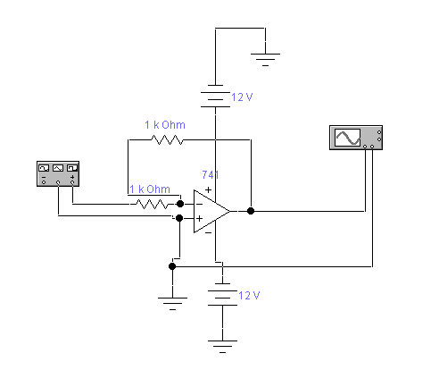

This analysis was done in Electronics Workbench using their 741 op-amp model which is pretty accurate. The circuit shown above has a gain of 1 (the exact gain is not important for this analysis), and is initially being driven by a 1 kHz sine wave of 10 volts peak amplitude. Under these conditions the output sine wave is very well formed and looks sinusoidal as shown below.

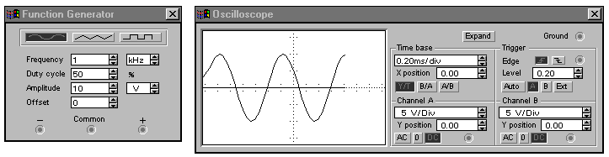

Lets look at what happens when we increase the frequency of the sine wave to about 8 kHz as shown below. The output still appears very sinusoidal.

This still looks fine. So, let’s increase it to 9 kHz.

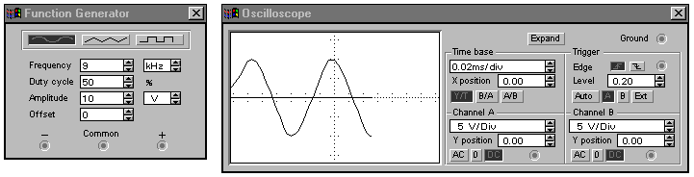

Let’s increase the generator frequency to 10 kHz.

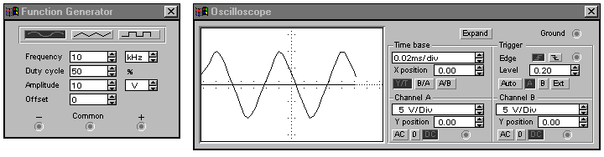
At 10 kHz the output waveform shown above is definitely triangular and is slew rate limited. Let’s go to 12 kHz.

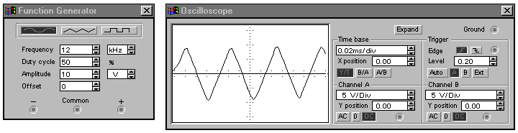

At 12 kHz the wave is very obviously triangular as shown above. Notice also that the amplitude of the output waveform has started to drop a little. This is approximately the frequency you should have measured in the lab.

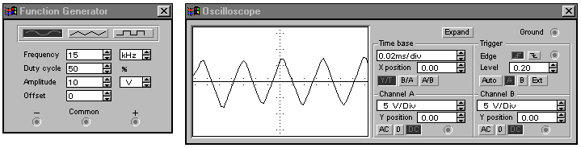
At 15 kHz the drop in the ampltude of the output waveform is very obvious. The relationship between slew rate and the frequency of a sinusoid was discussed in an e-mail. Basically, dv(t)/dt=slew rate and for a sinusoid, d/dt(Acosωt)=Aωsinωt. We can ignore the sinwt and just consider the waveform at its peak amplitude. Skew rate limiting of a sine wave occurs when the op-amp’s slew rate equals Aω for a given sine wave. The published slew rate for the 741 op-amp is about 0.5 volts/microsecond, or 0.5x10^6 volts/sec. The amplitude of the sine wave used in the simulation was 10 volts peak. Let’s solve for the corresponding slew rate frequency.

0.5x10^6=(10 volts)*2*π*f, or f=7958 Hz. This is about the frequency at which we first saw distortion of the sine wave and has a computed slew rate of 0.5 volts/microsecond. The actual amplitude did not noticably drop until about 12 kHz which corresponds to a slew rate of Aω=(10volts)*(2*π*12x10^3)=753,982 volts/second=0.75 volts/microsecond. This is not a bad estimate of the slew rate.

Comments on grading:
Part A:
This part was 30 points total. 2 points per question.
Function Generator
4. The generator will not change the output impedance; instead, it changes how it calculates it so that the programmed voltage will be correct.
Oscilloscope
7. The cursors are not used simply to measure time constant. There are two of them and they can be used to measure voltage and time differences. If you got these points confused or did not know that there were multiple cursors points were taken off.

Part B:
This part was 35 points total.
Most of the data collected seemed to be pretty good. There were some problems with the oscilloscope probe measurements and no points were taken off there. However, many people were off in the slew rate measurements by many orders of m,agnitude. The major problem seemed to be that people were using input voltages that were too small. Since no calculations or procedures were shown on most papers I had no choice but to take off points for data that was completely unreasonable. This part cost many people 1-5 points depending upon how unbelieveable or how undocumented the answer was. Very few points were taken off elsewhere.

Part C:
This part was 35 points total. Each question was 5 points.

