5.14 The classic timer chip: the 555

The next level of sophistication involves the use of timer or waveform-generator ICs as relaxation oscillators. The most popular chip around is the 555 (and its successors). It is also a misunderstood chip, and we intend to set the record straight with the equivalent circuit shown in Figure 5.32. Some of the symbols belong to the digital world (Chapter 8 and following), so you won't become a 555 expert for a while yet. But the operation is simple enough: The output goes HIGH (near VCC) when the 555 receives a TRIGGER' input, and it stays there until the THRESHOLD input is driven, at which time the output goes LOW (near ground) and the DISCHARGE transistor is turned on. The TRIGGER' input is activated by an input level below VCC, and the THRESHOLD is activated by an input level above VCC.

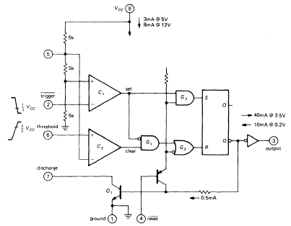
Figure 5.32. Simplified 555 schematic.

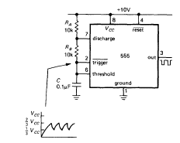
Figure 5.33. The 555 connected as an oscillator.

The easiest way to understand the workings of the 555 is to look at an example (Fig. 5.33). When power is applied, the capacitor is discharged; so the 555 is triggered, causing the output to go HIGH, the discharge transistor Q, to turn off, and the capacitor to begin charging toward 10 volts through RA + RB When it has reached 2/3*VCC, the THRESHOLD input is triggered, causing the output to go LOW and Q1 to turn on, discharging C toward ground through RB- Operation is now cyclic, with C's voltage going between 1/3*VCC and 2/3*VCC, with period T = 0.693(RA+2RB)C. The output you generally use is the square wave at the output.

EXERCISE 5.8
Show that the period is as advertised, independent of supply voltage.

The 555 makes a respectable oscillator, with stability approaching 1%. It can run from a single positive supply of 4.5 to 16 volts, maintaining good frequency stability with supply voltage variations because the thresholds track the supply fluctuations. The 555 can also be used to generate single pulses of arbitrary width, as well as a bunch of other things. It is really a small kit, containing comparators, gates, and flip-flops. It has become a game in the electronics industry to try to think of new uses for the 555. Suffice it to say that many succeed at this new form of entertainment.

A caution about the 555: The 555, along with some other timer chips, generates a big (~ 150mA) supply-current glitch during each output transition. Be sure to use a hefty bypass capacitor near the chip. Even so, the 555 may have a tendency to generate double output transitions.

CMOS 555s

Some of the less desirable properties of the 555 (high supply current, high trigger current, double output transitions, and inability to run with very low supply voltage) have been remedied in a collection of CMOS successors. You can recognize these by the telltale "555" somewhere in the part number. Table 5.3 lists most of these that we could find, along with their important specifications. Note particularly the ability to operate at very low supply voltage (down to 1V!) and the generally low supply current. These chips also can run at higher frequency than the original 555. The CMOS output stages give rail-to-rail swing, at least at low load currents (but note that these chips don't have the output-current muscle of the standard 555). All chips listed are CMOS except for the original 555 and the XR-L555. The latter is intended as a bipolar lowpower 555 and reveals its pedigree by the hefty output sourcing capability and good tempco.

The 555 oscillator of Figure 5.33 generates a rectangular-wave output whose duty cycle (fraction of time the output is HIGH) is always greater than 50%. That is because the timing capacitor is charged through the series pair RA + RB, but discharged (more rapidly) through RB alone. Figure 5.34 shows how to trick the 555 into giving you low duty-cycle positive pulses. The diode/resistor combination charges timing capacitor rapidly via the output, with slower discharge via the internal discharge transistor. You can only play this trick with a CMOS 555, because you need the full positive output swing.

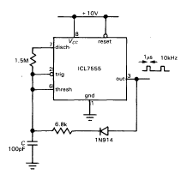
Figure 5.34. Low-duty-cycle oscillator.

By using a current source to charge the timing capacitor, you can make a ramp (or "sawtooth-wave") generator. Figure 5.35 shows how, using a simple pnp current source. The ramp charges to 2/3*VCC, then discharges rapidly (through the 555's npn discharge transistor, pin 7) to VCC, beginning the ramp cycle anew. Note that the ramp waveform appears on the capacitor
terminal and must be buffered with an op-amp since it is at high impedance. In this circuit you could simplify things somewhat by using a JFET "current-regulator diode" (Section 3.06) in place of the pnp current source; however, the performance (ramp linearity) would be slightly degraded, because a JFET operating at IDSS is not as good a current source as the bipolar transistor circuit.

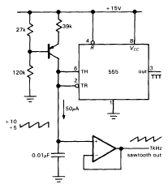
Figure 5.35. Sawtooth oscillator.

Figure 5.36 shows a simple way to generate a triangle wave with a CMOS 5 5 5. Here we wired a pair of JFET current regulators in series to generate a bidirectional current regulator (each current regulator behaves like a normal diode in the reverse direction, owing to gate-drain conduction). The rail-to-rail output swing thus generates a constant current, of alternating polarity, producing a triangle waveform (going between the usual 1/2*VCC and 2/3*VCC) at the capacitor. As before, you have to buffer the high-impedance waveform with an opamp. Note that you must use a CMOS 555, particularly when operating the circuit from +5 volts, since the circuit depends on a full rail-to-rail output swing. For example, the HIGH output of a bipolar 555 is typically 2 diode drops below the positive rail (npn Darlington follower), or +3.8 volts with a 5 volt supply; this leaves only 0.5 volt across the series pair of current regulators at the top of the waveform, obviously insufficient to turn on the current regulator (approximately 1V) and the series JFET diode (0.6V).

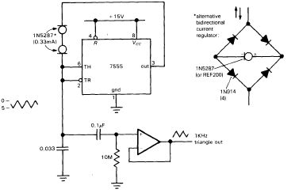
Figure 5.36. Triangle generator.

EXERCISE 5.9

Demonstrate that you understand the circuits of Figures 5.35 and 5.36 by calculating the frequency of oscillation in each case.

IC Relaxation Oscillator: 7555

The 555 and its derivatives have made the design of moderate-frequency oscillators easy. There is seldom any reason to design an oscillator from scratch, using an op amp as we did in the proceeding exercise. The 7555 is an improved 555, made with CMOS. It runs up to 500 kHz (versus 100 kHz for the 555), and its very high input impedances and rail-to-rail output swings can simplify designs.

7555 IC Oscillator (square wave),

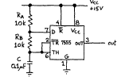
Figure 10-5: 7555 relaxation oscillator: traditional 555 astable

Connect a 7555 in the 555's classic relaxation oscillator configuration, as shown above. Look at the output. Is the frequency correctly predicted by

fosc =1 /(0.7 [RA + 2RB]C)
as derived in Exercise 5.8?

Now look at the waveform on the capacitor. What voltage levels does it run between? Does this make sense?

Now replace RB with a short circuit. What do you expect to see at the capacitor? At the output?

An Alternative Astable Circuit

The 7555 can produce a true 50% duty-cycle square wave, if you invent a scheme that lets it charge and discharge the capacitor through a single resistor. See if you can draw such a design, and then try it. Hint: the old 555 could not do this trick; the 7555 can because of its clean rail-to-rail output swing.

Figure 10.6 7555 relaxation oscillator: an alternative configuration (your design)

When you get your design working, consider the following issues:
In what way does the output waveform of this circuit differ from the output of the traditional 555 astable?
Is the oscillator's period sensitive to loading? See what a 10k resistive load does, for example.

If your design is the same as ours, then the frequency of oscillation should be
fosc = 1/(1.4 RC)
which is the same as for the 'classic' configuration, except that it eliminates the complication of the differing charge and discharge paths.

Does the value fosc that you measure for your design match what you would predict?

Finally, try VCC = +5V with either of your circuits, to see to what extent the output frequency depends on the supply voltage.

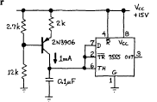
Figure 10.7: 7555 sawtooth oscillator

Generate a sawtooth wave by replacing RA and RB of the first circuit with a current source, as in the figure above (and Additional Exercise 3). Look at the waveform on the capacitor (be sure to use a X10 scope probe). What do you predict the frequency to be? Check it. What should the "output" waveform (pin 3) look like?

