CASE WESTERN RESERVE UNIVERSITY
Case School of Engineering
Department of Electrical Engineering and Computer Science

ENGR 210. Introduction to Circuits and Instruments (4)
Quiz No. 9 11/7/03

Name (Section): _________________________

Put answers in the space provided and show your work
Problem 1 (10 points)
A particular element is tested and found to have i(t) and v(t) as shown here. Identify the type of element and its value.
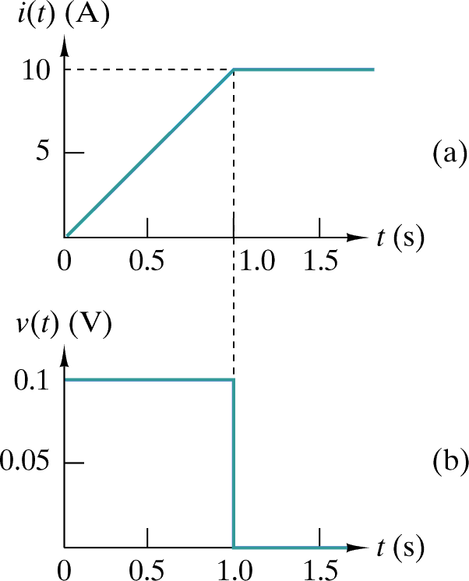
Type = _______________ Value = ______________

A second element is tested and found to have i(t) and v(t) as shown below. Identify the type of element and its value.
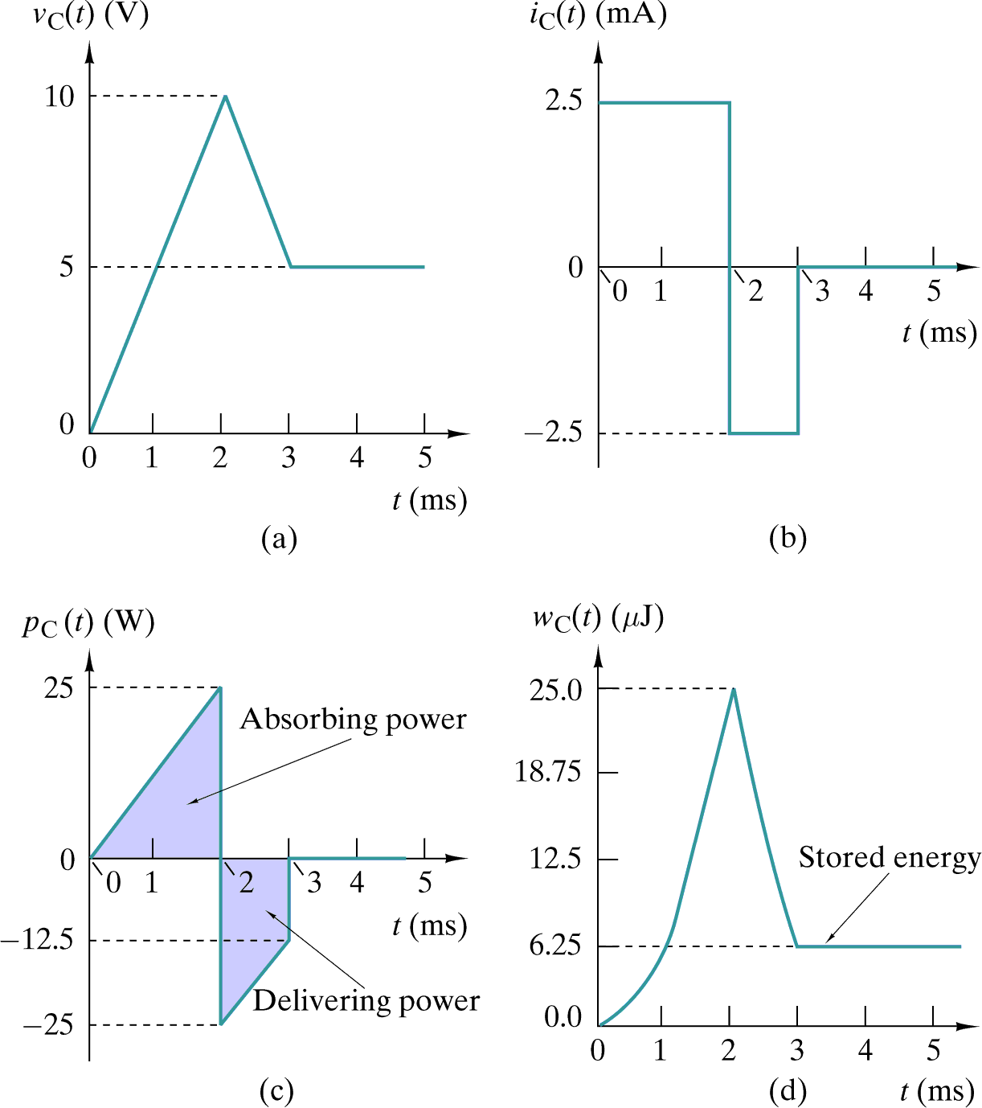
Type = _______________ Value = ______________
Problem 2 (10 points)
Write the expression for v_{O}(t) for each of these circuits.
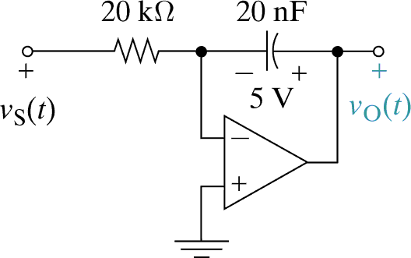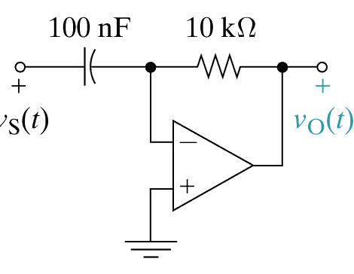

v_{O}(t) = _____________________ v_{O}(t) = _____________________

