CASE WESTERN RESERVE UNIVERSITY
Case School of Engineering
Department of Electrical Engineering and Computer Science

ENGR 210. Introduction to Circuits and Instruments (4)
Quiz No. 4 9/26/03

Name (Section): _________________________

Put answers in the space provided and show your work
Problem 1 (10 points)
Determine the proportionality factors that relate each independent source to the output v_{O}, in terms of R₁ and R₂. Then, given that K₁ ≡ (v_{O}/v_{S}) = 0.25 and K₂ ≡ (v_{O}/i_{S}) = 2 kΩ, calculate the value of v_{O} for specific inputs. Complete the table.
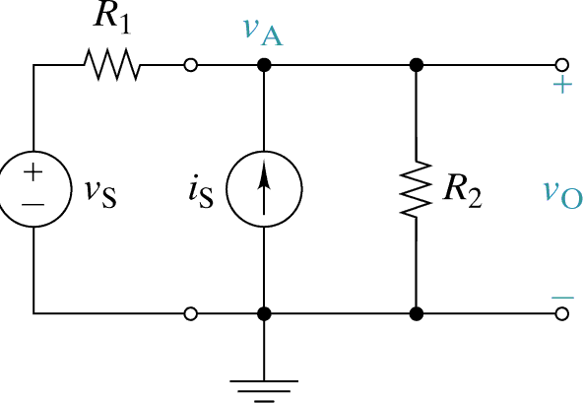

Prop. Factor | Expression
K₁ ≡ (v_{O}/v_{S})
K₂ ≡ (v_{O}/i_{S})

v_{S} | i_{S} | Output for K₁ = .25, K₂ = 2 kΩ
0 V | 1 mA
1 V | 0 mA
1 V | 1 mA
Problem 2 (10 points)
Find the Thevenin and Norton equivalent circuit parameters for the interface A-B in this circuit. Complete the table.
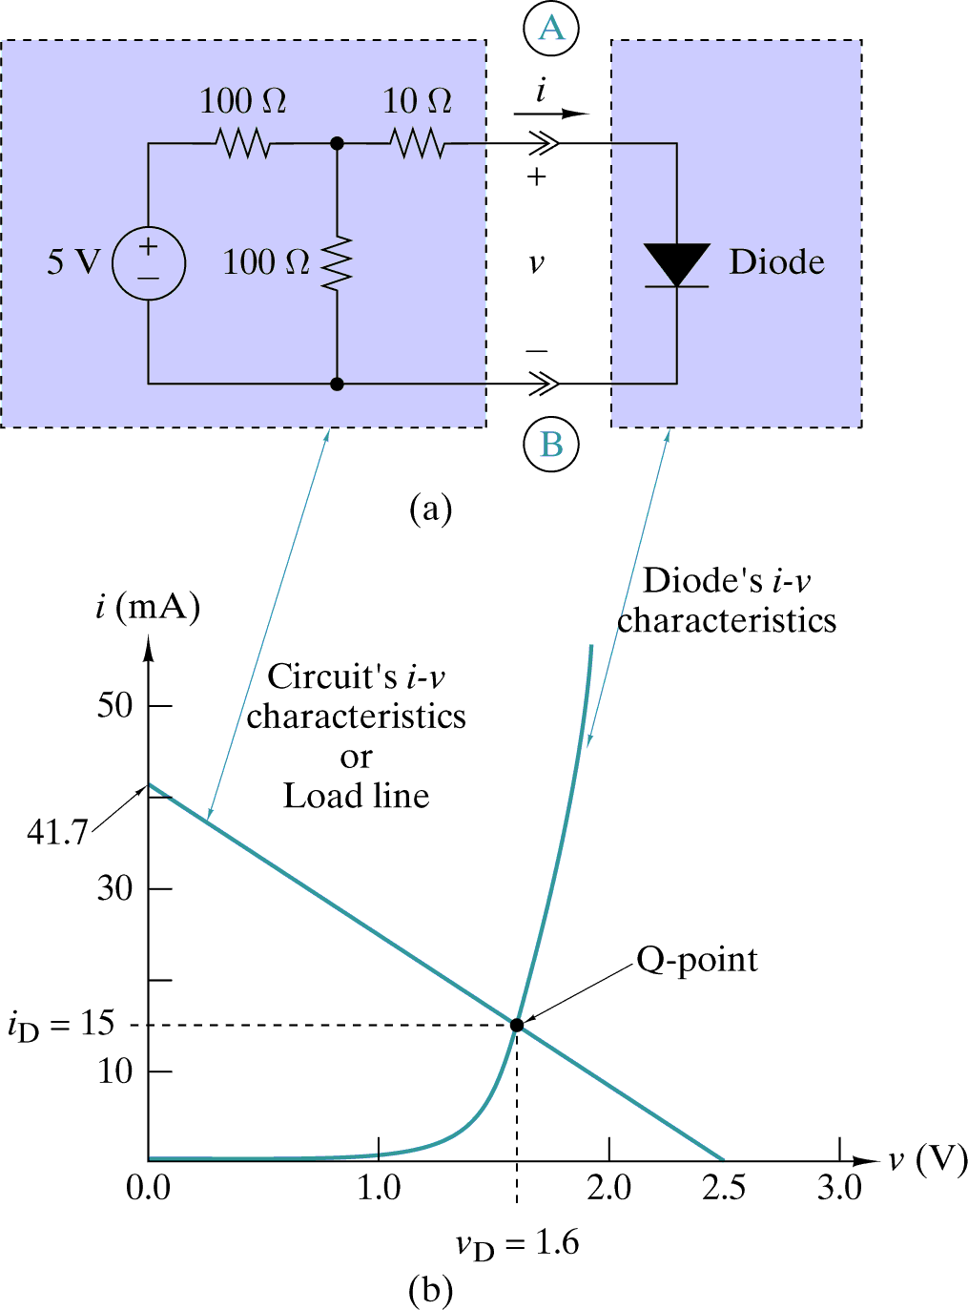

Element | Value
v_{T}
R_{T}
i_{N}
R_{N}

