CASE WESTERN RESERVE UNIVERSITY
Case School of Engineering
Department of Electrical Engineering and Computer Science

ENGR 210. Introduction to Circuits and Instruments (4)
Quiz No. 12 12/5/03

Name (Section): _________________________

Put answers in the space provided and show your work
Problem 1 (10 points)
Find the impedance of each element in this circuit for operation in sinusoidal steady state at an angular frequency ω = 4000 rad/sec, then find the total impedance of the circuit seen by v_{S}(t) at this frequency. Finally, find the phasor current I given V_{S} = 7.5 ∠ 0°. Numerical values are required. Complete the table.
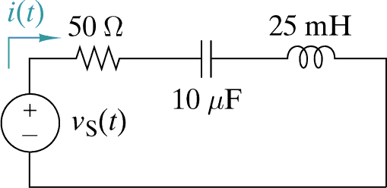
75 Ω

Quantity | value
Resistor Impedance, Z_{R}
Capacitor Impedance, Z_{C}
Inductor Impedance, Z_{L}
Circuit Impedance, Z_{EQ}
Phasor Current, I
Problem 2 (10 points)
Consider this passive filter in which the input voltage is applied across the left-hand interface and the output voltage is taken from the right-hand interface. Determine the filter type (low-pass, high-pass, band-pass, or band-stop), its passband gain, and its cutoff frequency. Numerical answers are required. Complete the table.
Hint: a capacitor acts as an open circuit for dc and a short circuit for very high frequencies. The input interface is considered to be a short circuit when calculating the Thevenin resistance seen by the capacitor.
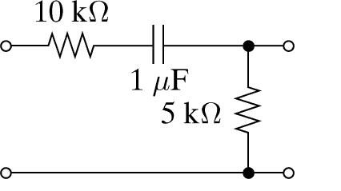

Quantity | value
Filter type
Cutoff frequency, ω_{C}
Passbnad gain

