CASE WESTERN RESERVE UNIVERSITY
Case School of Engineering
Department of Electrical Engineering and Computer Science

ENGR 210. Introduction to Circuits and Instruments (4)
Quiz No. 11 11/21/03

Name (Section): _________________________

Put answers in the space provided and show your work
Problem 1 (10 points)
In the circuit shown here, the switch has been in position A for a long time, and is set to position B at t = 0. Find the initial and final values of the state variable i_{L}, the time constant T_{C}, and write the expression for i_{L}(t) for t > 0. Numerical values are required. Complete the table.
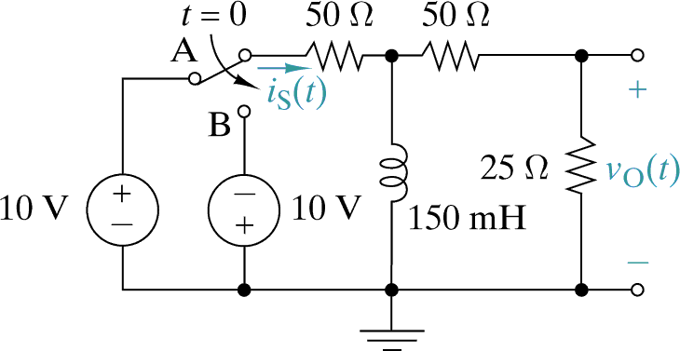
i_{L}(t)

Variable | value / Expression
Initial value i_{L}(t = 0)
Final value i_{L}(t → ∞)
Time constant T_{C}, for t > 0
Inductor current i_{L}(t), t > 0
Problem 2 (10 points)
Write the following phasors as sinusoidal waveforms, i.e. in the form A cos(ωt + φ). Numerical values are required for A, ω, and φ. Complete the table.

Phasor | cos()
20 + j20, ω = 500 rad/sec
10 √2 ∠-45°, ω = 500 rad/sec

