CASE WESTERN RESERVE UNIVERSITY
Case School of Engineering
Department of Electrical Engineering and Computer Science

ENGR 210. Introduction to Circuits and Instruments (4)
Quiz No. 10 11/14/03

Name (Section): _________________________

Put answers in the space provided and show your work
Problem 1 (10 points)
Find the time constant for each of these circuits.

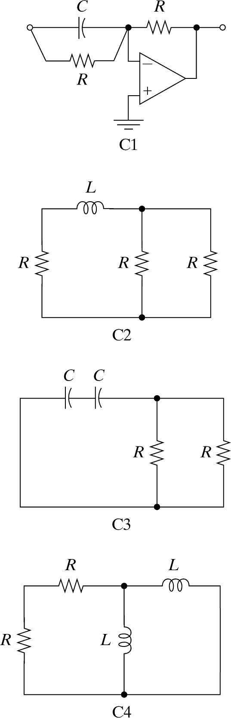

T_{C} = ____________________________

T_{C} = ____________________________

T_{C} = ____________________________

Problem 2 (10 points)
A step input of 1 V (Thevenin value) is applied to a circuit having a time constant of 2 msec. The state variable (a capacitor voltage) has an initial value of 4 V. The capacitor value is 5 μF. Write the expression for the capacitor voltage AND capacitor current for t > 0. Use NUMERICAL values.

v_{C}(t) = ____________________________________

i_{C}(t) = ____________________________________

