ENGR 210 Lab 9
Data Converters

In this lab you will investigate the operation and quantization effects of an A/D and D/A converter.
A. BACKGROUND
1. LED Displays
We have been using LEDs as indicators in some homework solutions. Two ways to use LEDs as indicators are shown in Figure 1. Note that these circuits do not work with all logic families — many times the logic gates cannot supply the current that the LED needs. In those cases you have to use an external transistor to supply extra current. The technique of using an external transistor can also be used to operate relays and lights from a logic gate. Although only an inverter is shown in Figure 1 you can use any logic gate which has the necessary current output. The actual current is dependent upon the particular LED used. If we assume a current of 10 mA and a typical voltage across the LED of about 1.7 volts, we can calculate R=(5-1.7)/0.01 mA = 3.3/0.1=330Ω. Using resistors in Figure 1 that are much smaller than this value can burn out the output of the integrated circuit. Larger values are better but will dim the LED.

(a) Using TTL output as a current sink. | (b) Using TTL output as a current source
Figure 1. LED driver circuits

2. Analog to Digital (A/D) and Digital to Analog (D/A) conversion
Data that is obtained from a physical system is generally in analog form, i.e., it varies in time and can have any level between some maximum and minimum value. In order to do computer-based processing of that data it is necessary to first convert the information from analog to digital form. This is done by quantizing, or subdividing, the voltage range into a number of finite-size steps. The number of steps is usually 2^{n}-1, where n is the number of bits available for the binary word that will represent the analog voltage. An example of this quantization is shown in Figure 2 where n=3 has been chosen. As can be seen by comparing the two columns at the right of the figure, there is always some error introduced in the conversion since no matter how many bits are chosen, there is always a step between levels.
Figure 2. Three bit A/D quantization effect.
There are various approaches to the implementation of an A/D converter. One of these makes use of a set of comparators whose inputs are referenced to the quantized voltage levels. This is the fastest type of A/D converter available and is often called a “flash" converter. To demonstrate the quantization effect we will build various parts of an A/D and D/A converter. (A full converter is a bit complicated to build and test in one lab period.) The fabricated circuit consists, in part, of an 8-bit, comparator-based flash A/D converter as shown in Figure 4. The output of the converter is an 8-bit code that is converted into a 3-bit binary code using the circuit of Figure 5. The output of this code converter is connected to the input of an op amp-based D/A converter (see ) whose output can, in turn, be displayed on a scope or a DMM.
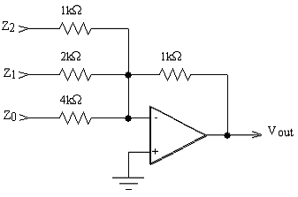

Figure 3. 3-bit D/A converter

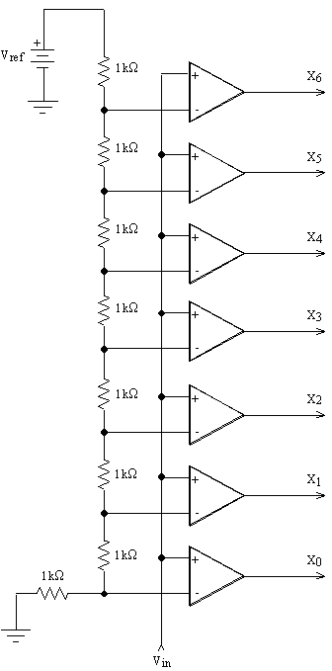
Figure 4. Flash A/D converter

Figure 5. 8-to-3 bit code converter
There are many other approaches to converting analog numbers to digital representations.
- You have actually already seen one other type of A/D converter in the 555 timer lab — a 555 timer can be used as a V/F converter where an analog voltage controls the frequency of a 555 timer. A computer is then used to count the number of output pulses over a fixed period of time — the count is a digital representation of the analog input quantity.
- Another common type of A/D converter uses an input voltage to charge up a capacitor. The time that it takes to discharge this voltage is timed by a computer or a digital counter. This is the type most often found in digital instruments such as a DMM and, depending upon the exact details of the implementation, is called a single or dual slope integrating A/D.
- Yet another common A/D called the successive approximation A/D uses a computer to generate a digital code which is sent to a D/A converter. This digitally generated voltage is compared to the input voltage with a comparator. If the input voltage is higher than the generated voltage the code number is increased, if the input voltage is less than the generated voltage the code number is decreased. The computer typically uses a binary search technique to rapidly find the largest code number which will generate the largest voltage less than or equal to the input voltage.
The difference between these converters lies in the details of how they work. The so-called “flash” A/D converter is the fastest. The dual slope integrating A/D converter is among the most accurate (especially using inexpensive components) and is among the slowest. The V/F converter is often the cheapest and is found in systems that use a microprocessor, such as computer controlled appliances.
B. LAB INSTRUCTIONS
Part 1: More logic circuits
- You will use a single 7402 logic gate to determine the actual LOW and HIGH logic levels of a logic gate. Select a single gate from the 7402. Tie its two inputs together. Connect these inputs to one of the positive-voltage outputs of your power supply using a 300Ω resistor — the exact value is not critical and you could use 330Ω, etc. (Note that the other positive-voltage supply output will be needed to provide a fixed +5 volts to the Vcc of the 7402 chip.) Make sure the adjustable power supply connected to these inputs is set to zero volts. Measure the output of your selected gate with a DMM. It should be near +5 volts if the input is zero. Remember that you have it connected essentially as an inverter. Now slowly increase the adjustable power supply voltage while monitoring the output of the selected gate with a DMM. Record the voltage at which the output goes low in Data Table 1.
Figure 6. A 7402 IC contains 4 2-input NOR gates.
- Repeat Step 1 except now start the input voltage at +5 volts and decrease the input voltage. Since the input is initially HIGH the output should be LOW. At some value of the input voltage, the output will change significantly. Record this voltage in Data Table 1.
- Add a resistor and diode to the output of your 7402 gate as shown in Figure 1(a). Use a value for R of 330Ω. Use the variable power supply to vary the input voltage to the 7402 gate between 0 and +5 volts. Does the LED function to indicate the output state of the gate? Measure the voltage drop across the LED and the resistor when the diode is on. Compute the current through the diode. Record these measurements in Data Table 2.
- Using the gates on a 7402, build the circuit shown in Figure 7.
Figure 7. R-S Flip-flop
Determine the truth table for this circuit and record your measurements in Data Table 3. This is actually a R-S flip flop and can have very perplexing behavior. Unlike combinational logic it works based upon the two inputs (R and S) AND the current (called the previous) output. To help you understand this circuit the theoretical behavior of an R-S flip-flop is shown in Figure 8. Notice that the new output (Q_{n+1}) is described in terms of R, S and the previous value of Q (called Q_{n}). DO NOT CONFUSE Q_{n+1} with the Q* shown in Figure 7 — Q_{n+1} is the NEXT state (value) of the Q output of Figure 7, after the inputs are applied. The actual operation of the R-S flip-flop can be more easily understood by a simple explanation. The R (also called the RESET) will always reset the Q output to zero (LOW) regardless of the previous state of the output. The S (also called the SET) will always set the Q output to one (HIGH) regardless of the previous state of the output. There will be no change in the Q output if both R and S inputs are zero (LOW). However, there is a problem if both R and S inputs are one (HIGH). Technically, you are trying to SET and RESET the output at the same time. As a result the output can be random and, consequently, undefined. In general, the Q* output of Figure 7 should behave as the NOT of Q and does not need to be separately explained.
S | R | Q_{n} (previous state) | Q_{n+1} (new state)
0 | 0 | 0 | 0
0 | 0 | 1 | 1
0 | 1 | 0 | 0
0 | 1 | 1 | 0
1 | 0 | 0 | 1
1 | 0 | 1 | 1
1 | 1 | 0 | undefined
1 | 1 | 1 | undefined
Figure 8. Theoretical operation of R-S Flip-flop

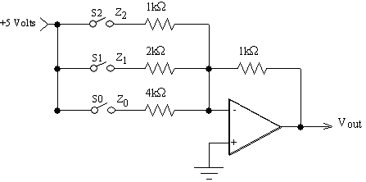
Figure 9. 3-bit digital to analog converter
Part 2: Digital to Analog conversion
- Build the 3-bit digital to analog converter circuit shown in . Use a DIP switch block for the switches S₂-S₀, and don’t forget to supply +Vcc (+15 Volts) and –Vcc +-(-15Volts) (not +5V and GND) to the 741 op-amp. The pinout diagram for the 741 op-amp is shown in Figure 10.
- Use switches S₂-S₀ to deliver logical 0 or 1 values to the digital inputs Z₂-Z₀ of the D/A converter; in this case, an “off” switch (open-circuit connection) is equivalent to a logical 0 at that input, and an “on” switch is equivalent to a logical 1. For all possible combinations of input logical values, measure and record the voltage at Vout in Data Table 4.
Figure 10. Pinout diagram of a 741 op-amp
DATA AND REPORT SHEETS FOR LAB 9

Student Name (Print): Student ID:
Student Signature: Date:
Student Name (Print): Student ID:
Student Signature: Date:
Student Name (Print): Student ID:
Student Signature: Date:
Lab Group:

Data Table 1. Voltage at which digital logic switches
 | Input voltage at which output switches | Initial Measured V_{out} | Measured V_{out} after switch
Increasing V_{in} from 0 volts
Decreasing V_{in} from +5 volts

Data Table 2. LED indicator characteristics (for LED illuminated)
 | Measured | Calculated
Voltage across R
Voltage across LED
Current through LED

Data Table 3. Truth table for R-S flip-flop
R | S | Q_{n} | Q_{n+1}
0 | 1
0 | 0
1 | 0
1 | 1

Data Table 4. D/A Converter Characteristics
Z₂ | Z₁ | Z₀ | V_{OUT}
0 | 0 | 0

Questions
- What do the outputs from the flash A/D in Figure 4 represent? HINT: Can the A/D converter generate an output code X₆X₅X₄X₃X₂X₁X₀=0001000?
- Explain how the digital logic in Figure 5 converts the A/D converter outputs X₆X₅X₄X₃X₂X₁X₀ in Figure 4 into the three-bit code Z₂Z₁Z₀ used by the D/A converter.
- What range of voltage does each level of the input code Z₂Z₁Z₀ to the D/A converter represent?
- Explain why an open-circuit input to the D/A converter is equivalent to a logical zero at that input. HINT: what is the voltage at V-?
- Suppose you wanted to redesign the A/D converter so that each input step corresponded to exactly 0.5 volts. An easy way to do this is to change the value of Vref. What should this new value of Vref be? Be sure to include your calculations.
- The buffer labeled U1 is required for the circuit in Figure 5 to work properly. Why?

