ENGR 210 Lab 7
Exponential Waveforms

Purpose: To measure the step response of circuits containing dynamic elements such as capacitors.

Equipment Required:
• 1 - HP 54xxx Oscilloscope
• 1 - HP 33120A Function Generator
• 1 - Protoboard
• 1 - Capacitance Meter (This is available in the lab near the resistor cabinet)
• 1 - 0.1-µF capacitor
• 1 - 1.1-k Ω resistor
• 1 - 0.22-µF capacitor

A. Prelab:
1. Reading
Read Sections 6-1, 6-4, and 7-1 to 7-3 in the text. *
Figure 1. Driven RC Circuit
2. Background
The equation describing the output v_{C}(t) of the circuit of Figure 1 is of the form:
$v_{C}\left(t\right)=\left(\text{IC}−\text{FC}\right)e^{−\frac{t}{T_{C}}}+\text{FC}$ (1)
where IC is the initial value (initial condition) of the voltage, FC is the final value (final condition) of the voltage, and T_{C} is the circuit time constant. Assume the function generator produces a square wave with a peak-to-peak voltage of 8 V, no DC offset (V_{avg} = 0V), and a period T_{O} greater than 10T_{C} . Under these circumstances the initial condition IC and the final condition FC will be equal to the maximum and minimum voltages of the source. In this case, the assignment of +4 V or –4 V to the initial condition IC depends on whether the charging cycle or the discharging cycle is being observed, as shown in Figure 2. For the discharging cycle the initial condition IC = +4 V and the final condition FC = -4 V. The opposite is true for the charging cycle, IC = -4 V and FC = +4 V.
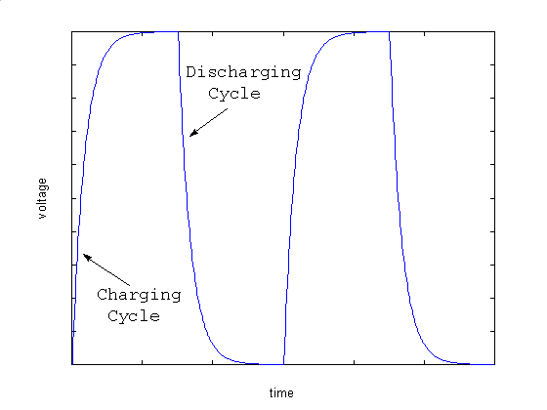
Figure 2. RC Charge/Discharge Cycle

B. Lab Procedure:
Determine the output resistance of the laboratory function generator, R_{TH} . This value can be determined from the HP instrument specifications available on the manufacturer’s web page (note that HP spun off their Test and Measure unit as Agilent). If you cannot find this data you may assume it is 50Ω but should state that assumption in Data Table 1. Record R_{TH} and your data source in Data Table 1. The Thévenin equivalent model of the function generator is shown in Figure 1.

1. Build the circuit shown in Figure 1 on your protoboard. Before constructing the circuit measure and record the EXACT value of your resistor and capacitor. Use a DMM to measure the value of your resistor. Record this value in Data Table 2. Use the digital capacitance meter, available in the lab near the resistor drawers, to measure the capacitance of the capacitor you use in your circuit. Also record this value in Data Table 2.

2. Function generator
Set the function generator to produce a square wave, with a frequency of 50 Hz, no DC offset and a peak-to-peak voltage of 8 V. Be sure that the output of the function generator is set to high impedance when you set the output of the function generator.

3. Oscilloscope
- Set the oscilloscope to display the waveform v_{c}(t) produced by this circuit. The display should be similar to a square wave but with slightly rounded edges as shown in Figure 3.

Figure 3. Oscilloscope display of RC response to square wave.
b. Adjust the scope’s horizontal and vertical position knobs and the trigger slope and level so that the waveform is completely visible, but fills the scope face. Line up the start of the exponential waveform with the vertical grid line on the left edge of the scope face. Set the horizontal scale (time base) so the trace looks something like Figure 4. It is not necessary that you be able to see 5 time constants; but it is good practice to expand the display so that at least 50% of the scope face is used for measurements (as shown in Figure 4).
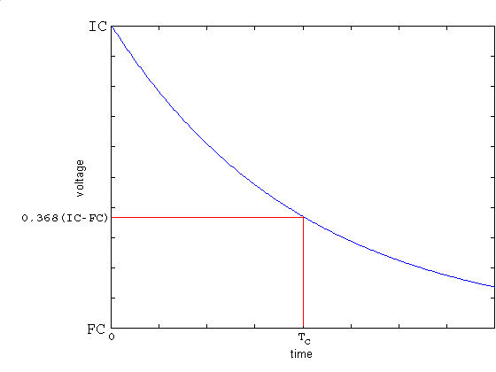
Figure 4. Oscilloscope display of exponential decay waveform
- Method 1 of MEASURING the time constant T_{C} — definition: This method uses no calculations and uses the definition of the time constant to measure it. Begin by adjusting the voltage cursor V1 to 0.368 of the voltage difference (FC-IC). Set the first time cursor t1 to the beginning of the decay, i.e. the initial value of the waveform at the left side of the display. Then adjust the second time cursor t2 to correspond to where the V1 cursor and the decaying waveform intersect. The value of ∆t displayed on the scope screen is the time constant T_{C}. Record this value in Data Table 3.

- Method 2 of MEASURING the time constant T_{C} — curve fitting: Use Benchlink Scope as described in Appendix 1 to make a printout or bitmap file of the oscilloscope display. This display will be analyzed as part of your lab writeup. Because you will use this display to determine T_{C} it is very important that you adjust the voltage sensitivity to get a display similar to that shown in Figure 4. You can use the oscilloscope's vertical positioning adjustment to accurately place the waveform's start at the left top of the screen.

3. Charging cycle
Set up the scope to display the charge cycle, i.e. the part of the waveform when the voltage is increasing. Determine T_{C} from this waveform using the cursors. Remember that the ∆t measured by the oscilloscope MUST correspond to the period in which the vertical voltage increases to 0.632 of its final value. Record this value of ∆t in . Use Benchlink to make a printout of this oscilloscope waveform.

4. Capacitors in series and parallel
For these measurements you can use either a charge or discharge cycle.
a. Obtain a 0.22µF capacitor. Measure its actual value using the capacitance meter. Put the 0.22µF capacitor in parallel with the 0.1µF in your circuit. Calculate and record the value of the parallel combination of these capacitors as C_{eff}. (Hint: for parallel capacitances, C_{eff} = C₁ + C₂ + C₃ +…). Using the cursor based method, measure the new T_{C} caused by this combination of capacitors. Record this value of T_{C} in Data Table 5. Use Benchlink to record the waveform you used to make your measurements.
b. Place the 0.22µF and 0.1µF capacitors in series. Calculate and record the value of the series combination of these capacitors as C_{eff}. (Hint: for series capacitances, 1/C_{eff} = 1/C₁ + 1/C₂ + 1/C₃ +…). Using the scope cursors determine the value of T_{C} and record it in Data Table 5. Use Benchlink to record the waveform you used to make your measurements.
DATA AND REPORT SHEET FOR LAB 7

Student Name (Print): Student ID:
Student Signature: Date:
Student Name (Print): Student ID:
Student Signature: Date:
Student Name (Print): Student ID:
Student Signature: Date:
Lab Group:

Data Table 1. Function Generator Characteristics
Generator Impedance: ______________Ω
Source of Information: _______________________________________
_____________________________________________________________
Data Table 2. Actual value of circuit components
Measured value
R
C
Data Table 3. Cursor Measurements (Discharge cycle)
Measured T_{C} [∆t from the oscilloscope] ___________________milliseconds

Data Table 4. Cursor Measurements (Charging cycle)
Measured T_{C} [∆t from the oscilloscope] ___________________milliseconds

Data Table 5. Parallel C_{eff} measurement
0.22µF measured value: | Measured T_{C} [∆t from the oscilloscope]
Parallel C_{eff}: | milliseconds
Series C_{eff}: | milliseconds

Data analysis:

- Include the Benchlink® Scope prinout of your actual circuit performance from part 3(d).

- From your Benchlink® Scope printout in part 2, estimate the actual T_{C} of the circuit by the following two methods. Show all calculations as well as any measured points on your plot and their time/voltage coordinates.

- Determine (IC - FC) from your first printout. This value of (IC -FC) should be the peak-to-peak voltage of the source and should be near 8 V. Locate the voltage 0.368*(8 V) = 2.94 V from FC on your printout. This should typically be about one third of the way up from the bottom of the oscilloscope display (as shown in Figure 4). This voltage level is significant because one time constant has elapsed when the exponential has decayed to 36.8% of the difference between the initial voltage and the final voltage. Determine this time T_{C} from your plot.
- Equation 1 can be used to solve for the time constant T_{C} by measuring the voltage and time coordinates of the waveform at two points, as shown in Figure 5.
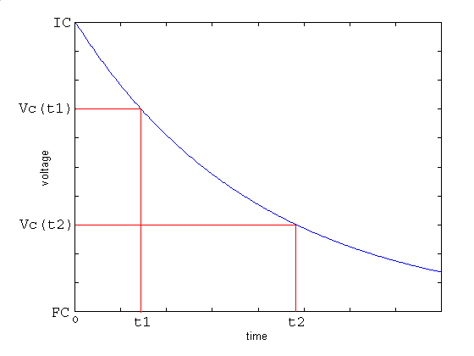
Figure 5. Measuring T_{C} by curve fitting to two points
- Moving the last term in Equation 1 to the left of the equal sign and dividing these two measurements gives
$\frac{v_{C}\left(t_{1}\right)−\text{FC}}{v_{C}\left(t_{2}\right)−\text{FC}}=\frac{\left(\text{IC}−\text{FC}\right)e^{−\frac{t_{1}}{T_{C}}}}{\left(\text{IC}−\text{FC}\right)e^{−\frac{t_{2}}{T_{C}}}}=e^{\frac{t_{2}−t_{1}}{T_{C}}}$ (2)
Solving for the time constant T_{C} is accomplished by taking the natural logarithm of both sides and rearranging to produce:
$T_{C}=\frac{t_{2}−t_{1}}{\text{ln}\left(\frac{v_{C}\left(t_{1}\right)−\text{FC}}{v_{C}\left(t_{2}\right)−\text{FC}}\right)}$ (3)
Solve for the time constant T_{C} using Equation (3).

- In the textbook, we have seen that the time constant is given by the equation T_{C} = RC. Use this equation, either value of T_{C} computed in Question 2, and the actual value of your resistor plus the actual output resistance of the function generator to compute the capacitance, C. Compute the percentage error between the capacitance value you computed and the capacitance measured with the capacitance meter. The nominal capacitance value is 0.1µF ±20%.

- Include your Benchlink waveform from Part 3.

- Include your Benchlink waveforms from Part 4.

Questions:
1. Does your value for T_{C} in Data Table 5 agree with the formula for capacitors in parallel? Show why or why not.

2. Does your value for T_{C} in Data Table 5 agree with the formula for capacitors in series? Show why or why not.

3. Which method of computing the time constant (See Data Analysis, 2(a) and 2(b), or the cursor method) do you feel is the more accurate? What are the sources of error?

4. How did your calculation of C from the measured time constant (See Data Analysis, 4) compare with the value measured with the capacitance meter?

5. Are the measured time constants for the discharge (Data Table 3) and the charge (Data Table 4) cycles the same?

*Reference: Roland E. Thomas and Albert J. Rosa, The Analysis and Design of Linear Circuits, 3rd Ed., Prentice Hall, (New Jersey, 2001)

Appendix 1
Using Benchlink® Scope to print HP scope waveforms

The Benchlink® Scope software uses the HPIB board inside the PC to read the image that the oscilloscope displays on its screen. This picture file is then displayed on the PC and can be copied, printed and saved as a bit map for use in any program. This software only works with HP 54xxx series scopes like we have in the laboratory.

To use Benchlink® Scope software to capture a waveform:
- On the PC, from the All Programs menu, go to Benchlink® suite under “Courseware” and choose the Benchlink® Scope program.
- As Benchlink® opens up it will search for the oscilloscope and (if successful) will display the window shown below:
If the program brings up an error window claiming that it can’t find the device, command the program to search on “National Inst. GPIB,” then click “OK.”
- If you get an error message make sure that the scope is turned on.
- Next, click on the Image menu and choose New....

- Click OK on the dialog box when you are ready to capture the scope image.
- The oscilloscope image is then displayed on the screen as a bitmap. Press F7 to update this image as often as you wish. You can Print or Copy this image or save it as a file.

