Project #4 Affine transformations
Due Thursday October 4th.

A. Euclidian warping

Background:
Many images are related to each other by simple geometric transformations of the form where
(1)
Equation (1) describes scaling by s, rotation by , and translation by (t_{x},t_{y}). Consider re-writing X as
(2)
If the re-written X contains all the image points we can warp the entire image in one operation. This describes a forward mapping of the entire image. Since you usually want to do a backwards mapping invert the transform to get which is now a backwards of the entire image. I leave it as an exercise for you to determine T⁻¹ and complete the implementation of this equation.

Suppose we have a corresponding point pair [x’,y’] and [x,y] and the transformation described by s, , t_{x},t_{y} is unknown. We can re-arrange the transformation just as for the polynomial warp to give
(3)
which can be easily solved for the transformation parameters.

Find the geometric transformation parameters which relate image (b) to image (a) and construct a larger image which displays the complete street scene. This is an example of constructing a photomosaic.

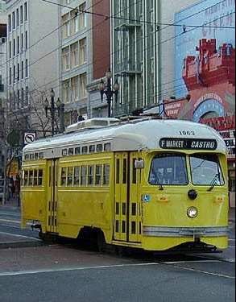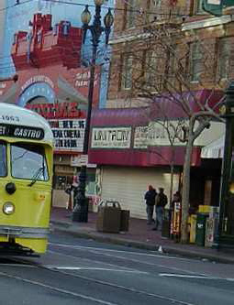
(a) (b)

B. Single Camera calibration

Although these images are in color, all that matters is the location of various colored objects in the image. This can be obtained using ginput or a variety of other methods.

Scott took these measurements in the first floor robotics lab. A computer interfaced camera is positioned 36 inches in front of a cabinet and is initially facing the cabinet perpendicularly.

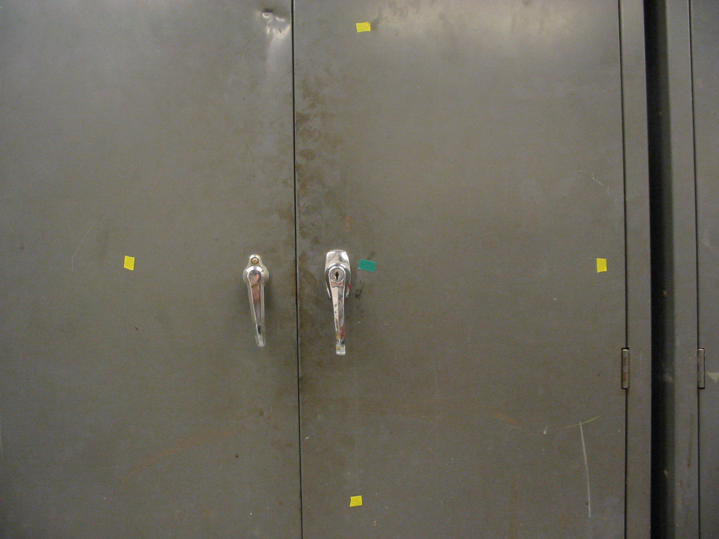
Figure 0: A piece of green tape is placed directly in front of the camera. Assume this is (0,0,0) in world coordinates. The cabinet front is the z=0 plane. The x-axis is assumed to be horizontal and the y-axis vertical forming a right-handed coordinate system. Yellow tape markers are placed at (12,0,0), (0,12,0), (-12,0,0) and (0,-12,0). All coordinates are in inches.

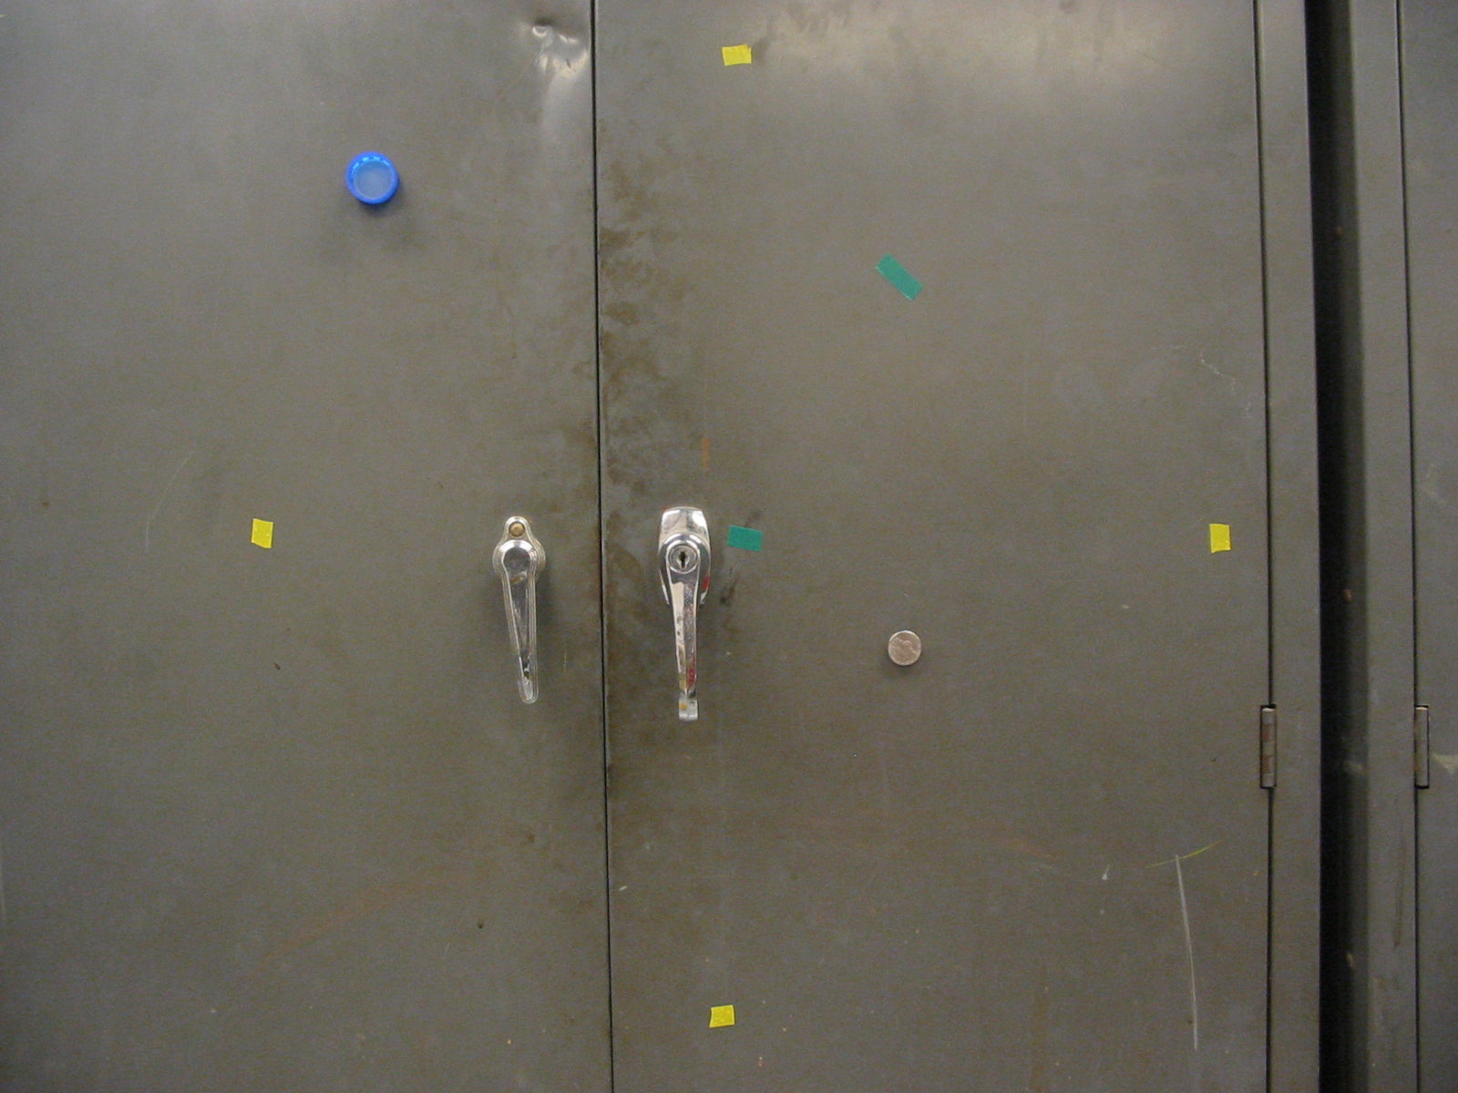
Figure 2: A nickel, a bottle cap, and another piece of green tape are placed on the z=0 plane as shown below. What are the world coordinates of the nickel, bottlecap, and green tape?

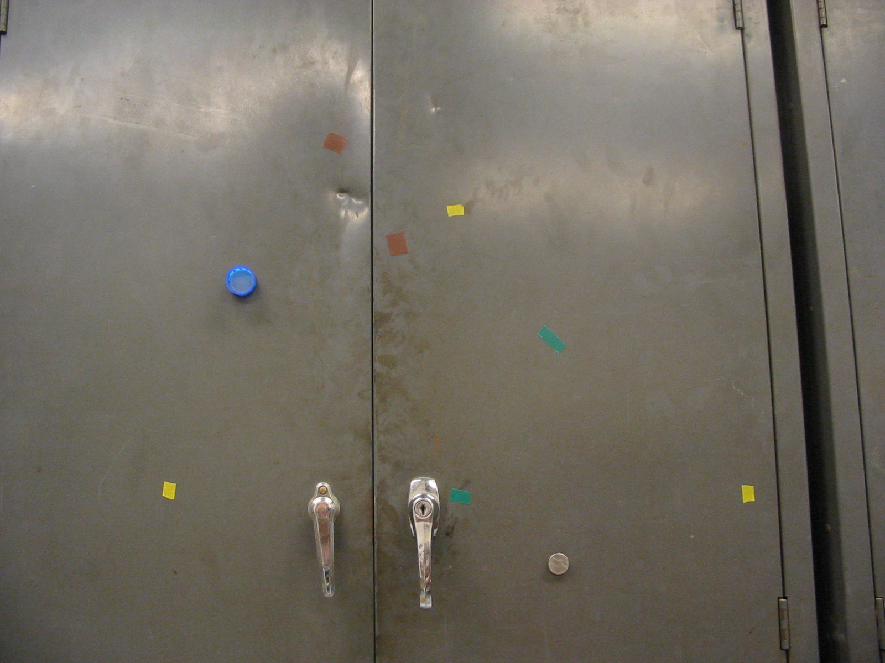
Figure 4: Two pieces of brown tape are added to the cabinet. Scott rotates the camera 10 degrees up giving the above picture. What are the world coordinates of the two pieces of brown tape?

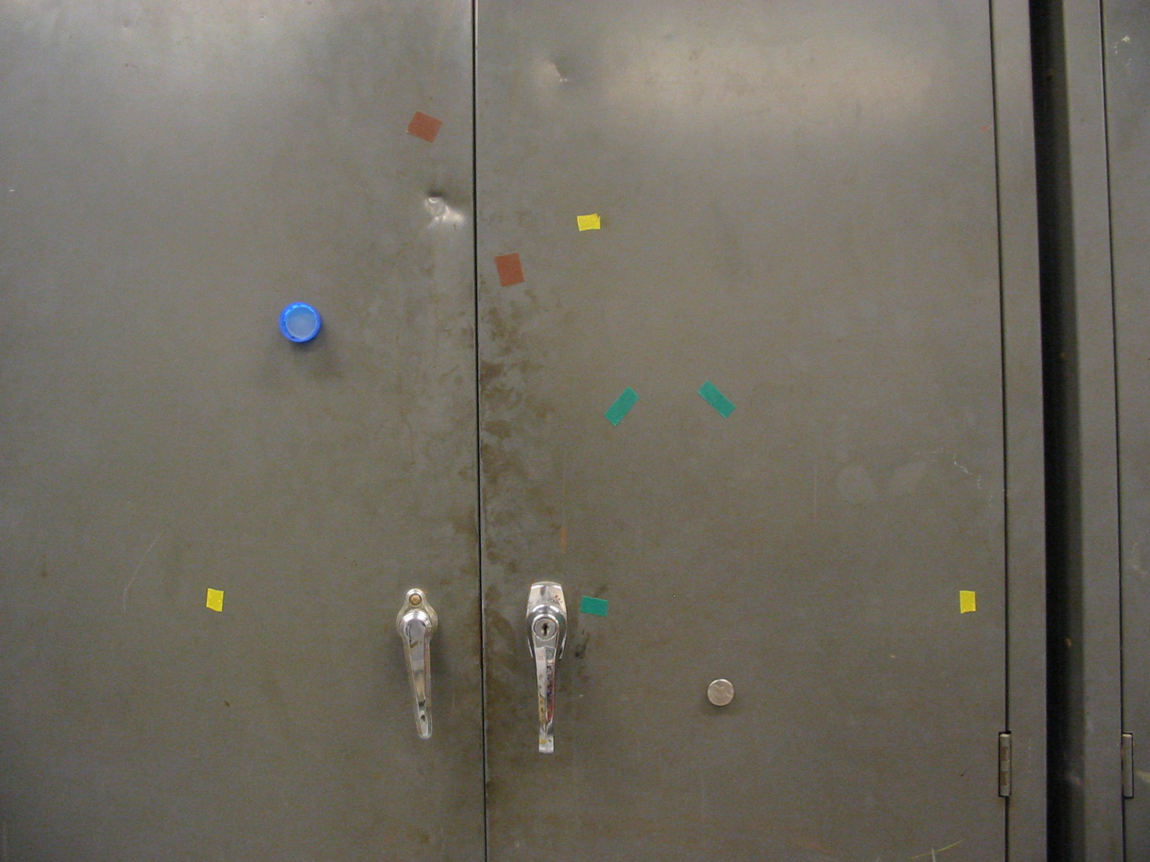
Figure 6: Scott returns the camera angle to zero. He then raises the camera’s height from (0,0,36) to (0,4.75,36), i.e., he lifts it an additional 4.75 inches above the floor. What are the world coordinates of the new piece of green tape above the nickel?

