Project #3 Image Warping
Due Thursday September 28th.

Background:
Mobile robots traveling in urban environments may need to use multiple cameras which are physically separate from one another, cameras which take pictures as the vehicle is traveling (different space or time coordinates), or using complex image optics.

In this assignment we will consider two applications of polynomial image warping. In the next assignment we will similar applications using rigid body and perspective transformations.

A. Warping (registering) two street scenes to each other.
This is best done using some form of two-dimensional warping. Remember that you must transform both the geometry and the gray scene. A key issue is that you must determine the corresponding control points. Easy to identify points such as corners of objects are best to use for this purpose.

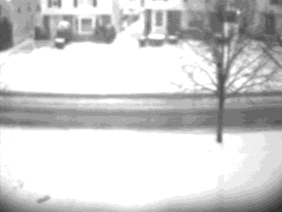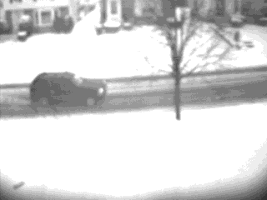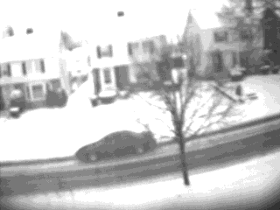
Figure 1 Figure 2 Figure 3

IMAGE INFORMATION: The images were taken using a Connectix B/W QuickCam (240x320) pixel resolution which I deliberately moved between exposures.

Your task is to compute (Figure 2 – Figure 1) and (Figure 3 – Figure 1) to get only a picture of the cars in Figures 2 and 3. To do this you must register the images and then perform image subtraction. Don’t be surprised if the images don’t look too good.

B. Image Rectification.
We are considering using a convex mirror to allow a camera mounted on the vehicle to obtain a very wide field of view.

Imagine that a mobile robot very close to the floor using a camera with a convex mirror sees the distorted picture shown below.

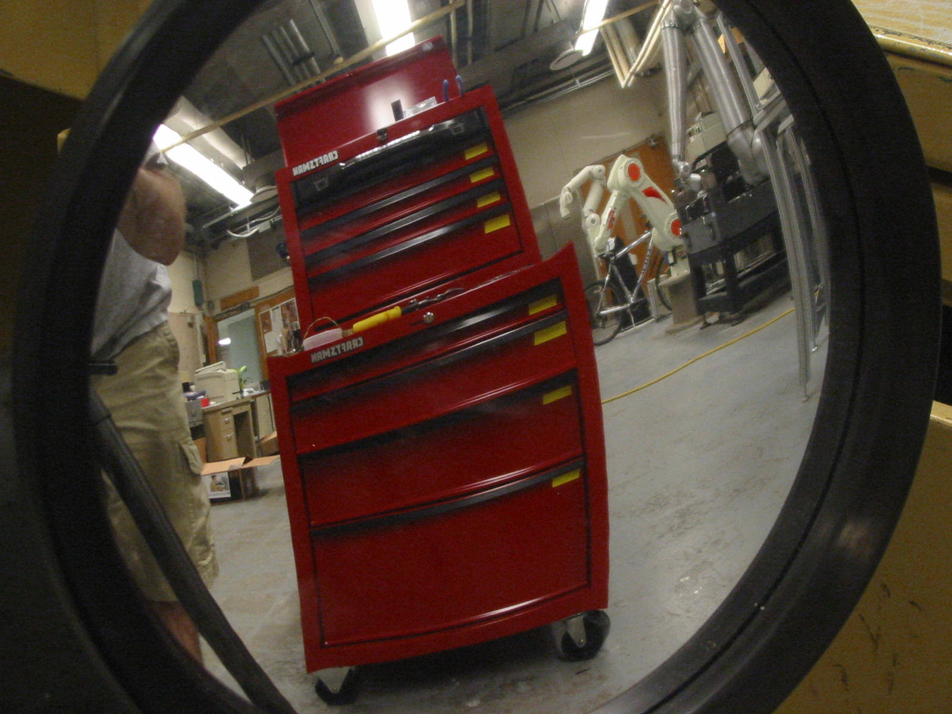

Your task is to rectify (straighten( this distorted image into the image shown below.

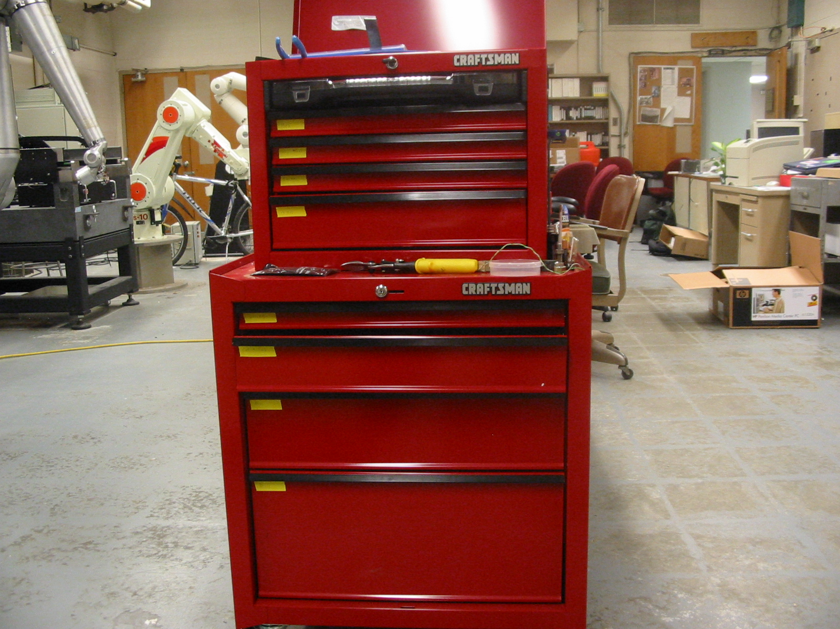

If you examine both photos closely you will see that the mirror does indeed reverse the image.

INSTRUCTIONS FOR WRITE-UP:
Discuss how well these techniques worked and whether they would be practical from the viewpoint of accuracy, automation and speed. Include any thoughts on what extensions may be necessary to make these techniques actually work.

APPENDIX Some MATLAB functions which may be useful for this assignment.

[x,y]=ginput(n) This function displays the image window with a cross hair whose position is controlled by the mouse. Pressing the mouse button will transfer one coordinate to [x,y]. Repeat this process until you get n coordinates.

Plot(x,y) This function plots vector x versus vector y.

Plot(x1,y1,x2,y2) This function plots the vector lines defined by [x1,y1] and [x2,y2]

Plot(x1,y1,’:’,x2,y2,’+’) This function plots the vector line defined by [x1,y1] as a dotted line and that defined by [x2,y2] as a set of + symbols corresponding to each data point.

Plot(x1,y1,’r’,x2,y2,’+g’) This function plots the vector line defined by [x1,y1] as a solid red line and that defined by [x2,y2] by green + symbols.

MATLAB supports the following:
Line-types point-types color
solid - point • red r
Dashed - - plus + green g
Dotted : star * blue b
Dash -. Circle o white w
x-mark x

