Introduction

Motivation and goal
Since the early days of the Internet (or the computer networks in general), researchers have proposed different ways to utilize network bandwidth. This is due to the high cost of bandwidth. Bandwidth rental accounts for about 55% of the ISPs (Internet Service Providers) operating expenses [22]. Having small amount of bandwidth in order to reduce the cost is not an option because on the Internet, there is a well-documented requirement that much more bandwidth be available than is used on average. This is due to the variability and the burstiness nature of the Internet traffic [31]. During normal network operation, 5% to 50% of the available bandwidth is only used [27]. However, two to twenty times more extra bandwidth than is used in average needs to be sit idle to handle “network spikes”, those times when network traffic peaks, using much more bandwidth than what is used in normal circumstances [28]. Network spikes could arise due to the increase in number of users or due to a heavy transfer periods like FTP sessions, downloading large files, or even watching online streaming multimedia. Thus, for a network to achieve acceptable performance, maintain adequate speed of operation and prevent degradation for its users, a good portion of its bandwidth must sit idle most of the time. Figure 1.1 shows how the Internet traffic looks and it also illustrates why extra bandwidth is needed to handle network spikes.

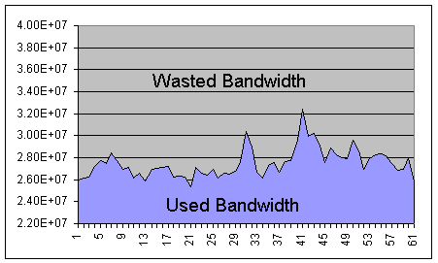

Figure 1.1 Bandwidth usage of Harvard Internet link

The network will be much more cost effective if the extra bandwidth could be used for other activities while it is not needed to handle a burst of pre-existing (normal) traffic. Meanwhile, Internet applications have created demands and expectations for differentiated treatment. One way to utilize the available bandwidth is to implement one of several differentiated service policies. A common method to differentiate between traffic flows is through the use of strict prioritization. Strict prioritization is defined by the following per-hop behavior: higher priority traffic is forwarded before lower priority traffic and higher priority packets are dropped only after low priority packets [21, 35]. In this strict prioritization method, certain packets can be marked as having the lowest possible priority. Thus, those low priority packets are forwarded after higher priority packets and dropped before them. On the original IPv6 RFC [13], this class of traffic is known as filler traffic.
In this research, we investigate (1) the effect of the filler traffic on the existing flows and (2) the filler traffic performance for two different types of filler traffics: CBR (Constant Bit Rate) and FTP/TCP. For each of these two types of filler traffic, we conduct extensive simulations on multiple traffic traces. Upon the completion of these simulations, several detailed statistics about the packet dynamics for the different types of flows were collected including average throughput, average delay, drop rate and the flow variability and self-similarity.

The rest of this thesis is organized as follows. Next sections on this chapter highlight the method that we used to implement the strict prioritization scheme and it describes the expected behavior of the network after the introduction of the filler traffic. The characteristics of the filler traffic are also described. We also give some background information that is necessary for the rest of this document. Then, in chapter two we describe the experimental environment and the different types of pre-existing and filler workloads that we simulated. In this chapter we also propose an accurate heuristic to partition the traces into incoming and outgoing flows. Chapters three and four relates to the two important characteristics of the filler traffic; the unobtrusiveness and the performance respectively. We then investigate the self-similarity of the aggregated traffic when CBR were used as the filler in chapter five. Chapter six deals, again, with the self-similarity of the traffic but this time when the FTP/TCP were used as the filler workload. Finally, chapter seven concludes the thesis by summarizing the results and giving some future work guidelines.

Method and behavior
According to this strict prioritization method, the normal (pre-existing traffic) will be given the highest priority and the filler traffic will be given the lowest priority. When the network spike occurs, normal traffic would take priority over this filler traffic, allowing the network to use this bandwidth as if it had been idle. Figure 1.2 shows, ideally, how the traffic will look like after injecting this low priority filler traffic into the network.

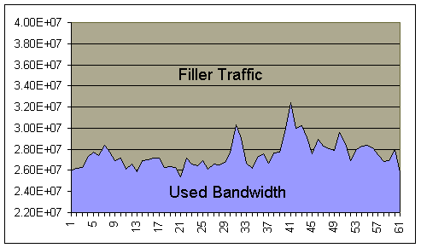
Figure1.2: Extra bandwidth being used by filler traffic

The pre-existing traffic should have higher precedence over the filler traffic. This is to ensure that the pre-existing traffic is not to be kept on hold while transmitting some filler traffic packets. In other words, the filler traffic should be halted when the bandwidth is needed by the pre-existing traffic. Practically, there will be a special kind of buffer (i.e, queue) where packets stay until they can be transmitted. Regular buffers usually implements a first come first served scheme (i.e, new packets get en-queued at the bottom of the buffer while packets are de-queued from the top of the buffer). However, using this prioritizing scheme, the packets with high priority will be placed in front of the buffer, ahead of all lower priority packets. At any point of time, if filler packets arrive and there are no pre-existing packets to send, then filler packets are transmitted immediately. However, if currently there are any high priority pre-existing packets waiting for transmission, the filler packets will be buffered on the queue until the line is free and no more pre-existing packets are waiting. When normal traffic levels were observed, filler traffic can resume transmission. Filler packets will be dropped if the queue is already full (i.e, there is no place to hold the packets).

Filler traffic characteristics
Recall that the role of the proposed filler traffic is to exploit the available unused bandwidth while not disturbing the already existing traffic. Based on this, for the filler traffic to be considered successful its not enough to achieve a reasonable performance, but also it should be unobtrusive from the pre-existing traffic point of view. Hence, it is clear that the filler traffic should not be used to carry any time-sensitive data as it could be substantially put on hold for a considerably long time due to the existence of pre-existing bursts.

Filler traffic unobtrusiveness
From the user point of view, the filler traffic should be completely transparent (i.e. users should not be able to tell that the filler traffic exists). This measures how the filler traffic affects the pre-existing traffic. The more unobtrusive the filler traffic is, the less it affects the pre-existing traffic and the better it is. So the goal is to try to make the filler traffic as unobtrusive (or as transparent) as possible. As stated above, the filler traffic should only use the extra bandwidth. However, pre-existing packets may arrive on the middle of a filler packet transmission. This will cause the pre-existing traffic to wait until the transmission of the filler packet is complete (because IP networks do not allow packet transmission to be aborted midway). This effect is much more visible with large filler packets and/or low PDB networks. Thus, it is clear that the filler traffic will have some affect on the pre-existing traffic. The task on hand is to study and try to minimize this affect by examining the packet dynamics (average throughput, average delay, and drop rate) of the pre-existing traffic.

Filler traffic performance
Filler performance describes how much work is really accomplished by the filler traffic. It will make no since if we inject filler packets into the network and we drop most of them during transmission. The challenge here is to maximize the performance while minimizing the obtrusiveness of the filler traffic. To measure the performance of the filler traffic, the packet dynamics of the filler traffic are considered and the goal is to minimize the delay and the dropped packets, while maximizing the average throughput.

Applications of the filler traffic
Because the excess bandwidth is needed at specific, unpredictable times, it must remain available to carry normal network traffic. Prioritization allows pre-existing traffic access to the extra bandwidth during those periodic times when it is needed to prevent a network showdown. Additionally, as mentioned above, the filler traffic should not be time sensitive as the pre-existing traffic can substantially delay its delivery.
In spite of these requirements, there are many possible applications for the filler traffic. At the transport layer, low priority traffic has been used in TCP fast start [29]. After a time out, fast start injects additional packets, but gives those packets low priority (i.e, as filler traffic). As a result, other network traffic is relatively insulated from the fast start packets. At the application layer, filler traffic is practically suited for several computer-to-computer background communications. For example, in the LSAM system, a server prepushes data to caches using low priority datagrams and multicast [37]. A different approach is to push web pages on a per-user basis using past access statistics and low priority datagrams [12]. Filler traffic is ideal for prefetching and prepushing in that it would adapt to the pre-existing traffic patterns and would not slow down on-demand traffic or increase queue length at buffers and delays [9]. Additional applications of filler traffic lie in the areas of data backup, distributed garbage collection [32], consistency maintenance [14], document upload [4], per-to-per networking [8], web crawling [7], on-line monitoring and troubleshooting [39], not-for-profit distributed computing (e.g, Seti@Home), and background agent communication.

Background
Self-similarity and long-range dependence
Recent experiments of LAN traffic and wide area network traffic have challenged the commonly assumed models for network traffic, e.g, Poisson process. Measurements of real traffic indicate that significant traffic variance (burstiness) is present on a wide range of time scales [23, 31]. Traffic that is bursty in many or all time scales can be described using the notion of self-similarity. Self-similarity is the property associated with one type of fractal – an object whose appearance is unchanged regardless of the scale at which it is viewed. In case of stochastic objects like time series, self-similarity is used in the distributional sense: when viewed at varying scales, the object’s correlation structure remains unchanged. As a result, such a time series exhibits bursts (i.e, extended periods above the mean) at a wide range of time scales [11]. Since a self-similar process has observable bursts at a wide range of time scales, it can exhibit long-range dependence; values at any instance are typically non-negligibly positively correlated with values at all future instances. For detailed discussion of self-similarity in time series data and statistical tests, see [3,41].
Mathematically, given a zero-mean, stationary time series X = (X_{t}; t = 1, 2, 3, …), we define the m-aggregated series X^{(m)} = (X_{k}^{(m)}; k = 1, 2, 3, …) by summing the original series X over non-overlapping blocks of size m. Then we say that X is H self-similar if for all positive m, X^{(m)} has the same distribution as X rescaled by m^{H}, that is:

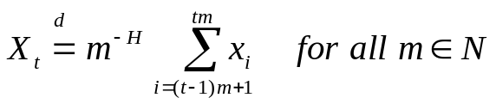.
If X is H self-similar, it has the same autocorrelation function 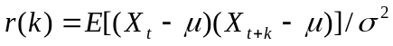 as the series X^{(m)} for all m. Note that this means that the series is distributionally self-similar: the distribution of the aggregated series is the same (except for a change in scale) as that of the original.
As a result, self-similar processes can show long-range dependence. A process with long-range dependence has an autocorrelation function . Thus the autocorrelation function follows a power law, as compared to exponential decay exhibited by the traditional traffic models. Power low decay in slower than exponential decay, and since 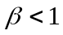, the sum of the autocorrelation values of such a series approaches infinity. This has a number of implications. First, the variance of the mean of n samples from such a series does not decrease proportionally to 1/n (as predicted by basic statistics for uncorrelated data sets) but rather decreases proportionally to 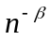. Second, the power low spectrum of such a series is hyperbolic, rising to infinity at frequency zero (reflecting infinite influence of the long-range dependence of the data).
One of the attractive reasons of using self-similar models for time series is that the degree of self-similarity of a series is expressed using only one parameter. The parameter expresses the speed of the decay of the series’ autocorrelation function. For historical reasons, the parameter used is the Hurst parameter 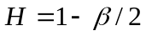. Thus for self-similar series with long-range dependence, 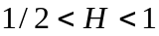. As 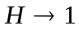 the degree of both self-similarity and long-range dependence increase.

In this research, we use three methods to test for self-similarity: the absolute value of the aggregated series, the Periodogram, and the wavelet method [38]. In the absolute value method, we calculate the aggregated series. Then we find the absolute values of the aggregated series, namely,
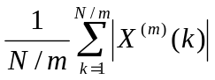.
Then the logarithm, of this statistic is plotted versus the logarithm of m. If the original series is self-similar with parameter H, then the result should be a line with slope H – 1 [36].
For the Periodogram, one first calculates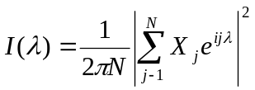,
where is a frequency, N is the number of terms in the series, and X_{j} is the data. Then a series with long-range dependence should have a Periodogram that is proportional to 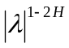 close to the origin. Therefore, a regression of the logarithm of the Periodogram on the logarithm of the frequency should give a coefficient of 1 - 2H [36].
The wavelet method is described fully in [1] and the theory behind is beyond the scope of this thesis. Darryl Veitch created a MATLAB based tool for time series analysis using the wavelet analysis method. The tool is available for public at http://www.emulab.ee.mu.oz.au/~darryl/estimation_code.html.

